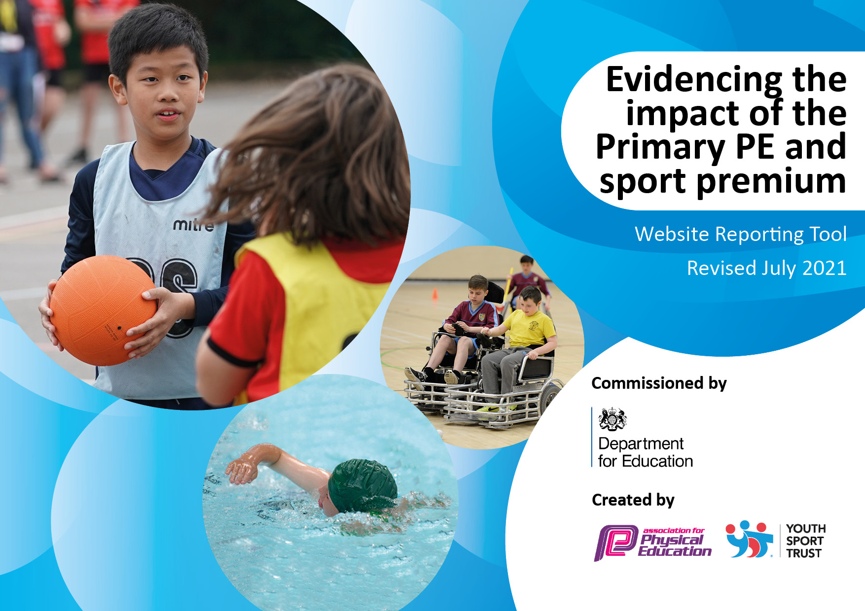
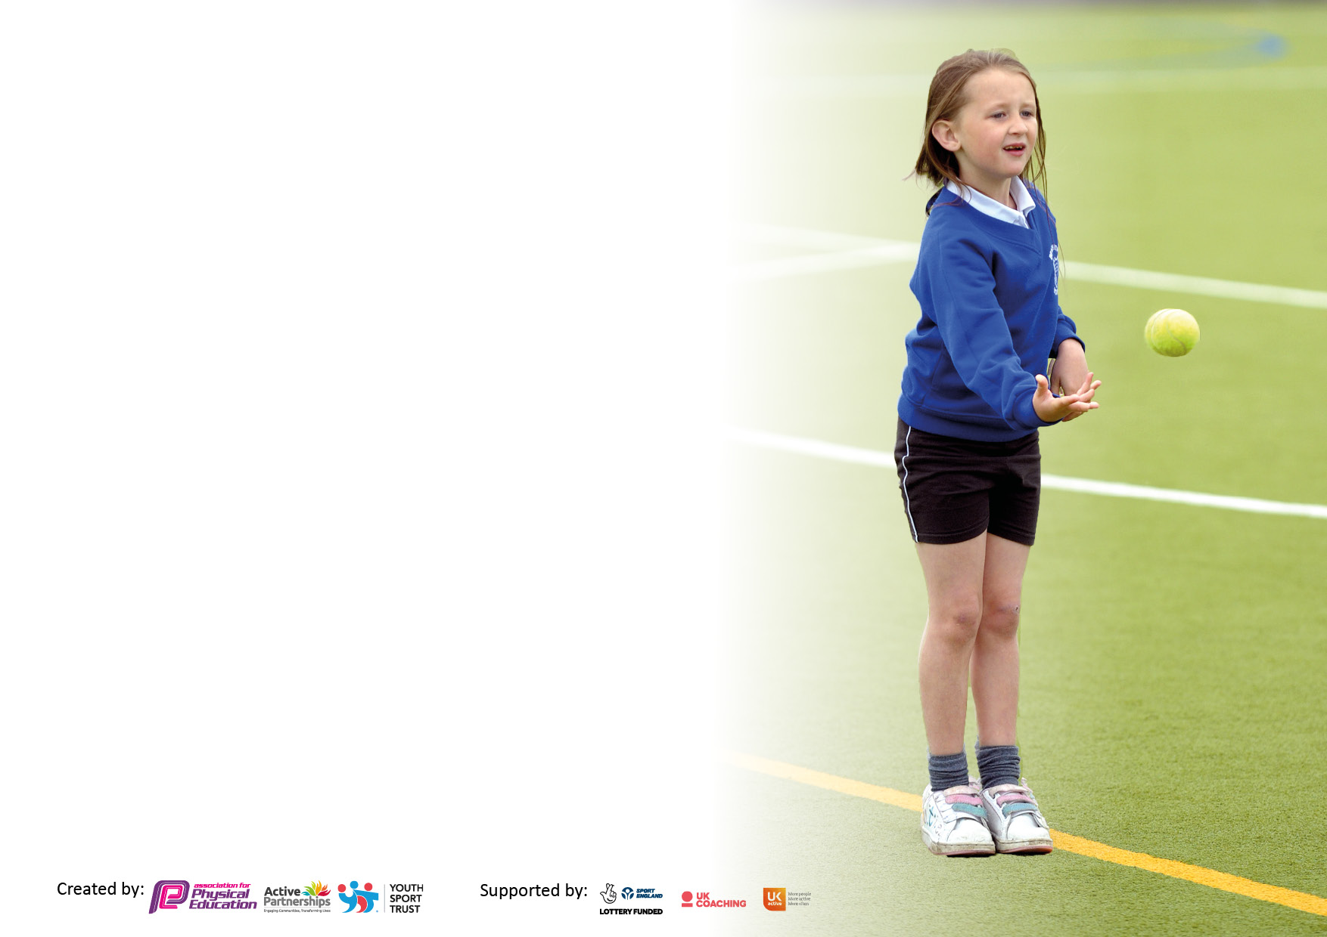

It is important that your grant is used effectively and based on school need. The Education Inspection Framework makes clear there will be a focus on ‘whether leaders and those responsible for governors all understand their respective roles and perform these in a way that enhances the effectiveness of the school’.

Under the Quality of Education Ofsted inspectors consider:
Intent - Curriculum design, coverage and appropriateness
Implementation - Curriculum delivery, Teaching (pedagogy) and Assessment
Impact - Attainment and progress

To assist schools with common transferable language this template has been developed to utilise the same three headings which should make your plans easily transferable between working documents.

Schools must use the funding to make additional and sustainable improvements to the quality of Physical Education, School Sport and Physical Activity (PESSPA) they offer. This means that you should use the Primary PE and sport premium to:

- Develop or add to the PESSPA activities that your school already offer
- Build capacity and capability within the school to ensure that improvements made now will benefit pupils joining the school in future years
- The Primary PE and sport premium should not be used to fund capital spend projects; the school’s budget should fund these.

Pleasevisitgov.ukfortherevisedDfEguidanceincludingthe5keyindicatorsacrosswhichschoolsshoulddemonstrate animprovement.Thisdocumentwillhelpyoutoreviewyourprovisionandtoreportyourspend.DfEencouragesschools to use this template as an effective way of meeting the reporting requirements of the Primary PE and sport premium.

We recommend you start by reflecting on the impact of current provision and reviewing the previous spend.

Schools are required to publish details of how they spend this funding, including any under-spend from 2019/2020, as well as on the impact it has on pupils’ PE and sport participation and attainment. All funding must be spent by 31st July 2022.

We recommend regularly updating the table and publishing it on your website throughout the year. This evidences your ongoing self-evaluation of how you are using the funding to secure maximum, sustainable impact. Final copy must be posted on your website by the end of the academic year and no later than the 31st July 2021. To see an example of how to complete the table please click HERE.

Details with regard to funding
Please complete the table below.

Total amount carried over from 2019/20 | £0
Total amount allocated for 2020/21 | £19100
How much (if any) do you intend to carry over from this total fund into 2021/22? | £10,000
Total amount allocated for 2021/22 | £19,000
Total amount of funding for 2021/22. To be spent and reported on by 31st July 2022. | £29,000
Swimming Data
Please report on your Swimming Data below.

Meeting national curriculum requirements for swimming and water safety.  N.B. Complete this section to your best ability. For example you might have practised safe self-rescue techniques on dry land which you can then transfer to the pool when school swimming restarts.  Due to exceptional circumstances priority should be given to ensuring that pupils can perform safe self rescue even if they do not fully meet the first two requirements of the NC programme of study | No data due to COVID-19
What percentage of your current Year 6 cohort swim competently, confidently and proficiently over a distance of at least 25 metres?  N.B. Even though your pupils may swim in another year please report on their attainment on leaving primary school at the end of the summer term 2020.  Please see note above | No data due to COVID-19
What percentage of your current Year 6 cohort use a range of strokes effectively [for example, front crawl, backstroke and breaststroke]?  Please see note above | No data due to COVID-19
What percentage of your current Year 6 cohort perform safe self-rescue in different water-based situations? | No data due to COVID-19
Schools can choose to use the Primary PE and sport premium to provide additional provision for swimming but this must be for activity over and above the national curriculum requirements. Have you used it in this way? | Yes/No I DON’T KNOW?

Action Plan and Budget Tracking
Capture your intended annual spend against the 5 key indicators. Clarify the success criteria and evidence of impact that you intend to measure to evaluate for pupils today and for the future.

Academic Year: 2021/22 | Total fund allocated: | Date Updated:
Key indicator 1: The engagement of all pupils in regular physical activity – Chief Medical Officers guidelines recommend that primary school pupils undertake at least 30 minutes of physical activity a day in school |  |  |  | Percentage of total allocation:
 |  |  |  | %
Intent | Implementation |  | Impact
Your school focus should be clear what you want the pupils to know and be able to do and about  what they need to learn and to  consolidate through practice: | Make sure your actions to achieve are linked to your intentions: | Funding allocated: | Evidence of impact: what do pupils now know and what can they now do? What has changed? | Sustainability and suggested next steps:
Encourage all children to be as active as possible – particularly because of COVID-19 lockdown which has instilled a sedentary lifestyle in some children. | Daily mile focus and encouragement/ to be reviewing and potentially altered to another form of daily exercise.  Equipment out at breaks and lunches  Participation in sports days locally and nationally – ESSD, National School Sports Week, WASSP competitions etc. | Est £600 on pedometers for full phase set.  £1500 playtime equipment & Speaker system for dance area.
To engage the less active children in more physical activity. | Complete activities to identify target groups such as fitness trackers and pupil voice (Sep 2021)  Ensure that extra-curricular activities are available to encourage participation.  Offer a range of non-traditional sports for extra-curricular. | No cost  Teaching staff-led, no extra cost  TBC
Ensure that ALL children can participate in PE lessons and engage with activity during break times etc. | Allow chn to attend WASSP ability days to encourage participation and train staff on how to adapt lessons for them.  TAs/teaching staff to attend training for adapting lessons to support physically disabled/SEND chn. | Included in WASSP package
Key indicator 2: The profile of PESSPA being raised across the school as a tool for whole school improvement |  |  |  | Percentage of total allocation:
 |  |  |  | %
Intent | Implementation |  | Impact
Your school focus should be clear what you want the pupils to know and be able to do and about  what they need to learn and to  consolidate through practice: | Make sure your actions to achieve are linked to your intentions: | Funding allocated: | Evidence of impact: what do pupils now know and what can they now do? What has changed?: | Sustainability and suggested next steps:
Take part in local and national sports events | Ensure that we are registered and participate in at least one event each half term – ESSD Aut1, NSSW – Summer 2 | N/A
Develop a more interactive, engaging sports day and plan to make it suitable for all weathers to avoid cancellations | Year 6 children and TH to work together to plan and deliver activities for younger year groups’ sports days.  Purchase medals/stickers/trophies to reward. | £300
Staff to role model PE kit, improving children’s attendance in PE and thus attainment (a lot of children do not wear correct kit etc). Staff will be clearly identified as having PE that day yet will still be smartly dressed for work attire. | Purchase staff T-shirts and hoodies for all PE teaching staff which can then be worn on PE days. Uniform to follow school’s blue ‘Team Beamont’ with badge representation. | £650

Key indicator 3: Increased confidence, knowledge and skills of all staff in teaching PE and sport |  |  |  | Percentage of total allocation:
 |  |  |  | %
Intent | Implementation |  | Impact
Your school focus should be clear | Make sure your actions to | Funding | Evidence of impact: what do | Sustainability and suggested
what you want the pupils to know | achieve are linked to your | allocated: | pupils now know and what | next steps:
and be able to do and about | intentions: |  | can they now do? What has
what they need to learn and to |  |  | changed?:
consolidate through practice:
Continue to a build a cohesive curriculum that sequence’s knowledge within the architectural structure of key concepts. | Use PE Hub for lesson plans for PE and follow the LTP to ensure that content/skills etc develop year upon year. | £600
To ensure the teaching of PE is good or outstanding across the school. | TH to deliver 1 lesson per week to classes and class teacher the other. All will follow the same PE Hub formats.  Staff audits to be completed termly to ensure confidence and competence  Learning walks/observations to be carried out by subject lead alongside outside SLA.  Provide CPD where required (staff voice to be completed) | £1700 SLA  Est £2000 CPD
To develop PE subject leader’s understanding of PE within the curriculum. | Buy into outside agencies to support subject leader and provide network meetings, subject leader days etc as well as SLA to work with SL on observations, audits etc. | As above
To introduce a formal assessment system to PE which is clear and simple for staff to use. | Create a spreadsheet document with objectives for each unit of PE for each year group and spend time sharing this with staff and implementing it into every day PE lessons.  Reassess effectiveness and impact after Autumn term to make changes if/where required. | £500
Use technology effectively to enhance lessons and assessment. | Ensure all teaching staff have easy access to PE hub and the new assessment system. Use of iPad for lessons to share videos with children, share feedback from recordings of them, use for collating evidence and data.  >iPad for TH  > screen in upstairs hall. | TBC est £1500
Key indicator 4: Broader experience of a range of sports and activities offered to all pupils |  |  |  | Percentage of total allocation:
Intent | Implementation |  | Impact
Your school focus should be clear | Make sure your actions to | Funding | Evidence of impact: what do | Sustainability and suggested
what you want the pupils to know | achieve are linked to your | allocated: | pupils now know and what | next steps:
and be able to do and about | intentions: |  | can they now do? What has
what they need to learn and to |  |  | changed?:
consolidate through practice:
Pupils to be exposed to/ involved in a variety of sports both traditional and non-traditional and inclusive. | WASSP membership to engage with experience days and competitions, equipment loans for broad variety of sports.  Organise inclusive sports such a wheelchair basketball for all children to be involved with.  Extra-curricular activities to be planned based on pupil voice and consideration on non-standard activities to provide a broader range.  Yoga, skipping, judo, archery etc. | £2700  TBC  TBC
Children to be exposed to yoga and the positive mental benefits this can have as well as physical. | Buy in a trained yoga instructor to train staff on basic level 1 yoga which can then be taught to all children. | £800
Improve the experiences for children in gymnastics. Purchase new equipment to give a range of activities for this subject. | Purchase large hall climbing frame, balance beams, mats etc. | Est £10,000

Key indicator 5: Increased participation in competitive sport |  |  |  | Percentage of total allocation:
 |  |  |  | %
Intent | Implementation |  | Impact
Your school focus should be clear | Make sure your actions to | Funding | Evidence of impact: what do | Sustainability and suggested
what you want the pupils to know | achieve are linked to your | allocated: | pupils now know and what | next steps:
and be able to do and about | intentions: |  | can they now do? What has
what they need to learn and to |  |  | changed?:
consolidate through practice:
Children to be offered opportunities to compete in sports within school and with other schools. | Work with WPAT to organise competitions with teams.  Attend SGO and WASSP competitions  Work locally with nearby schools to organise friendlies for new teams to practice competing.  Work with Y6 chn to organise tournaments at least once per term – leading to winners V staff game. | Included in WASSP package
Encourage higher participation from girls in competitive sports | Football team organised and girls signed up to compete in WASSP competition.
Design a sports day to encourage healthy competition and participation for all. | See above (indicator 1)

Signed off by
Head Teacher:
Date:
Subject Leader:
Date:
Governor:
Date:

