Subject: Science Year: Year 6 – Electricity

NC/PoS:
- associate the brightness of a lamp or the volume of a buzzer with the number and voltage of cells used in the circuit
- compare and give reasons for variations in how components function, including the brightness of bulbs, the loudness of buzzers and the on/off position of switches
- use recognised symbols when representing a simple circuit in a diagram

Prior Learning (what pupils already know and can do)

Electricity is a form of energy and can only travel if there is a complete circuit. A simple circuit includes needs a cell (battery) and wires to connect to a component such as a bulb, buzzer or motor. The flow of electricity is controlled by a switch and this can be placed anywhere in the circuit. Electrical conductors allow electricity to pass through them, electrical insulators do not.

End Goals (what pupils MUST know and remember)

To know when a switch is open, the circuit is incomplete
To know that by adding more batteries the bulb gets brighter or the buzzer becomes louder as there is a greater current
To know current is the amount of electricity flowing through the circuit
To know that the higher the voltage of a battery, the more powerful it is – the more current flowing through a circuit
To know that using higher voltage batteries causes a brighter bulb or a louder buzzer
To know if you add more bulbs, the bulbs get dimmer
To know if you add more buzzers, they buzz more quietly
To know several motors would each turn more slowly than just one
To know using longer wires between the components provides more resistance so bulbs dimmer and buzzers quieten
To know the symbols of a simple circuit:
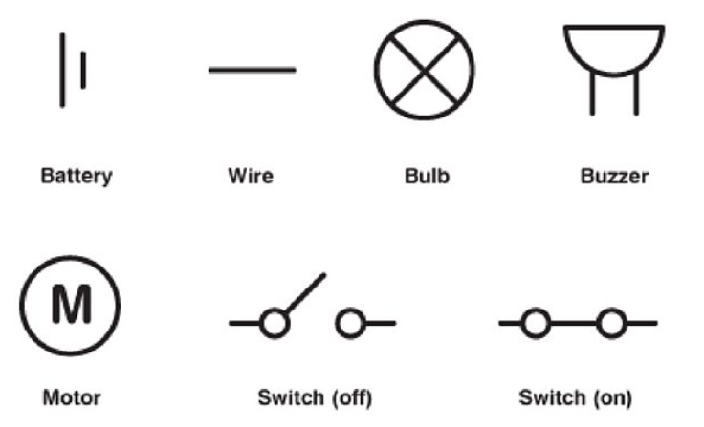

Key Vocabulary
Circuit, complete circuit, circuit diagram, circuit symbol, cell, battery, bulb, buzzer, motor, switch, voltage, current, components
Session 1: Review prior learning – ensure children can make a simple circuit, draw and label the different components

Vocabulary: simple circuit, components, buzzer, motor, bulb, cell, battery, switch, terminal (positive and negative)
Session 2: Lo: to record drawings using circuit symbols

Discuss the reasoning behind using symbols for the components of a circuit. Explain to the children that because it was important that electrical circuits could be understood anywhere in the world, an internationally recognised series of symbols was developed to represent the different circuit components.
Match definition of function of component, photo of component and circuit symbol, (STEM resources – electricity) make simple circuits and record both annotated drawings (real-life) and drawing using circuit symbols.
Ensure use of ruler for drawing of wires

Vocabulary: circuit symbol, circuit diagram
Session 3: LO: to predict whether a circuit will work or not

BBC Bitesize: how a circuit works https://www.bbc.co.uk/bitesize/topics/zj44jxs/articles/zrd2qfr
Give the children a variety of circuits, (drawings using symbols/ photographs of symbols etc.) Children explain which circuits wouldn’t work and why not? How would they complete the circuit?

Vocabulary: closed circuit, open circuit, break, complete
Session 4: This is the opportunity to look for patterns using a variety of different scenarios
LO: to look for patterns ………………..

Ensure the children know the differences between current and voltage before investigating:
Scenario 1: how does increasing the voltage of the battery affect the components?

Scenario 2: How does the length or thickness of the wires affect the brightness of a bulb?

Scenario 3: How does the number of cells affect the components within a circuit?
Each scenario needs circuit drawings with their observations recorded and an explanation for what they saw.

A common misconception is that electrons are used up by the devices in a circuit as they flow through them. Electrons are not used up in the circuit – they transfer their energy and always flow back to the battery.

Vocabulary: voltage, current
Session 5: LO: To observe how the components are affected when more are added to the circuit.

In a circuit, energy is shared between the components, so if the number of components is increased, the less energy there is for each component. If there are too many components in a circuit, there may be insufficient energy available for the components to work properly.

Children predict, record observations, evaluate their results

Vocabulary: components
Link to careers:
Electrician https://www.youtube.com/watch?v=tmfso_119No
Electronics
Power plant operator
Scientists who have helped develop understanding in this field: Georg Ohm, Alessandro Volta https://www.youtube.com/watch?v=XTygNnmL4Gs just watch up to Georg Ohm

