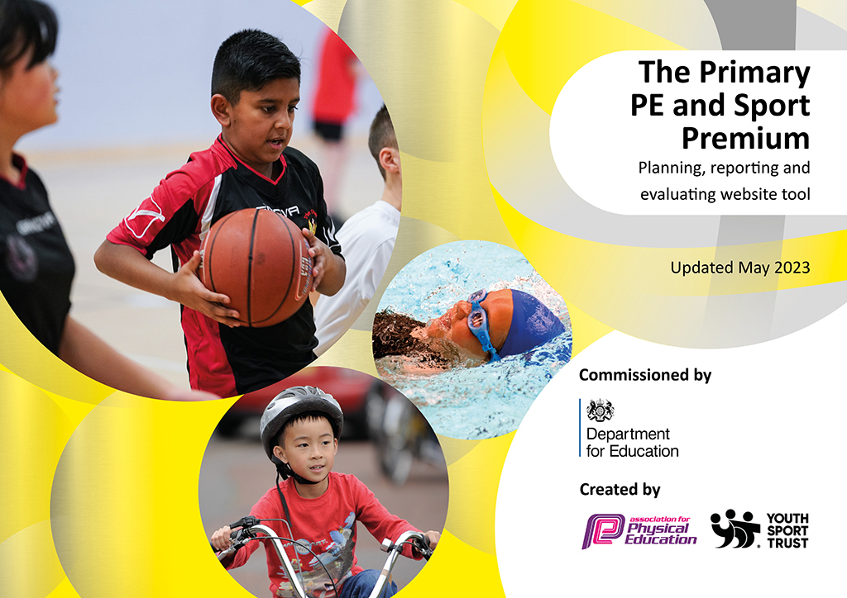
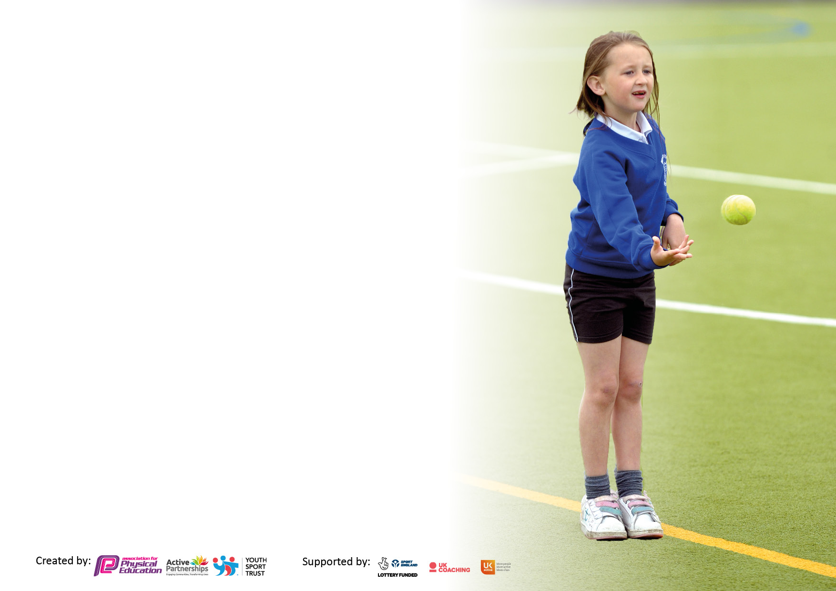

It is important that your grant is used effectively and based on school need. The Education Inspection Framework makes clear there will be a focus on ‘whether leaders and those responsible for governors all understand their respective roles and perform these in a way that enhances the effectiveness of the school’.

Under the Quality of Education Ofsted inspectors consider:
Intent - Curriculum design, coverage and appropriateness
Implementation - Curriculum delivery, Teaching (pedagogy) and Assessment
Impact - Attainment and progress

To assist schools with common transferable language this template has been developed to utilise the same three headings which should make your plans easily transferable between working documents.

Schools must use the funding to make additional and sustainable improvements to the quality of Physical Education, School Sport and Physical Activity (PESSPA) they offer. This means that you should use the Primary PE and sport premium to:

- Develop or add to the PESSPA activities that your school already offer
- Build capacity and capability within the school to ensure that improvements made now will benefit pupils joining the school in future years
- The Primary PE and sport premium should not be used to fund capital spend projects; the school’s budget should fund these.

Pleasevisitgov.ukfortherevisedDfEguidanceincludingthe5keyindicatorsacrosswhichschoolsshoulddemonstrate animprovement.Thisdocumentwillhelpyoutoreviewyourprovisionandtoreportyourspend.DfEencouragesschools to use this template as an effective way of meeting the reporting requirements of the Primary PE and Sport Premium.

We recommend you start by reflecting on the impact of current provision and reviewing the previous spend.

Schools are required to publish details of how they spend this funding, including any under-spend from 2021/2022, as well as on the impact it has on pupils’ PE and sport participation and attainment. All funding must be spent by 31st July 2023.

We recommend regularly updating the table and publishing it on your website throughout the year. This evidences your ongoing self-evaluation of how you are using the funding to secure maximum, sustainable impact. Final copy must be posted on your website by the end of the academic year and no later than the 31st July 2023. To see an example of how to complete the table please click HERE.

Details with regard to funding
Please complete the table below.

Total amount carried over from 2021/22 | £ 0
Total amount allocated for 2021/22 | £ 0
How much (if any) do you intend to carry over from this total fund into 2022/23? | £0
Total amount allocated for 2022/23 | £ 0
Total amount of funding for 2023/23. To be spent and reported on by 31st July 2023. | £ 19,230
Swimming Data
Please report on your Swimming Data below.

Meeting national curriculum requirements for swimming and water safety.  N.B. Complete this section to your best ability. For example you might have practised safe self-rescue techniques on dry land which you can then transfer to the pool when school swimming restarts.  Due to exceptional circumstances priority should be given to ensuring that pupils can perform safe self rescue even if they do not fully meet the first two requirements of the NC programme of study | Children only attended swimming for 10 weeks in Year 5 due to COVID in Year 4.
What percentage of your current Year 6 cohort swim competently, confidently and proficiently over a distance of at least 25 metres?  N.B. Even though your pupils may swim in another year please report on their attainment on leaving primary school at the end of the summer term 2022.  Please see note above | %
What percentage of your current Year 6 cohort use a range of strokes effectively [for example, front crawl, backstroke and breaststroke]?  Please see note above | %
What percentage of your current Year 6 cohort perform safe self-rescue in different water-based situations? | %
Schools can choose to use the Primary PE and sport premium to provide additional provision for swimming but this must be for activity over and above the national curriculum requirements. Have you used it in this way? | Yes/No

Action Plan and Budget Tracking
Capture your intended annual spend against the 5 key indicators. Clarify the success criteria and evidence of impact that you intend to measure to evaluate for pupils today and for the future.

Academic Year: 2022/23 | Total fund allocated: | Date Updated:
Key indicator 1: The engagement of all pupils in regular physical activity – Chief Medical Officers guidelines recommend that primary school pupils undertake at least 30 minutes of physical activity a day in school |  |  |  | Percentage of total allocation:
 |  |  |  | % 23
Intent | Implementation |  | Impact
Your school focus should be clear what you want the pupils to know and be able to do and about  what they need to learn and to  consolidate through practice: | Make sure your actions to achieve are linked to your intentions: | Funding allocated: | Evidence of impact: what do pupils now know and what can they now do? What has changed?: | Sustainability and suggested next steps:
To ensure children have a variety of equipment and resources available to engage them with physical activity during lessons and during break times. | Lunch and break clubs engaged some children with use of new equipment. After school clubs too. | £ 4, 250 | Chn are engaged at break times more with physical games. Uptake of extra-curricular has increased. | Equipment can be used for years now.
To engage the less active children in more physical activity. | Ensure that extra-curricular activities are available to encourage participation. | £250 | Chn really enjoy Judo. We engage children whom may not normally participate in sports clubs. | Uptake increased for clubs. Will look at asking teaching staff to deliver some next year, too.
Key indicator 2: The profile of PESSPA being raised across the school as a tool for whole school improvement |  |  |  | Percentage of total allocation:
 |  |  |  | 23%
Intent | Implementation |  | Impact
Your school focus should be clear what you want the pupils to know and be able to do and about  what they need to learn and to  consolidate through practice: | Make sure your actions to achieve are linked to your intentions: | Funding allocated: | Evidence of impact: what do pupils now know and what can they now do? What has changed?: | Sustainability and suggested next steps:
To hire in a gymnastics company to deliver sessions to the children. Staff to engage with the sessions as CPD with the intent for teachers to deliver it themselves in future. | Beth Tweddle Gymnastics booked to deliver 12 weeks of sessions to all children (Rec – Year 6) | £4,488 | Chn really enjoyed the sessions. Improvements in attainment/ability. Staff felt they benefited from them.  Break time club was set up on the back of sessions as some chn really enjoyed it and showed strong talent. | Rebooking for one more academic year. Then, staff will deliver it themselves after that.

Key indicator 3: Increased confidence, knowledge and skills of all staff in teaching PE and sport |  |  |  | Percentage of total allocation:
 |  |  |  | 48%
Intent | Implementation |  | Impact
Your school focus should be clear | Make sure your actions to | Funding | Evidence of impact: what do | Sustainability and suggested
what you want the pupils to know | achieve are linked to your | allocated: | pupils now know and what | next steps:
and be able to do and about | intentions: |  | can they now do? What has
what they need to learn and to |  |  | changed?:
consolidate through practice:
To ensure children are given a high-quality PE curriculum which is delivered well and staff can be supported to deliver well, too. | To employ a PE specialist coach to deliver PE and support teachers with their delivery of PE. | £6,410
Continue to a build a cohesive curriculum that sequence’s knowledge within the architectural structure of key concepts. | SL to review planning (use of PE Hub) and ensure it is still right for Beamont. | £455 | Using PE Hub for lesson plans for PE and follow the LTP to ensure that content/skills etc develop year upon year.  Adaptations made to LTP to ensure the units work cohesively and follow on from one another to build a progressive curriculum. | Fairly priced for access to good lesson planning which staff follow and adapt well.
For our PE coach to enhance his specialism in the subject. | THolt enrolled onto Level 5 PE specialism course | £800 | Pupils are receiving higher-quality provision and other staff are being supported well as TH is bringing back the knowledge acquired and developing other staff with this too.
To support subject leader and ensure confidence and competence of PE across the school | SLA employed | £1,700 | Provision of PE is strong and has been observed alongside SLA to adhere to this.
Key indicator 4: Broader experience of a range of sports and activities offered to all pupils. |  |  |  | Percentage of total allocation:
 |  |  |  | 4%
Intent | Implementation |  | Impact
Your school focus should be clear | Make sure your actions to | Funding | Evidence of impact: what do | Sustainability and suggested
what you want the pupils to know | achieve are linked to your | allocated: | pupils now know and what | next steps:
and be able to do and about | intentions: |  | can they now do? What has
what they need to learn and to |  |  | changed?:
consolidate through practice:
To provide children with opportunities to engage with a wider range of sporting activities. | External providers of dance and yoga booked.  Judo | Parent/carer funded  See indicator 1 | Good uptake on clubs. Chn really enjoy them. | Rebooked for next year with feedback from parents/carers that they are happy to continue contributing.
 | Purchase an archery kit based on the success of last year’s outside agency delivery of the sport, so that it can be run internally this year. | £293 | We had a good up-taking on the archery clubs. Children enjoyed it and we engaged some children who would not normally participate in clubs. | Staff will continue to offer archery as a club.
For children to experience and engage with a SEND catered sport. | Year 5 and 6 children to have a wheelchair basketball coach in for a session. | £506 | Pupils had a wonderful day and enjoyed the sessions. One y6 pupil who is permanently in a wheelchair said it was the best day of his life and the children loved the experience. | Rebooking for next year for more pupils to experience (3-6) as part of school sports week,

Key indicator 5: Increased participation in competitive sport |  |  |  | Percentage of total allocation:
 |  |  |  | 2%
Intent | Implementation |  | Impact
Your school focus should be clear | Make sure your actions to | Funding | Evidence of impact: what do | Sustainability and suggested
what you want the pupils to know | achieve are linked to your | allocated: | pupils now know and what | next steps:
and be able to do and about | intentions: |  | can they now do? What has
what they need to learn and to |  |  | changed?:
consolidate through practice:
To engage the school teams with competitions within the MAT | Purchased a school logo designed football kit which the football team have then been able to wear to events. | £ 331 | Boy’s football team have attended several competitions. Their confidence has increased and they have fed back that they like having the kit. | Next steps: consider wider range of kit needs (i.e. girls’ team).

Signed off by
Head Teacher:
Date:
Subject Leader: | SARAH CORNELIA
Date: | 06.07.2023
Governor:
Date:

