Year 1 Warrington
Context:
We live in Warrington which is in the northwest of England.
Concepts:
Place, space, environment , interconnection , change

Facts | Vocabulary
1.Warrington is a large town in the northwest of England in the UK. Sankey Bridges is in Warrington. | Brook – a small stream  River – a natural flowing watercourse  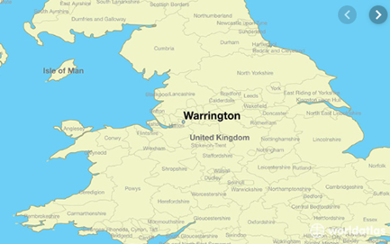  Canal – a manmade waterway  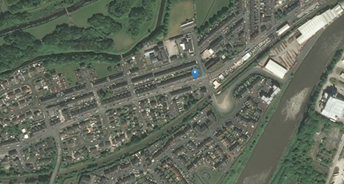  Warrington  Our local area  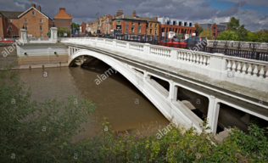  River Mersey  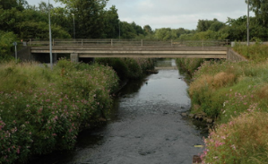  Sankey Brook  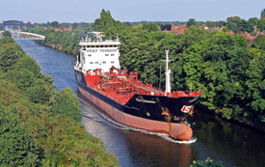  Manchester Ship Canal
2. Physical Features - Are natural features such as trees, mountains, oceans, rivers, lakes.

3. Human Features - Are things that are built by humans such as bridges and roads.

4. Physical features of Warrington - River Mersey, Sankey Brook, flat land, vegetation.

5. Human features of Warrington - Manchester Ship Canal, railway stations, bridges, motorways, industry, retail areas, housing. It is an urban area.

6. Warrington generally has warm summers and cool winters. Rain is spread across the year, with thunderstorms only usually occurring in the summer months.

www.maps.nls.uk
https://kids.kiddle.co/Warrington

