Year 3 Settlements and Land Use in the North West
Context: Since prehistory the settlements and land use of the UK have changed and will continue to change
Concepts: place, space, environment, scale, change

Facts | Vocabulary
- Settlements:  - A place where people establish a community.  - Settlements can vary in size from the very small (a house) to extremely large (a city)  - They can be permanent or temporary.  - Settlements start in different places for different reasons - protection , building materials, water for drinking, food and crops and flat land for building easily. | 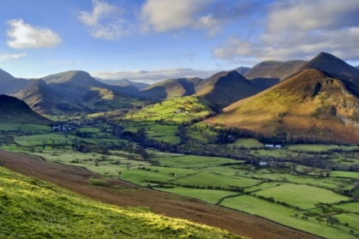  Transport – from Latin transportare, from trans- ‘across’ + portare ‘carry’.  Rural landscape  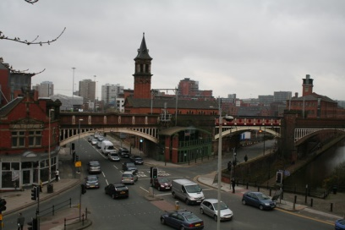  Urban landscape  Map of North West  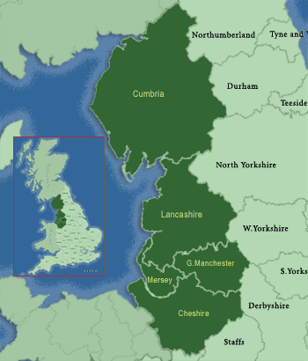  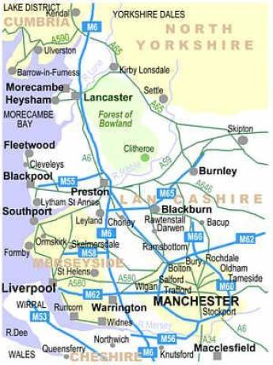  Motorways in NW
- Types of settlements:
- Hamlet – this is a very small group of homes. There are unlikely to be any other facilities.
- Village – larger than a hamlet and contains more facilities e.g. a few shops, a post office, a village hall and possibly a primary school and doctor’s surgery
- Town – may contain tens of thousands of people and has a range of facilities e.g. shopping centres, railway stations, secondary schools and hospitals.
- City – an area with large numbers of people which provide a very large range of specialised facilities e.g. universities, large hospitals and sports stadium
- Changing landscape:
- Some local services in towns, such as shops, have closed over time and people rely more on shopping in supermarkets, out of town hypermarkets, or online.
- Shops in towns and cities now face tough competition from shopping malls and internet shopping, and many local shops have vanished from our high streets.
- Definition of land use is the function of the land – what it is used for.
- Land use varies from area to area.
- In rural areas (countryside) land use can include forestry and farming.
- In urban areas (towns and cities) land use could be housing or industry.
- Types of land use:
- Residential - housing
- Agricultural- farmland
- Recreation – fun, non- essentials like parks
- Transportation – roads, railways and airports
- Commercial- businesses and factories
- North West Region of England: (land use)
a) Residential - nearly 40% of the population live in Greater Manchester, 21% in Lancashire, 20% Merseyside, 15% Cheshire and the rest in Cumbria
b) Agriculture - Grazing Livestock which has the largest percentage followed by dairy farming
c) National parks - Lake District, Yorkshire Dales and Peak District
d) Transportation – main airports – Manchester, Liverpool, main port – Liverpool, main railway stations –Crewe, Liverpool, Manchester, Carlisle, main motorways – M6, M62, M56, M60, M57
- Physical geography of the North West:
- Cumbrian mountains (Lake District) – the highest mountains in England, containing Scafell Pike.
- Rivers: Mersey, Derwent, Dee, Ribble
- Lake District – England’s largest national park
- Human geography of the North West:
- Third most populated region in the UK
Websites: Geographical association - settlements
https://www.bbc.co.uk/bitesize/topics/zx72pv4/articles/zrbvjhv settlements

