Year 4 Europe – (with a study of Greece)
Context: The U.K. is part of Europe, one of the smallest continents
Concepts: place •space •environment •interconnection •scale •change

Facts | Vocabulary
1. Europe is the second smallest continent | 1. peninsula – a piece of land surrounded by water on three sides  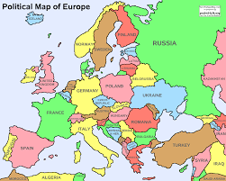  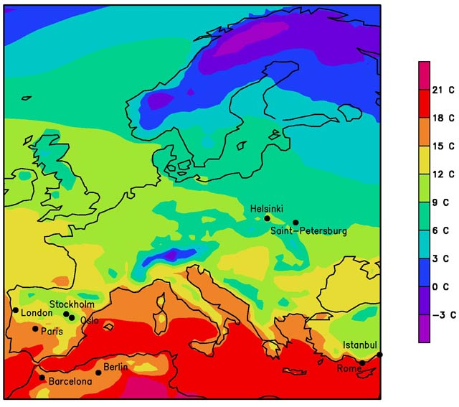  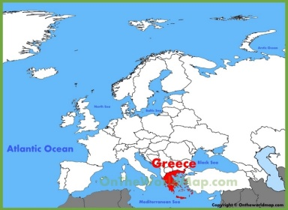  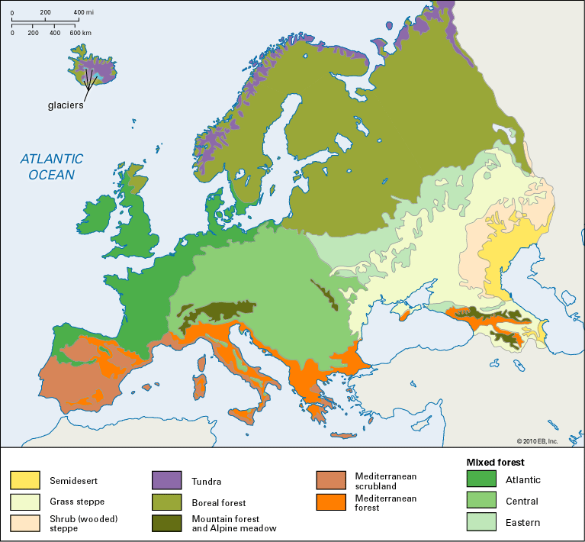  You tube: https://youtu.be/RNx0akt3_XI  https://www.youtube.com/watch?v=zOti8U_-BNM  https://www.youtube.com/watch?v=Zs_DldO_G1w
2. Europe is made up of 44 countries
- Albania, Andorra, Austria, Belgium, Bosnia & Herzegovina, Belarus, Bulgaria, Czech Republic, Croatia, Cyprus, Denmark, Estonia, Finland, France, Germany, Greece, Hungary, Iceland, Ireland, Italy, Latvia, Liechtenstein, Luxemburg, Lithuania, Malta, Monaco, Moldova, Netherlands, Norway, Poland, Russia, Romania, San Marino, Serbia, Slovakia, Slovenia, Turkey, Sweden, Switzerland, Spain, Ukraine, United Kingdom, Republic of Macedonia, Montenegro
3. Definition of a biome and vegetation belts: an area or region with a distinctive community of plants and animals.
4. Biomes in Europe:
a) Tundra – below freezing for most of the year. There is a brief warm period in the summer months which brings shrubs, lichens, mosses and flowers to life.
b) Coniferous forest – whole of Northern Europe (Finland, Sweden and Norway)
c) Deciduous forest – cool summers and mild winters. Rain throughout the year.
d) Mediterranean – hot, dry summers and warm, wet winters
e) Mountains – very cold, thin soils, limited vegetation
5. Physical geography:
a) Great European Plain – largest mountain free landform in Europe.
b) Mountainous regions – Grampian Mountains, Scandinavian Mountains, Ural Mountains, Pyrenees, Carpathians, Caucasus, Balkans, Alps (Mont Blanc –highest mountain in Europe)
c) Main rivers - the Danube, the Volga, the Loire, the Rhine and the Elbe.
d) Active volcanoes - Mount Etna and Mount Vesuvius in Italy.
6. Human geography:
a) There are 24 official languages spoken in Europe.
b) The major religions are Christianity, Islam, and Judaism though Europe is predominantly Christian
c) Europe is a complex and mostly urban continent.
d) Many European countries are investing in sustainable energy sources, such as solar energy, wind energy, tidal energy, and nuclear energy.
e) Europe’s most important forest industries are woodworking, paper products, and construction and furniture products.
7. Greece (Physical geography):
a) mostly mountains with ranges extending into the sea as peninsulas or chains of islands
b) Mount Olympus 2,917 m
c) Climate - temperate; mild, wet winters; hot, dry summers
d) Over 200 inhabited islands
e) Major bodies of water - Ionian Sea, Aegean Sea, Sea of Crete, Mediterranean Sea
8. Greece (Human geography)
a) Greece is divided up into thirteen regions
b) Major Industries: tourism, food and tobacco processing, textiles, chemicals, metal products; mining, petroleum
c) Agricultural Products: wheat, corn, barley, sugar beets, olives, tomatoes, wine, tobacco, potatoes; beef, dairy products
d) Capital city - Athens
e) Natural resources - lignite, petroleum, iron ore, bauxite, lead, zinc, nickel, magnesite, marble, salt, hydropower potential
https://www.slideshare.net/laurey1507/physical-geography-of-europe-11852826
https://world-geography-games.com/continents/index.html rivers and mountains
https://www.bbc.co.uk/cbbc/quizzes/european-countries-quiz
https://www.bbc.co.uk/cbbc/quizzes/top-class-european-capital-cities

