KS1 Living things and their habitats (Year 2)
Prior Learning: A good habitat provides everything a plant or animal needs
P.O.S – Living things and their habitats
Concept – biology – cell development
Facts | Vocabulary
- Everything is either living, dead or has never been alive  - Living means alive – grow  - Dead means no longer alive  - Never been alive – doesn’t grow | - Habitat - from Latin, literally ‘it dwells’, from habitare.
- Needs of all living things:  - Food  - Shelter  - Warmth  - Water  - Space | Different habitats:  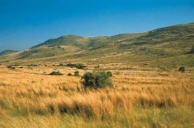  grassland desert tundra  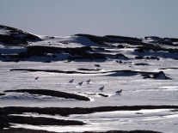  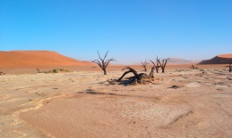  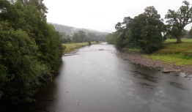  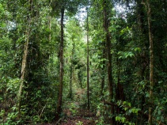  forest river ocean  Micro-habitats:  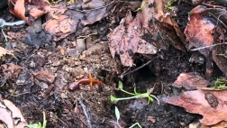  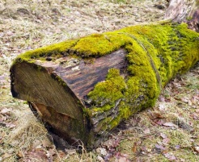  Simple food chain:  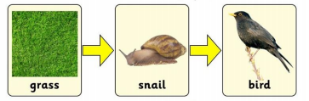  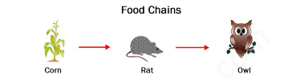
- Habitat - type of natural environment in which a particular animal or plant live
- Habitats for plants:
- Grassland - purple needlegrass, wild oats, ryegrass
- Forest – ferns, foxgloves, primroses
- Pot – tomatoes, peas, eggplant
- Desert – prickly pear, aloe vera, cactus
- River – pondweed, waterweed, wild celery
- Tundra – Artic moss, artic willow, artic poppy
- Habitats for animals:
- Grassland –elephant, zebra, lion
- Desert – camel, scorpion, fennec fox,
- River – turtle, fish, crab
- Tundra – polar bear, snowy owl, reindeer
- Forest – squirrel, deer, bird
- Definition of a Micro-habitat:
- a small specialized habitat within a larger habitat.
- Micro-habitats:
- Decomposing log – earthworm, centipede, beetle
- Temporary pool of water – water mites
- Under rocks – worm, ant, cricket
- Animals diet:
- All animals obtain their food from plants and other animals.
- Food chains:
- A food chain shows how each living thing gets food
- Shows how nutrients and energy are passed from creature to creature
- All start with a plant
Websites:
https://www.bbc.com/bitesize/topics/zx882hv
https://www.bbc.com/bitesize/clips/z96r82p

