KS1 Plants (Year 2)
Prior Learning: plants can grow from a bulb or seed
P.O.S – plants
Concept – biology – cell development
Facts | Vocabulary
- Seeds:  - A seed is the part of a flowering plant which can grow into a new plant.  - Seeds need water to grow but usually don’t need light  - Seeds have a store of food inside them. | - Germination - comes from the Latin germinationem, "a sprouting forth or budding."
- Bulbs:  - Bulbs are underground masses of food storage from which plants grow.  - Bulbs need water to grow but usually don’t need light | How seeds/bulbs grow:  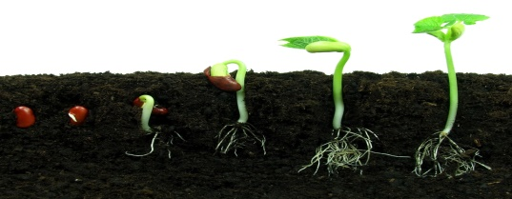  Seeds:  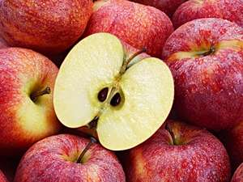  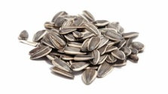  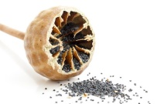  apple sunflower poppy  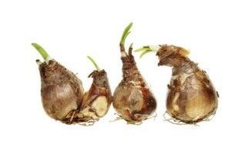  Bulbs:  Daffodil  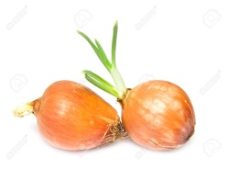  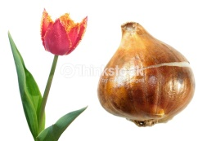  Tulip  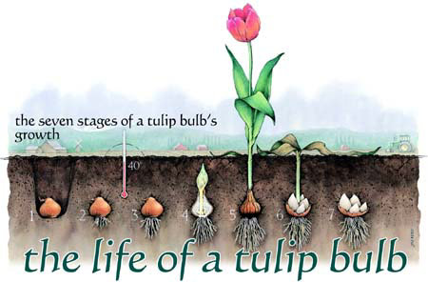  Onion
- Names of seeds:
a) sunflower
b) apple
c) poppy
- Names of bulbs:
- daffodil
- tulip
- onion
- How a seed and bulb grow into a plant:
- Seeds/bulbs are planted
- grow roots
- roots take hold and anchors the plant within the soil
- a small plant will begin to emerge and break through the soil.
- When this happens, the seed/bulb has sprouted. This process is called germination.
- plant grows and begins to make its own food from nutrients it takes from the soil
- Carry on growing
- Requirements for plants to make food and grow:
- Water
- Light
- Suitable temperature - not too hot or too cold
Websites:
https://www.youtube.com/watch?v=tkFPyue5X3Q
David Attenborough - plant growing

Activity ideas:
- Plant some seeds/bulbs and keep a plant diary with illustrations. You can use the knowledge organiser to help you.
- Draw and label a flower/plant and label the different parts of it. Can you explain the job of each part of the flower/plant.
- Draw the life cycle of a plant/flower from a seed/bulb and write about each stage.
- Go on a plant hunt in your garden or if you go on a walk with family. What plants can you spot? Can you draw them?
- Write about what plants need to survive. Why do they need those things?

