KS1 Seasonal change (Year 1)
Prior Learning: The weather is the state of the atmosphere at a particular place and time regards to heat, cloudiness, dryness, sunshine, wind, rain etc
P.O.S – Seasonal change
Concept – chemistry – chemical reactions
Facts | Vocabulary
- Definition of seasons: -  - each of the four divisions of the year marked by particular weather patterns and daylight hours, resulting from the earth changing its position with regard to the sun.  - Winter – December, January, February  - Spring – March, April, May  - Summer – June, July, August  - Autumn – September, October, November | - Season - from Latin satio(n- ) ‘sowing’, later ‘time of sowing’, from the root of serere ‘to sow’
- Daylight:  - Summer has the longest daylight in a day  - Winter has the shortest amount of daylight in a day | 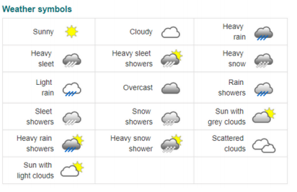  Spring Summer Autumn Winter  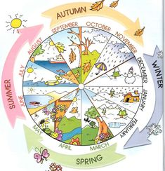  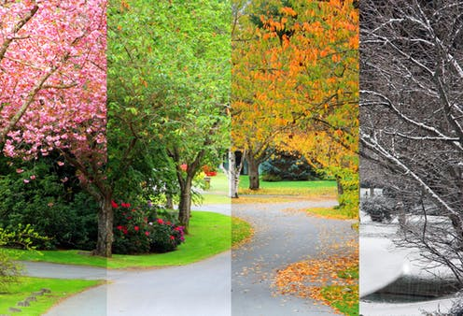
- Usual weather in the seasons:
- Winter - snow or ice or cold rain
- Spring - warmer, often wetter and increased rainfall, can cause flooding.
- Summer - temperatures may increase to their hottest of the year.
- Autumn - temperatures cool again
- Temperate climate:
- The UK has a temperate climate which means not extreme – not burning hot or too cold
- Changes in the seasons:
- Winter – animals find ways to warm themselves, and may have changed their appearance to adapt
- Spring - animals wake or return from warmer climates, often with newborns. Seeds take root and plants begin to grow.
- Summer - If the temperature goes high, heat waves or droughts may cause trouble for people, animals, and plants.
- Autumn - Plants may begin to grow inactive. Animals might prepare themselves for the upcoming cold weather, storing food or travelling to warmer regions
- Danger from the sun:
- It is not safe to look directly at the sun even when wearing dark glasses
Websites:
https://www.bbc.com/bitesize/articles/zmhw7p3
https://www.bbc.com/bitesize/articles/zcx3gk7
https://www.bbc.com/teach/class-clips-video/science-ks1-ks2-wonders-of-nature-the-changing-seasons/zh4rkmn

