KS1 Animals including humans (Year 1)
Prior Learning: An animal is a living organism that feeds on organic matter
P.O.S – Animals including humans
Concept – biology – cell development
Facts | Vocabulary
- Classification of animals:  - Fish- trout, salmon, cod, plaice  - Amphibians- frog, newt, toad  - Reptiles- lizard, snake, turtle  - Birds- sparrow, blackbird, robin  - Mammals- human, dog, rat, bear | - Amphibian - from Greek amphibion (noun use of amphibios ‘living both in water and on land’, from amphi ‘both’ + bios ‘life’).
- Structure of different animals:  - Fish – have a backbone, gills and fins  - Amphibians – have moist, scaleless skin that  absorbs water and oxygen  - Reptiles – have tough scales and efficient lungs for  breathing air.  - Birds - have a light skeletal system and muscles to help it  fly.  - Mammals – have hair or fur, female produce milk for  their young | 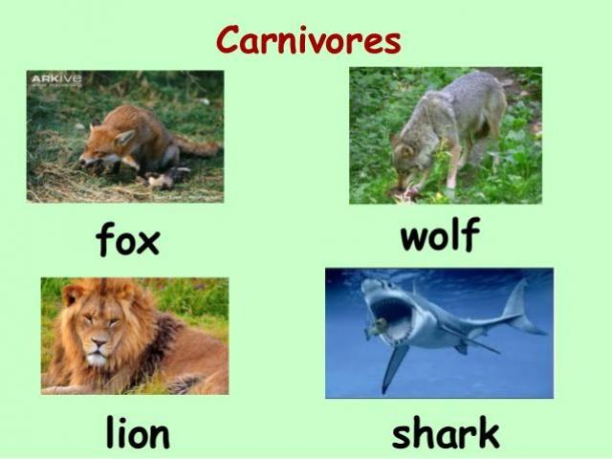  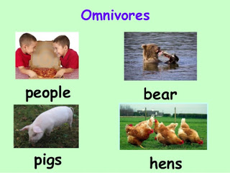  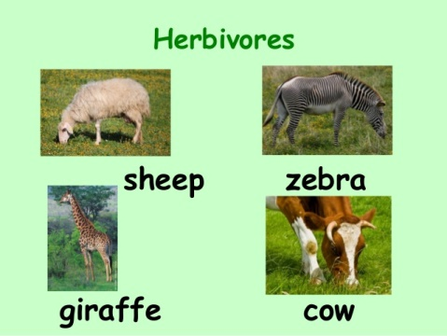
- 3. Definition of cold blooded:
- do not have a constant body temperature but instead
take on the temperature of their environment.
- fish, reptiles, amphibians
- Definition of warm blooded:
- animals maintain a constant body temperature
- mammals, birds
- Diets of animals:
- Carnivore - an animal that feeds on other animals
- Herbivore: an animal that feeds on plants.
- Omnivore: an animal that eats a variety of food including
both plants and animals
- Body and senses:
- Touch – hands
- Smell – nose
- Taste – mouth
- See – eyes
- Hear – ears
Websites:  https://www.bbc.com/bitesize/topics/z6882hv | 