KS1 Use of everyday materials (Year 2)
Prior Learning: The shape of materials can be changed to make them useful
P.O.S – Use of everyday materials
Concept – Physics - energy transfer, forces
Facts | Vocabulary
- Different types of materials:  - Wood  - Metal  - Plastic  - Glass  - Brick  - Rock  - Paper  - cardboard | - property - from an Anglo-Norman French variant of Old French propriete, from Latin proprietas, from proprius ‘one's own, particular’
- Uses for materials:  - Wood - fuel, construction material, for making tools and weapons, furniture and paper.  - Metal – jewellery, fasteners, screws and pots for cooking  - Plastic - packaging goods  - Glass - windows, light bulbs, and tableware  - Brick - building material, used to make walls and pavements  - Rock – decorations, household tiles, statues and monuments  - Paper - books, magazines and newspapers, money and photographic paper, writing paper, toys, boxes, wrapping paper, glassine, paper napkins, toilet paper, paper towels, facial tissue and paper plates  - Cardboard - shipping or storing products | 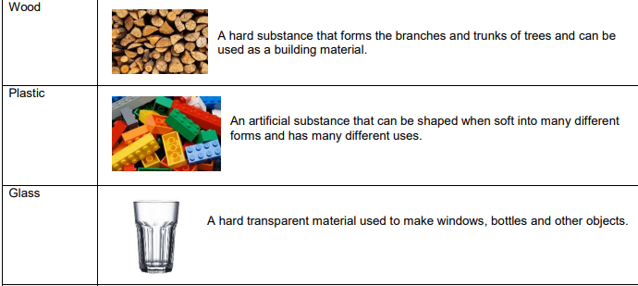  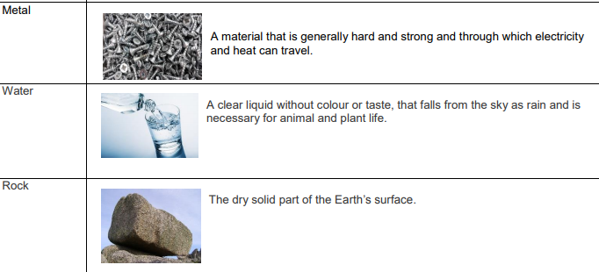  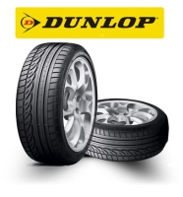  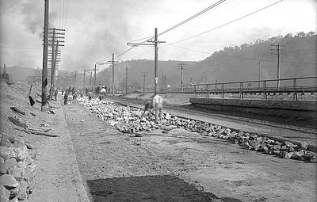  Solids changing shape:  McAdam road surface  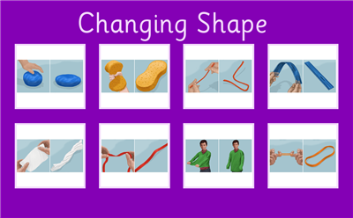
- The shape of some solid objects can be changed by:
- Squashing
- Bending
- Twisting
- stretching
- John McAdam:
- Scottish inventor and road builder
- Came up with the idea of the macadam road surface.
- John Dunlop:
- A Scottish inventor
- developed the inflatable rubber tyre
- Founded the company Dunlop Tyres.
Websites:
https://www.youtube.com/watch?v=tGfLhPslEjQ

