KS1 Materials (Year 1)
Prior Learning: A material is a matter of which a thing can be made from
P.O.S – Materials
Concept – physics energy transfer and forces
Facts | Vocabulary
- Objects:  - are things we can see or touch  - can be made from one or more materials | - Object - medieval Latin objectum ‘thing presented to the mind’,  - Graphite - from Greek graphein ‘write’
- Definition of a material:  - the matter from which a thing is or can be made from | Everyday materials:  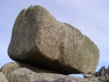  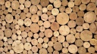  wood water rock  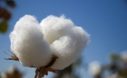  cotton leather  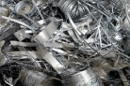  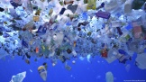  plastic metal glass  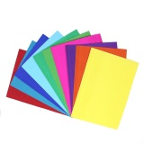  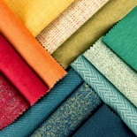  foil  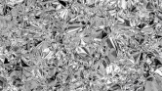  paper fabric  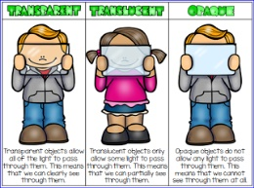
- Natural everyday materials:
- A natural material is any product or physical matter that comes from plants, animals, or the ground.
- water, wood, rock, cotton, iron, oil, leather
- Man-made everyday materials:
- Man-made materials are materials that have been produced by man
- plastic, metal, glass, brick, paper, fabric, foil
- Physical properties of everyday materials:
- transparent – allows light through
- opaque - blocks light
- rigid/stiff – not flexible
- soft – not hard or firm
- smooth- no roughness, lumps or holes
- rough- uneven and not smooth
- shiny- objects are bright and reflect light
- dull – a colour that is not too bright
- flexible/bendy – bends easily into a curved shape
- waterproof - does not let water pass through it
- absorbent – able to soak up liquid easily
- elastic/stretchy

Websites:
https://www.bbc.com/bitesize/topics/zrssgk7

