LKS2 Forces and magnets (Year 3)
Prior Learning: Force is a strength or energy as an attribute of physical action or movement
P.O.S – Forces and magnets
Concept – physics – energy transfer and forces
Facts | Vocabulary
- Objects on different surfaces:  - Friction is the contact force between two objects moving against each other; the kind of surface that objects have affects how objects move against each other.  - Gravity is the force that pulls objects down slopes or makes them fall.  - A force can slow down or speed up an object. | - Magnet - from Latin magnes, magnet-, from Greek magnēs lithos ‘lodestone’,
- Forces:  - Some forces need contact between two objects but magnetic forces can act at a distance | Different types of magnets with two poles:  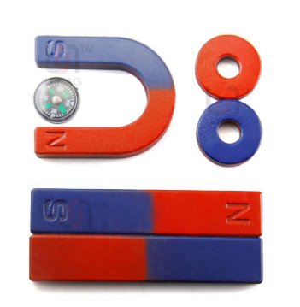  Magnet attracting iron fillings:  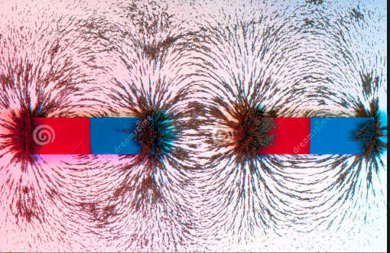  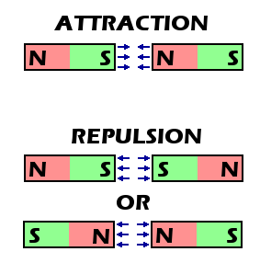
- Magnets and their force:
- A magnet is a material or object that produces a magnetic field.
- A magnetic field is invisible but is responsible for the most notable property of a magnet
- A force that pulls on other magnetic materials, such as iron, and attracts or repels other magnets.
- Metals:
- All magnetic materials are metal but not all metals are magnetic
- Metals that are magnetic:
- Iron
- Cobalt
- nickel
- Steel
- Magnets have two poles:
- North
- South
- North and South attract -the force by which one object attracts another.
- North and North repel
- South and South repel
Websites:
https://www.bbc.com/bitesize/topics/zyttyrd
https://www.bbc.com/bitesize/clips/zk9rkqt

