LKS2 Living things and their habitats (Year 4)
Prior Learning: All living organisms are classified into groups based on very basic, shared characteristics. This grouping system makes it easier for scientists to study certain groups of organisms.
P.O.S – Living things and their habitats
Concept – biology cell development
Facts | Vocabulary
- 1) Living Things
- a) Plants all share the common characteristic of being able to make their own food using water and sunlight. Because they only require a few simple requirements, plants can grow almost anywhere.
- b) Animals are multicellular and rely on other organisms for food.
- Within the plant kingdom, plants are divided into two main groups:  - The largest group contains the plants that produce seeds – flowering plants and conifers  - The other group contains the seedless plants that reproduce by spores. | 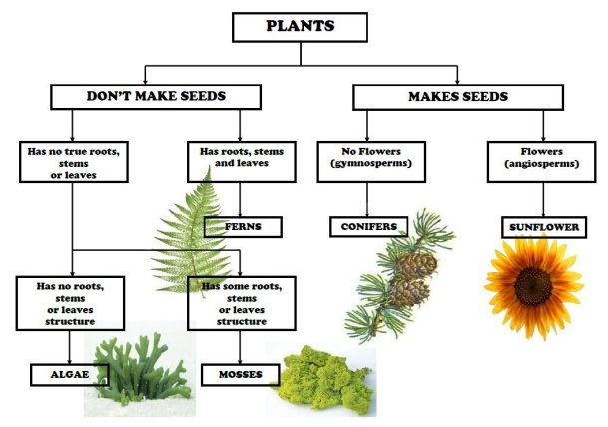  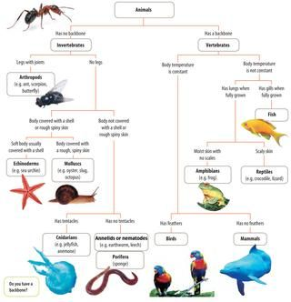
3. Vertebrates:
a) mammals - warm-blooded, have hair on their bodies, females produce milk for their babies
b) birds - warm-blooded, most can fly, have feathers and wings
c) fish - aquatic animals, breath through gills, cold-blooded, most have scales,
d) amphibians - live part of their life cycle in water and part on land, have gills when young, later develop lungs, cold-blooded, usually have moist skin.
e) reptiles - hatch from eggs, cold-blooded, have dry, thick, scaly skin
- Invertebrates:
- insects - a small animal that has six legs and generally one or two pairs of wings.
- arachnids - almost all adult arachnids have eight legs.
- worms - creeping or burrowing invertebrate animals with long, slender soft bodies and no limbs.
- mollusc - have a soft unsegmented body and live in aquatic or damp habitats e.g. slugs, snails
5) Negative environmental changes:
a) global warming - a long-term rise in the average temperature of the Earth's climate system
b) litter – rubbish such as paper, cans, and bottles left lying in an open or public place.
c) oil spill - oil is released into the ocean or coastal waters, but spills may also occur on land.
d) chemical pollution - chemical pollution is defined as the presence or increase in our environment of chemical pollutants that are not naturally present there or are found in amounts higher than normal
e) deforestation - is the removal of a forest from land which is then converted to farms or urban use.
f) land development - is altering the landscape for agriculture or housing.
6) Positive environmental changes:
a) nature reserves
b) parks
ponds
Websites: https://ypte.org.uk young people’s trust for the environment

