LKS2 Animals including humans (Year 4)
Prior Learning: animals have body systems, health can be affected by different things
Concept: cell, energy transfer
Facts | Vocabulary
- Digestive system:  - Digestion is the breakdown of food into small molecules, which are then absorbed into the body. | - Digest - from Latin digest- ‘distributed, dissolved, digested’, from the verb digerere, from di- ‘apart’ + gerere ‘carry’;
- The function of the digestive system is digestion and absorption. | 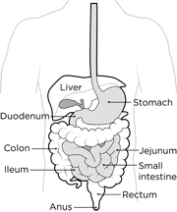  Types of teeth  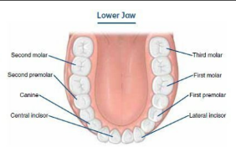  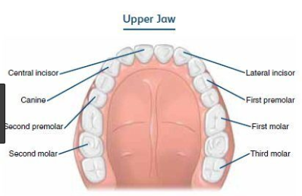  Food chain  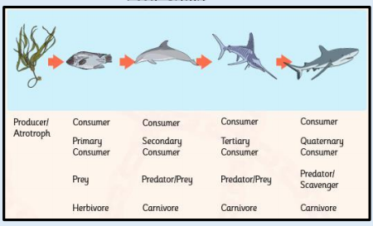
- Part and what role it plays:
- Mouth and teeth – where the digestion starts, breaks down food by chewing
- Salivary glands – produces saliva and lubricates the food so it can go down the oesophagus
- Oesophagus - muscular tube that moves food to the stomach
- Stomach – breaks down the food more and produces acid
- Pancreas - makes hormones (including insulin) to regulate the blood glucose level. It also makes enzymes that break down food in the intestines.
- Liver – stores energy and helps get rid of toxins
- Gallbladder – stores bile and releases it to help digest fats
- Small intestine – absorbs nutrients and minerals from food
- Large intestine – absorbs water from food
- Rectum – stores stool until it leaves the body
- Anus – where stool leaves the body
- Types of human teeth and their functions:
- Incisors - bite off and chew pieces of food.
- Canines - tearing and ripping food.
- Molars - crush and grind food.
- Carnivores and omnivores have the same types of teeth as humans
- Herbivores have molars and incisors
- Food chains:
- Animals are called consumers because they eat plants and other animals. They do not make their own food.
- Animals that eat other animals are called predators.
- The animals they eat are called prey.
Youtube:
https://www.youtube.com/watch?v=Og5xAdC8EUI

