Animals including humans (Year 3)
Prior Learning: animals including humans need nutrients to survive, animals move in different ways
Concept: cell - biology
Facts | Vocabulary
- Animals cannot make their own food:  - Animals get nutrients from food they eat | - muscle – latin name musculus means little mouse  - nutrient – latin name nutrire means to feed, support, nurse and preserve
- There are seven types of nutrients:  - Water – essential for survival, makes up 60% of human body  - Carbohydrates – gives animals energy and prevents loss of muscle mass  - Protein – building blocks for cells and essential for forming muscles  - Fats – boosts absorption of vitamins and protects the organs of the body  - Vitamins – help the bones grow and support the immune system  - Minerals – helps the body to work properly  - Fibre – helps the digestive system stay healthy | Human skeleton  fish  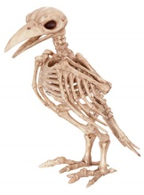  reptile  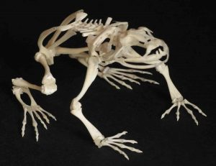  reptile  bird  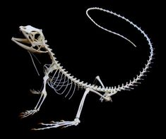  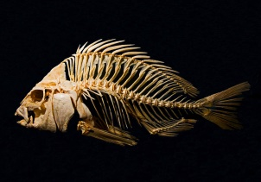  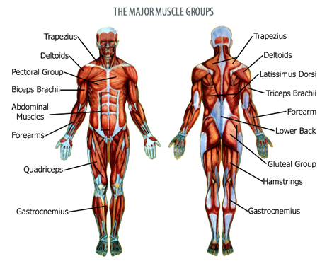  amphibian
- History of the word nutrient:
- In 1650 used as an adjective meaning providing nourishment
- Amounts of nutrition:
- A balanced diet is important because the organs and tissues need proper nutrition to work effectively
- A balanced diet includes foods which are low in fat and unnecessary sugars but high in vitamins, minerals and other nutrients
- The following groups are essential as part of a balanced diet- fruits, vegetables, grains, proteins, dairy and oil
- 20 % of water intake comes from food sources
- Most animals including humans have a skeleton and muscles:
- A skeleton is a framework of bones
- Muscle is a soft tissue that produces force and motion and maintains the position of parts of the body.
- Muscles are joined to bones by tendons
- The major functions of skeletons and muscles are:
- to support the body
- protect the organs
- help the body to move
- Names of major muscles and bones  - Muscles – biceps, triceps and quadriceps  - Bones - clavicle, pelvis and sternum | 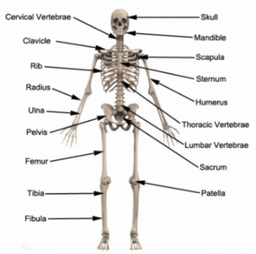
Youtube:
www.youtube.com/watch?v=fIoBoGSPkws – basic anatomy
https://www.bbc.com/bitesize/articles/zpbxb82 - how do your muscles work

