LKS2 Electricity (Year 4)
Prior Learning: Electrical objects need energy to move, batteries are called cells
POS - Electricity
Concept – energy transfer
Facts | Vocabulary
- Household appliances run on electricity:  - Television  - Fridge/freezer  - Microwave  - Washing machine  - lights | - Electricity - The term came from the classical Latin electrum, amber, from the Greek ἤλεκτρον (elektron), amber. The origin of the Greek word is unknown, but there is speculation that it might have come from a Phoenician word elēkrŏn, meaning 'shining light'.  - Circuit- late Middle English: via Old French from Latin circuitus, from circuire, variant of circumire ‘go round’, from circum ‘around’ + ire ‘go’.  Symbols for a circuit:  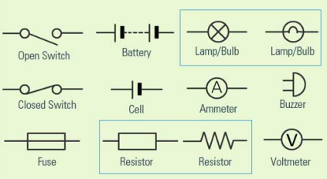  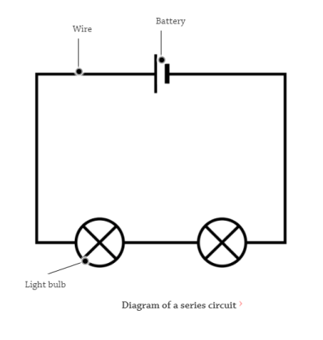
- Simple circuit:
- A simple circuit has conductors, a switch, a load and a power source (normally battery)
- A switch stops the flow of an electrical current
- Series circuit:
- has more than one resistor, (anything that uses some of the power from the cell) but only one path through which the electricity (electrons) flows.
- From one end of the cell (battery), the electrons move along one path with NO branches, through the resistors, to the other end of the cell.
- All the components in a series circuit are connected end-to-end.
- Conductor :
- a material that allows electricity to easily pass through them.
- Good conductors - aluminium, copper, gold, water, people
- Insulator :
- a material that does not allow electricity to easily pass through them.
- good insulators – rubber, plastics, wood , paper
Websites:
https://www.bbc.com/bitesize/topics/zq99q6f

