0 Light (year 3)
Prior Learning: light is an electromagnetic wave that can be seen by humans, darkness is the absence of light
POS: Light
Concept: physics transformation of energy
Facts | Vocabulary
- 1. Sources of light:  - a) natural sources – sun, stars, fire and electricity in storms  - artificial light – light bulbs, LED lights, fluorescent lighting | ultra - a prefix occurring originally from Latin, with the basic meaning “on the far side of, beyond.”
- Reflection of light:
- reflection of light is the process of sending back the light rays which falls on the surface of an object

- Sun
- the sun is 93 million miles away
- most of the space between the Earth and the sun is empty which allows the sun’s energy to reach us easily
- the sun’s energy is light and heat
- the sun helps our bodies make vitamin D which helps us to have strong bones and teeth.

- Danger from the sun:  - ultraviolet light - is a form of radiation which is not visible to the human eye.  - sunburn - ultraviolet rays can burn our skin cells, the skin gets red and feels warm.  - 80 percent of the sun’s ultraviolet rays can get through on a cloudy day.  - eye damage – never directly look at the sun even with sunglasses on | 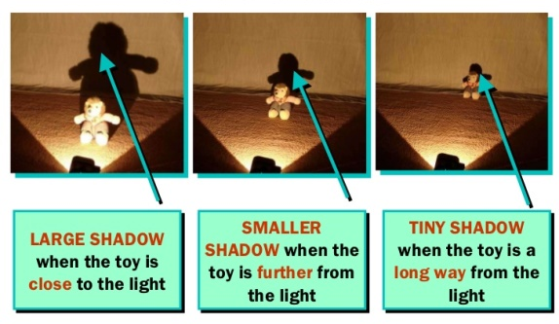  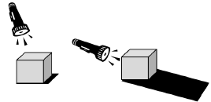  As the light source moves higher in relation to the object, the shadow gets shorter. As the light source moves lower, the shadow gets longer.  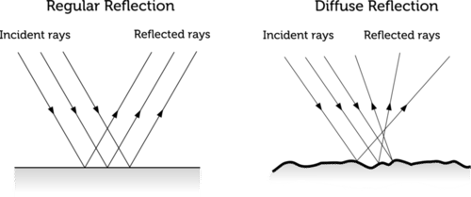
- Formation of shadows:
- shadows are formed when light is blocked by an object

- Size of shadows:
- the closer an object is to a light source the bigger the shadow
- the further away from a light source the smaller the shadow
- the shortest shadows are formed at noon when the sun is highest in the sky.

Youtube:

https://www.youtube.com/watch?v=KXdr1YwmNWc

