LKS2 Plants (year 3)
Prior Learning: plants are made up of cells, plants get energy from the sun, reproduction is the process of making a new plant (offspring)

Facts | Vocabulary
- Structure and function of flowering plant:  - roots – root anchors the plant and absorbs nutrients and water needed for growth  - stem/trunk – supports the plants, elevates the leaves and flowers and transports water between the roots and the rest of the plant  - leaves – produce food for the plant by photosynthesis  - flowers – the reproductive part of the plant | - Lavender – scientific name lavandula  - latin name lavare means to wash  - photosynthesis - the process by which a plant uses the energy from the light of the sun to produce its own food  - excretion – to get rid of material such as solid waste or urine from the body  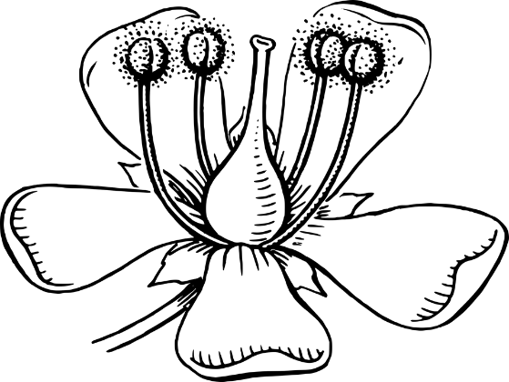
- Names of common flowering plants:
- Lavender
- Chrysanthemum
- Orchid
- History of the lavender:
- A herb, part of the mint family
- Brought over to this country by the Romans
- Used in mummification in Ancient Egypt
- What plants need for life and growth:  - water  - air  - light  - nutrients from the soil  - room to grow | 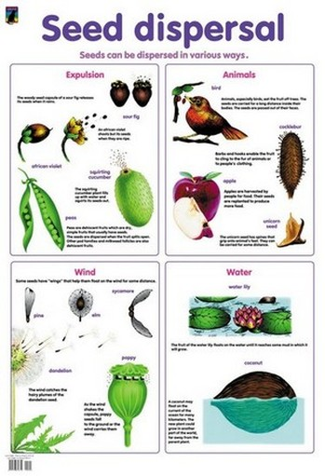  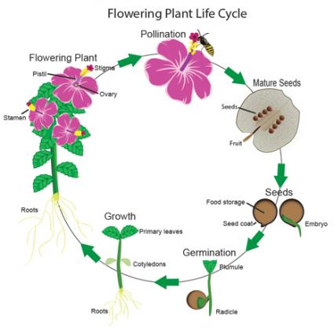
- Transportation of water
- Water is transported from the roots through the stem to the leaves and flower
- Flowering plant reproduction
- pollination
- seed formation
- seed dispersal
- Process of pollination:
- pollen is carried by insects or blown by the wind from one flower to another
8. Process of seed dispersal:
a) movement of seeds or transportation away from the parent plant
b) seeds can be scattered by wind, animals, explosion, water and animal excretion
9. Life cycle of a plant:
a) seed germination
b) growth
c)reproduction
d) pollination
e) seed dispersal
Youtube:
www.youtube.com/watch?v=JBLyHmwkXX8 plant habitat and adaptation
www.youtube.com/watch?v=xY4JFOSuqvY – seed dispersal the great escape
www.youtube.com/watch?v=j-S5ui9Us7U – what is pollination and how does it work?

