LKS2 Rocks (Year 3)
Prior Learning: the Earth is made up of different types of rocks which form part of the surface of the earth and other similar planets. They are found exposed on the surface or underneath the soil.

Facts | Vocabulary
- There are three main types of rocks:  - sedimentary – these rocks are formed from the broken remains of other rocks that become joined together.  - metamorphic – these rocks are formed from other rocks that are changed because of heat or pressure.  - igneous – these rocks are formed from molten rock that has cooled and solidified. | - metamorphic - Greek words "meta" meaning change, and "morpho" meaning form.  - igneous - Latin word ignis meaning fire  - geological - derived from the Greek ‘gê’ meaning earth and ‘logos’ meaning speech.
2. Names of common rocks:  - sedimentary – chalk, limestone, shale, sandstone  - metamorphic – slate, marble, quartzite, anthracite  - igneous – basalt, granite, pumice, obsidian | 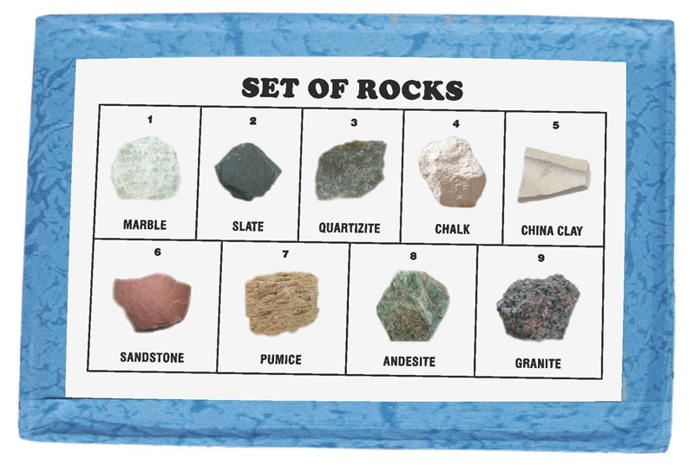  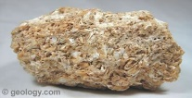  limestone  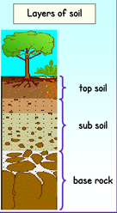  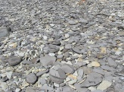  shale  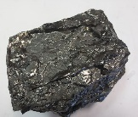  anthracite  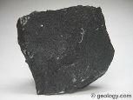  basalt  fossil  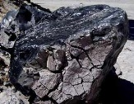  obsidian  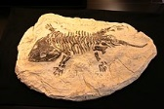  Youtube:  Fossil formation - www.youtube.com/watch?v=ID7qhn1ipmw  Types of soil - www.youtube.com/watch?v=dsfJRwZXaVk
- Texture of rocks:
- sedimentary – arrangement of the grains
- igneous and metamorphic – arrangement of the crystals
- Properties of rocks:
a) hard/soft– some rocks need to be cut or split with tools because they are so hard (e.g. granite) but others are soft and can be moulded (e.g. clay).
b) permeable/impermeable – permeable rocks allow water to pass through (e.g. pumice) but impermeable rocks do not let water pass through (e.g. marble)
c) durable– rocks which are resistant to erosion last longer and are more durable. Buildings are often made with these (e.g. limestone)
d) density – if the particles in the rock are tightly packed then it has a high density. These rocks would sink in water (e.g. basalt).
- Definition of a fossil:
- A fossil is any preserved remains, impression, or trace of any once-living thing from a past geological age.
- Fossil formation:
- a) most are formed when a plant or animal dies in a watery environment
- the plant or animal is buried in mud and silt.
- soft tissues quickly decompose leaving the hard bones or shells behind.
- over time sediment builds over the top and hardens into rock.
- Where are fossils found?
- Fossils are found all over the world.
- Most fossils are found in sedimentary rock such as shale, limestone, and sandstone.
- Definition of a soil:
- the upper layer of earth in which plants grow, a black or dark brown material typically consisting of a mixture of organic remains, clay, and rock particles.
- Names of common soils:
- clay, sandy, loamy
- peaty, chalky and silty are mixtures of the above

