LKS2 Sound (Year 4)
Prior Learning: Vibration means to move quickly back and forth or up and down
P.O.S – Sound
Concept – Physics - energy transfer
Facts | Vocabulary
- Definition of sound:  - Sound is vibrations that travel through the air or another medium and can be heard when they reach a person's or animal's ear | - Vibrate - from Latin vibratus, past participle of vibrare "move quickly to and fro, shake,"
- How is sound produced:
- by continuous and regular vibrations
- created when something vibrates (shakes back and forth), sending waves of vibrations into the ears of the listener.
- Sounds travel in a wave. The vibrations make air particles closes to the object vibrate, which then passes the vibrations to the particle next to it and so on. | Sound wave  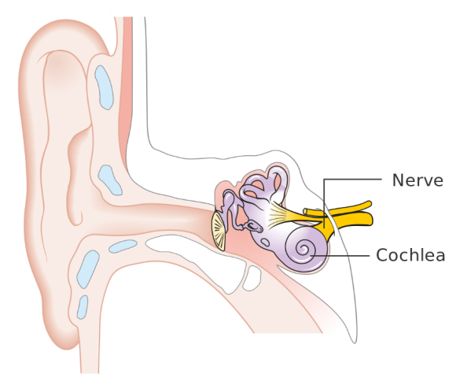  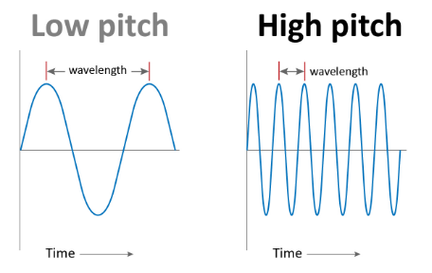
- Sound vibrations can travel through different materials:
- solids - metals, stone, wood
- liquids – water
- gases – air
- sound travels better through some materials than others. It travels very well through metal pipes for example.
- Volume :
- loudness from the intensity of a sound wave
- the louder the sound, the stronger the vibrations
- sound gets fainter as the distance increases away from it
- Frequency –:
- determines pitch (quality of a sound by the rate of vibrations producing it)
- high pitch = fast vibrations
- slow pitch = slower vibrations
- Parts of the ear:
- Ear drum which passes vibrations to the middle ear bones.
- Middle ear bones which include the hammer, anvil and stirrup. (The smallest bones in the human body!)
- Cochlea - contains thousands of tiny hair cells which change the vibrations to electrical signals.
- Nerve - sends electrical signals to the brain
Websites:
https://www.bbc.com/bitesize/topics/zgffr82/resources/1
https://www.bbc.com/teach/class-clips-video/music--science-ks2-what-is-sound/zbnmhbk

