Subject: Science Year: Year 5

NC/PoS:
- describe the differences in the life cycles of a mammal, an amphibian, an insect and a bird
- describe the life process of reproduction in some plants and animals
Prior Learning (what pupils already know and can do)
All animals obtain their food from plants or other animals. Understand simple food chains. Animals need shelter, nutrients, water and air. All plants need space, nutrients, water and air. Mammals, reptiles, birds, amphibians and fish are vertebrates. Insects are invertebrates. All animals have offspring. Seeds and bulbs grow into mature plants. The life cycle of plants includes germination, growth, reproduction and seed dispersal. To know basic life cycle of animals includes: birth, growth, reproduction and death. All living things have a life cycle.
End Goals (what pupils MUST know and remember)

To know that there are different types of reproduction, including sexual and asexual reproduction in plants, and sexual reproduction in animals.
To know that sexual reproduction in plants involves pollen from one flower fertilising the egg of another to produce a seeds.
To know asexual reproduction in plants happens without pollen or an egg. The new plant grows from cuttings from the parent plant.
To know the life cycle of a mammal - live young born and get milk from mothers, grow from babies to adults, reproduce then die
To know the life cycle of an amphibian - egg in jelly laid in water, develops tail and legs, grows lungs to breathe and leaves water, takes 2 years to grow to adult size
To know the life cycle of an insect - eggs laid by the female insect; eggs hatch and larva is born; when the larva moults for the last time, a pupa is formed.
To know some insects only have 3 stages: born as an egg, hatches as a nymph and changes into an adult.
To know the life cycle of a bird – egg, hatches and is fed by the parents, juvenile– leaves the nest when flight feathers are grown, adult attracts mate to reproduce.
To know the naturalist David Attenborough
To know the animal behaviourist Jane Goodall
To know amphibians and insects go through metamorphosis.

Key Vocabulary: life cycle, life span, metamorphosis, gestation, pupa, larva, sexual, asexual, nymph, naturalist, behaviourist, spores, runners, clones, stigma, stamen, filament, ovary, anther, fledgling, style, ovary

Review prior learning

Match different animals/plants to their habitat. Revisit the needs of animals and plants.
Using the images of animals and plants children create a simple food chain.
Introduce David Attenborough through https://www.youtube.com/watch?v=ofxCVJvHqj0 introduction to plants
Introduce Jane Goodall through https://www.youtube.com/watch?v=FRlUJrEUn0Y
Session 1:
Recap: the structure of animals within the vertebrate groups: birds, reptiles, mammals, amphibians and fish.

LO: To research the life cycles of different animals

Watch video to introduce life cycles

https://www.youtube.com/watch?v=CH_YkA6Deo4
https://www.youtube.com/watch?v=gU_pJ8PAWwQ humming birds birth to fledgling - use as a stimulus to model life cycle with detail added

Research the following: (add detail to the life cycle not just the stages) Child researches one from each category
Life cycle of a mammal – bat, kangaroo, dolphin or chimpanzee
Life cycle of an amphibian – frog, newt, toad or salamander
Life cycle of an insect – beetle, bee, dragonfly, woodlouse
Life cycle of a bird – owl, penguin, pigeon, duck

Vocabulary: life cycle, metamorphosis, pupa, larva, nymph, fledgling, adult, juvenile
Session 2:
Recap: lifecycle of an amphibian, insect, bird and mammal

To use Venn diagrams to compare life cycles
Pick 2 from different groups
For example: frog and beetle,
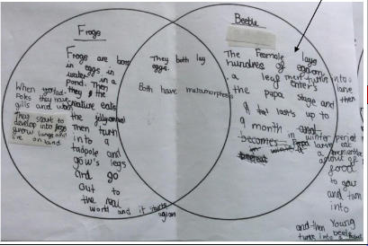
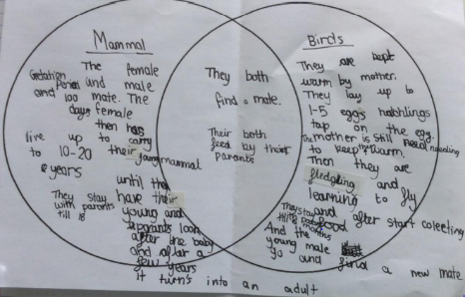

Vocabulary: data collection, comparison, similarities, differences
Session 3:
Recap: lifecycles of different amphibians, insect, bird and mammal

Lo: To look for patterns when researching the differences between life cycles

Watch https://www.youtube.com/watch?v=bFPSS2im_3o gestation 3.22-4.40

Introduce lifespan.
Children research lifespan or gestation or different animals collecting data for amphibians, insects, birds and mammals. Plot results and explain any patterns they see.

Vocabulary: gestation, life span, weight, height
Session 4:
Recap: differences between life cycles in previous lesson and life cycle of a flowering plant (use growing seed from Explorify as a stimulus)

Lo: To understand sexual reproduction in plants

https://www.bbc.co.uk/bitesize/topics/zdqdcqt/articles/zyv3jty
https://www.youtube.com/watch?v=bFPSS2im_3o sexual reproduction plants up to 3.22

Look at images of lily, bellflower and climbing rose
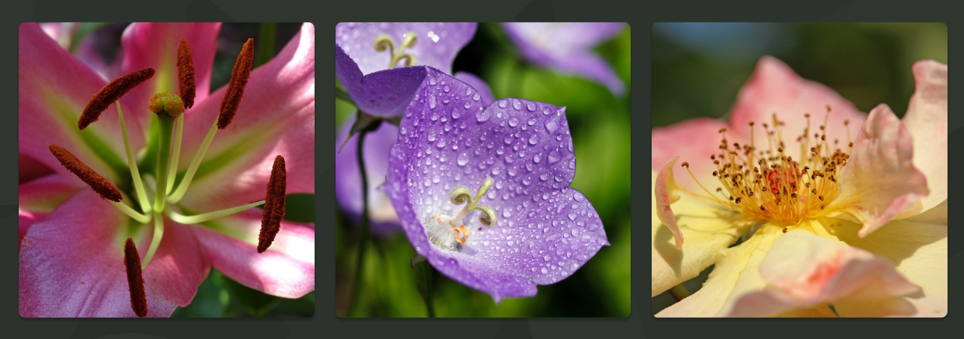

Discuss differences in stigma and stamen and their function. Dissect a flower into male and female parts and describe the process of reproduction

Vocabulary: sexual reproduction, stigma, stamen, anther, filament, style, ovary
Session 5:

Lo: To understand asexual reproduction in plants
The parent plant produces identical offspring. There are no female or male parts involved as in sexual reproduction.
Adapt Twinkl powerpoint and use the first 7 slides.
runners, bulbs, tubers, cuttings

Vocabulary: runners, bulbs, tubers, cuttings
Session 6:

Lo: To observe asexual reproduction in plants

Plant the following:
Strawberries – school allotment
Mint – use cuttings and discuss why some growers use cuttings rather than seeds to propagate (the cuttings or buds taken from an adult plant produce progeny that mature faster and are sturdier than a seedling grown from a seed.)
Spider plant – classroom plant
Daffodils – school grounds

Vocabulary: propagate, propagation
Link to career scientist:

https://pstt.org.uk/application/files/7916/2851/6348/Marine_biologist_-_Dawood_Qureshi.pdf

https://pstt.org.uk/application/files/2416/2851/6697/Veterinary_Surgeon_-_Daniella_Dos_Santos.pdf

Scientists who have helped develop understanding in this field: David Attenborough, Jane Goodall

