Beamont Primary School
Reception PSHE Medium Term Plans
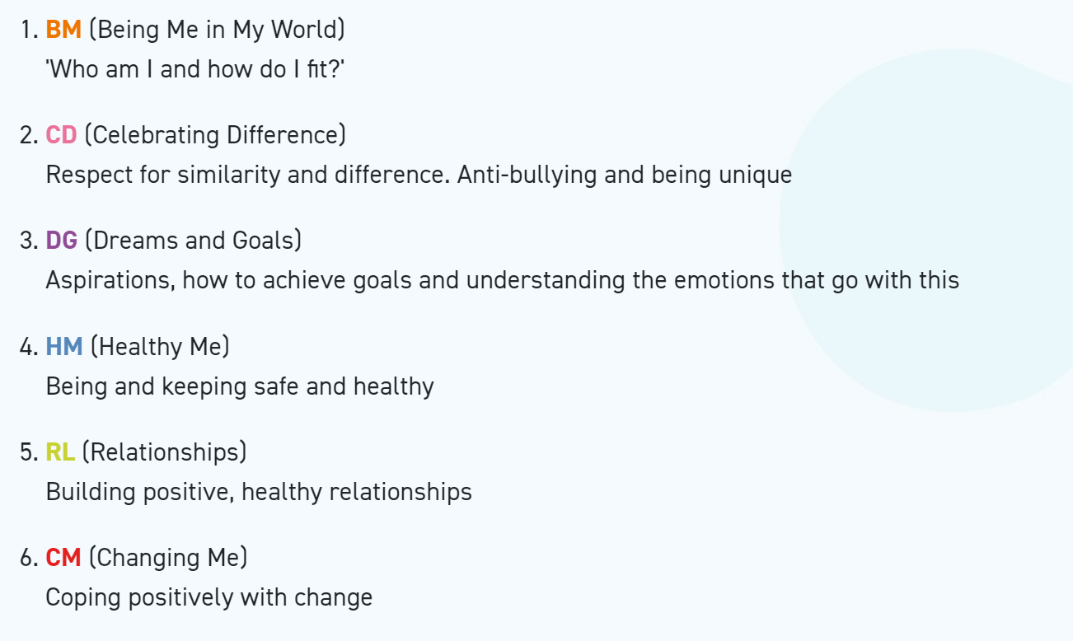
Reception Autumn 1 PSHE
Being In My World

Weekly Celebration | Piece | PSHE learning intention | Resources
Help others to feel welcome | - Who…Me?! | I understand how it feels to belong and that we are similar and different | Jigsaw Song sheet: ‘Together As One’ Decorated box and an assortment of toys (from inside and outside learning environments) Jigsaw Jenie Jigsaw Jerrie Cat
Try to make our Nursery/Pre-school community a better place  Think about everyone’s right to learn | - How am I feeling today?  3. Being at School | I can start to recognise and manage my feelings  I enjoy working with others to make school a good place to be | Jigsaw Song sheet: ‘Together As One’ Jigsaw Jenie 4 hoops Emotion photos Jigsaw Jerrie Cat  Assortment of toys Paper General mess Clipboards Timers Bell Police hats Jigsaw Jenie Jigsaw Jerrie Cat
Care about other people’s feelings | 4. Gentle hands | I understand why it is good to be kind and use gentle hands | Jigsaw Song sheet: ‘Together As One’ Book: ‘Hands are not for hitting’, by Martine Agassi, or similar themed book e.g. ‘No Hitting, Henry’ by Lisa Regan Jigsaw Jenie Jigsaw Jerrie Cat
Work well with others | 5. Our Rights | I am starting to understand children’s rights and this means we should all be allowed to learn and play | Blindfold Keys Jigsaw Jenie Jigsaw Jerrie Cat
Choose to follow the Learning Charter | 6. Our Responsibilities | I am learning what being responsible means | Book: ‘Dogger’ by Shirley Hughes Cubes Jigsaw Jenie Jigsaw Jerrie Cat

Reception Autumn 2 PSHE
Celebrating Difference
Weekly Celebration | Piece | PSHE learning intention | Resources
Accept that everyone is different | 1. What I am good at? | I can identify something I am good at and understand everyone is good at different things | Jigsaw Song sheet: ‘There’s a Place’ Large box/bag Selection of objects that demonstrate things that the grown-up is good at/likes Jigsaw Jenie Jigsaw Jerrie Cat Jigsaw Chime
Include others when working and playing | 2. I’m Special, I’m Me! | I understand that being different makes us all special | Book: ‘Naked Trevor’ by Rebecca Elliot (being comfortable with who you are) Book: ‘Barry the Fish with Fingers’ by Sue Henra (being different is a good thing) Book: ‘It’s OK to Be Different’ by Todd Parr Jigsaw Jenie Large selection of catalogues, magazines, leaflets for cutting up Plain paper Scissors Glue Pencils Jigsaw Jerrie Cat Jigsaw Chime
Know how to help if someone is being bullied | 3. Families | I know we are all different but the same in some ways | . Jigsaw Song sheet: ‘There’s a Place’ Large selection of pictures ranging from adults, children, families from around the world (Teachers to find more) Book: ‘The Family Book’ by Todd Parr Book: ‘The Hueys in the New Jumper’, by Oliver Jeffers: (similarities and differences amongst people) Jigsaw Jenie Jigsaw Jerrie Cat Jigsaw Chime
Try to solve problems | 4. Houses and Homes | I can tell you why I think my home is special to me | Teddies Construction materials Photos of different houses from around the world (Teachers to find more) Jigsaw Jenie Jigsaw Jerrie Cat Jigsaw Chime
Try to use kind words | 5. Making Friends | I can tell you how to be a kind friend | Jigsaw Song sheet: ‘There’s a Place’ Book: ‘The Dog and the Dolphin’, by James Dworkin Jigsaw Jenie Jigsaw Jerrie Cat Jigsaw Chime
Know how to give and receive compliments | 6. Standing Up for Yourself | I know which words to use to stand up for myself when someone says or does something unkind | Puppets or teddies Jigsaw Jenie Jigsaw Jerrie Cat Jigsaw Chime

Reception Spring 1 PSHE
Dreams and Goals
Weekly Celebration | Pieces | PSHE learning intention | Resources
Stay motivated when doing something challenging | - Challenge | I understand that if I persevere I can tackle challenges | Jigsaw Song sheet: ‘For Me’ Resources for challenge in ‘Interest Me’ Book: ‘Love Monster’ by Rachel Bright Book: ‘Don’t worry, Hugless Douglas’ by David Melling Jigsaw Jenie Jigsaw Jerrie Cat
Keep trying even when it is difficult | 2. Never Giving Up | I can tell you about a time I didn’t give up until I achieved my goal | Jigsaw Song sheet: ‘For Me’ Book: ‘The Hare and The Tortoise’, Aesop’s Fables (available on-line) Book: ‘The Jungle Run’ by Tony Mitton Jigsaw Jenie Jigsaw Jerrie Cat Jigsaw Chime
Work well with a partner or in a group | 3. Setting a goal | I can set a goal and work towards it | Jigsaw Song sheet: ‘For Me’ Jigsaw Jenie Jigsaw Jerrie Cat Jigsaw Chime Wooden bricks Paper Pencils
Have a positive attitude | 4. Obstacles and Support | I can use kind words to encourage people | . 2 teddies/puppets Jigsaw Jenie Jigsaw Jerrie Cat Jigsaw Chime
Help others to achieve their goals | 5. Flight to the Future | I understand the link between what I learn now and the job I might like to do when I’m older | Large variety of picture and word cards of different jobs done by adults (Teachers to find more) Box or bag to hold picture cards Jigsaw Jenie Jigsaw Jerrie Cat Jigsaw Chime
Are working hard to achieve their own dreams and goals | 6. Footprint Awards | I can say how I feel when I achieve a goal and know what it means to feel proud | Well done certificate A special box/bag Children’s goals from Piece 3 Jigsaw Jenie Jigsaw Jerrie Cat Jigsaw Chime

Reception Spring 2 PSHE
Healthy Me
Weekly Celebration | Pieces | PSHE learning intention | Resources
Have made a healthy choice | 1. Everybody’s Body | I understand that I need to exercise to keep my body healthy | . Jigsaw Song sheet: ‘Make a Good Decision’ Jigsaw Jenie Colouring pictures Assortment of pictures of active play/sports (Teachers to find more) Jigsaw Jerrie Cat Jigsaw Chime
Have eaten a healthy, balanced diet | 2. We like to move it, move it! | I understand how moving and resting are good for my body | Large space needed Calm music to assist with the cool down Small apparatus Jigsaw Jenie Jigsaw Jerrie Cat Jigsaw Chime
Have been physically active | 3. Food, Glorious Food | I know which foods are healthy and not so healthy and can make healthy eating choices | An assortment of healthy food and not so healthy food (preferably real) to make a sandwich Fruit for directed activity Shopping bags/basket Food, Glorious Food song Jigsaw Jenie Jigsaw Jerrie Cat Jigsaw Chime
Have tried to keep themselves and others safe | 4. Sweet Dreams | I know how to help myself go to sleep and understand why sleep is good for me | Bedtime equipment: Pyjamas, Teddy, Hot water bottle, Dressing gown, Glass of milk, Night light, Story book Chitty Chitty Bang Bang DVD (or similar example) Jigsaw Jenie Lullaby CD Large clock Jigsaw Jerrie Cat Jigsaw Chime
Know how to be a good friend and enjoy healthy friendships | 5. Keeping Clean | I can wash my hands thoroughly and understand why this is important especially before I eat and after I go to the toilet | Cleaning equipment: jug of water, bowl, soap, flannel, towel Fruit/vegetables Dirt Jigsaw Jenie Jigsaw Jerrie Cat Jigsaw Chime
Know how to keep calm and deal with difficult situations | 6. Stranger Danger | I know what a stranger is and how to stay safe if a stranger approaches m | . Book: ‘Not Everyone is Nice’ (Let’s Talk Book) by Ann Tedesco, or similar Book” ‘Never Talk to Strangers’, by Irma Joyce If possible, ask your local PCSO to come by and chat to the children about Stranger Danger. Jigsaw Jenie Jigsaw Jerrie Cat Jigsaw Chime

Reception Summer 1 PSHE
Relationships
Weekly Celebration | Pieces | PSHE learning intention | Resources
Know how to make friends | 1. My Family and Me! | I can identify some of the jobs I do in my family and how I feel like I belong | Staff photo - preferably on IWB Jigsaw Jenie Jigsaw Jerrie Cat Jigsaw Chime
Try to solve friendship problems when they occur | 2. Make friends, make friends, never ever break friends! Part 1 | I know how to make friends to stop myself from feeling lonely | Jigsaw Song sheet: ‘RELATIONSHIP’ Lonely child photo Body puzzle template Jigsaw Jenie Jigsaw Jerrie Cat Jigsaw Chime
Help others to feel part of a group | 3. Make friends, make friends, never ever break friends! Part 2 | I can think of ways to solve problems and stay friends | Jigsaw Song sheet: ‘RELATIONSHIP’ Book: ‘Mabel and Me’, by Sarah Warburton Book: ‘George and Martha: The Complete Stories of Two Best Friends’ by James Marshall (or similar) Jigsaw Jenie Jigsaw Jerrie Cat Jigsaw Chime
Show respect in how they treat others | 4. Falling Out and Bullying Part 1 | I am starting to understand the impact of unkind words | . Jigsaw Song sheet: ‘RELATIONSHIP’ Sparkly box, bin and bag Assortment of phrases (positive/negative) e.g. you are brilliant, thank you very much, you are stupid, shut up, etc. Squirty cream and plate Jigsaw Jenie Jigsaw Jerrie Cat Jigsaw Chime
Know how to help themselves and others when they feel upset and hurt | 5. Falling Out and Bullying Part 2 | I can use Calm Me time to manage my feelings | Wall paper roll Mark-making materials YouTube (or similar) video clips of tantrums Puppets Calming music Jigsaw Jenie Jigsaw Jerrie Cat Jigsaw Chime
Know and show what makes a good relationship | 6. Being the best friends we can be | I know how to be a good friend | You’ve Got A Friend In Me’ by Randy Newman (Toy Story song) ‘True Friends’ song by Miley Cyrus (Hannah Montana) ‘That’s what friends are for’ (Fox and Hounds song) Pictures of friends from TV/movies e.g. Woody and Buzz but separate so that children can match (Teachers to find) Jigsaw Jenie Jigsaw Jerrie Cat Jigsaw Chime

Reception Summer 2 PSHE
Changing Me
Weekly Celebration | Pieces | PSHE learning intention | Resources
Understand that everyone is unique and special | 1. My Body | I can name parts of the body | Large paper big enough to fit the outline of a child on Post-its or labels of body parts Book: ‘Look Inside Your Body’ by Louie Stowell Jigsaw Jenie Jigsaw Jerrie Cat Jigsaw Chime
Can express how they feel when change happens | 2. Respecting My Body | I can tell you some things I can do and foods I can eat to be healthy | Jigsaw Song sheet: ‘Make a Good Decision’ Selection of pictures that show healthy/less healthy activities/food 2 containers/hoops for sorting Magazines/food leaflets for child-initiated Paper Jigsaw Jenie Jigsaw Jerrie Cat Jigsaw Chime
Understand and respect the changes that they see in themselves | 3. Growing Up | I understand that we all grow from babies to adults | Jigsaw Song sheet: ‘A New Day’ Book: ‘Tell Me What It’s Like To Be Big’, by Joyce Dunbar Book: ‘I Wonder Why Kangaroos Have Pouches’, by Jenny Wood Picture cards showing different developmental stages of life ranging from baby to elderly (Teachers to find more) Jigsaw Jenie Jigsaw Jerrie Cat Jigsaw Chime
Understand and respect the changes that they see in other people | 4. Fun and Fears Part 1 | I can express how I feel about moving to Year 1 | Jigsaw Song sheet: ‘A New Day’ Book: ‘The Huge Bag of Worries’ by Virginia Ironside Book: ‘I Wonder Why Kangaroos Have Pouches’, by Jenny Wood Book: The Very Hungry Caterpillar’, by Eric Carle Box or bag for worries/looking forward to ideas Jigsaw Jenie Jigsaw Jerrie Cat Jigsaw Chime
Know who to ask for help if they are worried about change | 5. Fun and Fears Part 2 | I can talk about my worries and/or the things I am looking forward to about being in Year 1 | Jigsaw Jenie Music Jigsaw Jerrie Cat Jigsaw Chime
Are looking forward to change | 6. Celebration | I can share my memories of the best bits of this year in Reception | Paper A special box Jigsaw Jenie Jigsaw Jerrie Cat Jigsaw Chime

