Beamont Primary School
Year 1 PSHE Medium Term Plans
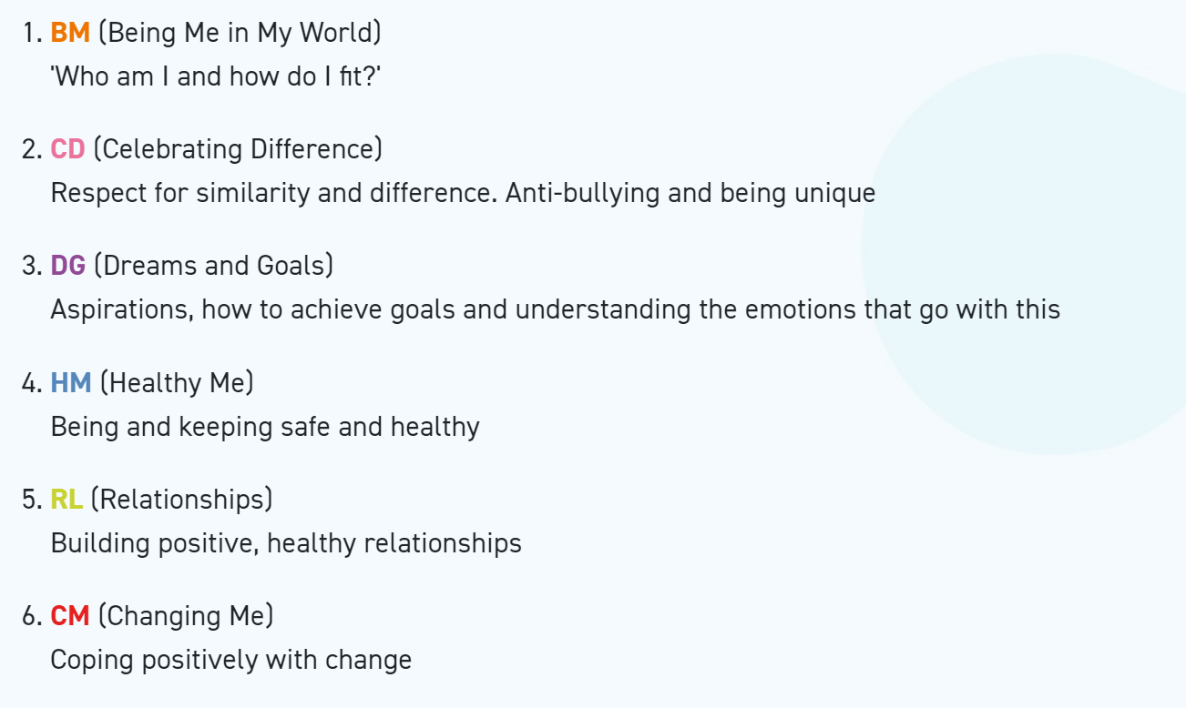
Year 1 Autumn 1 PSHE
Being In My World

Weekly Celebration | Piece | PSHE learning intention | Social and emotional development learning intention | Resources
Help others to feel welcome | 1. Special and Safe | I know how to use my Jigsaw Journal | I feel special and safe in my class | Jigsaw Charter, Jigsaw Chime,  Slide show,  ‘Calm Me’ script, Jigsaw Jack,  Jigsaw Jack’s letter,  ‘Safe’ pictures, Jigsaw Journals,  My Jigsaw Learning,  Jigsaw Jerrie Cat.
Try to make our school community a better place | 2. My Class | I understand the rights and responsibilities as a member of my class | I know that I belong to my class | Jigsaw Charter, Jigsaw Chime,  Slide show,  ‘Calm Me’ script,  Jigsaw Jack,  ‘I am special’ song sheet,  Jigsaw Journals,  My Jigsaw Learning,  Jigsaw Jerrie Cat.
Think about everyone’s right to learn | 3. Rights and Responsibilities | I understand the rights and responsibilities for being a member of my class | I know how to make my class a safe place for everybody to learn | Jigsaw Charter,  Jigsaw Chime,  Slide show,  ‘Calm Me’ script,  Jigsaw Jack,  rights/responsibility pictures,  Jigsaw Journals,  My Jigsaw Learning,  Jigsaw Jerrie Cat.
Care about other people’s feelings | 4. Rewards and Feeling Proud | I know my views are valued and can contribute to the Learning Charter | I recognise how it feels to be proud of an achievement | Jigsaw Charter, Jigsaw Chime,  Slide show  ‘Calm Me’ script, colour cards,  treasure chest,  proud face pictures,  I feel proud of you tickets,  Jigsaw Journals,  My Jigsaw Learning,  Jigsaw Jerrie Cat.
Work well with others | 5. Consequences | I can recognise  the choices I make and understand the consequences | I recognise the range of feelings when I face certain consequences | Jigsaw Charter, Jigsaw Chime, ‘Calm Me’ script, Jigsaw Jack, Slideshow  Jigsaw Song: ‘Together As One’  Flipchart from rights/responsibility lesson (Piece 3), Jigsaw Journals,  My Jigsaw Learning,  Jigsaw Jerrie Cat.
Choose to follow the Learning Charter | 6. Owning our Learning Charter | I understand my rights and responsibilities within our Learning Charter | I understand my choices in following the Learning Charter | Jigsaw Charter, Jigsaw Chime,  Slide show,  ‘Calm Me’ script, Jigsaw Jack, postcards made into puzzles,  Jigsaw Journals, certificates,  My Jigsaw Learning,  flipchart from Piece 3, Jigsaw Jerrie Cat.

Year 1 Autumn 2 PSHE
Celebrating Difference
Weekly Celebration | Piece | PSHE learning intention | Social and emotional development learning intention | Resources
Accept that everyone is different | 1. The same as... | I can identify similarities between people in my class | I can tell you some ways in which I am the same as my friends | Jigsaw Chime, ‘Calm Me’ script, Jigsaw Jack, Spot the similarities pictures, Set of picture cards e.g. Snap, Happy Families. Cardboard cut-out gingerbread person, T-shirt templates for gingerbread person, Jigsaw Journals, My Jigsaw Learning, Jigsaw Jerrie Cat.
Include others when working and playing | 2. Different from... | I can identify differences between people in my class | I can tell you some ways I am different from my friends | Jigsaw Chime, ‘Calm Me’ script, Jigsaw Jack, Yes and no labels, Spot the difference pictures, Set of pair cards, Shorts templates for gingerbread people (could be trouser templates as an alternative), Jigsaw Journals, My Jigsaw Learning, Jigsaw Jerrie Cat.
Know how to help if someone is being bullied | 3. What is ‘bullying’? | I can tell you what bullying is | I understand how being bullied might feel | Jigsaw Chime, ‘Calm Me’ script, Jigsaw Jack, Bully pictures, Bullying pictures, Hat templates, Jigsaw Journals, My Jigsaw Learning, Jigsaw Jerrie Cat.
Try to solve problems | 4. What do I do about bullying? | I know some people who I could talk to if I was feeling unhappy or being bullied | I can be kind to children who are bullied | Jigsaw Chime, ‘Calm Me’ script, Puzzle Song sheet: ‘There’s a Place’, Jigsaw Jack, Shoes template, Jigsaw Journals, My Jigsaw Learning, Jigsaw Jerrie Cat.
Use kind words | 5. Making new friends | I know how to make new friends | I know how it feels to make a new friend | Jigsaw Chime, ‘Calm Me’ script, Soft/sponge football, Jigsaw song: ‘There’s a Place’, Jigsaw story, Friendship tokens, Friendship token template, Jigsaw Journals, My Jigsaw Learning, Jigsaw Jerrie Cat.
Know how to give and receive compliments | 6. Celebrating difference; celebrating me  Assessment Opportunity | I can tell you some ways I am different from my friends | I understand these differences make us all special and unique | Jigsaw Chime, ‘Calm Me’ script, Jigsaw song: ‘There’s a Place’, Jigsaw Jack, Celebrating Me label template (one per child), Gingerbread people, Jigsaw Journals, My Jigsaw Learning, Jigsaw Jerrie Cat.

Year 1 Spring 1 PSHE
Dreams and Goals
Weekly Celebration | Pieces | PSHE learning intention | Social and emotional development learning intention | Resources
Stay motivated when doing something challenging | 1. My Treasure Chest of Success | I can set simple goals | I can tell you about a thing I do well | Jigsaw Jack, Treasure chest filled with marbles, beads, coins, coloured stones, Jigsaw Chime, ‘Calm Me’ script, Success pictures, Success coin templates, Treasure chest boxes/simple boxes, Jigsaw Journals, My Jigsaw Learning, Jigsaw Jerrie Cat.
Keep trying even when it is difficult | 2. Steps to Goals | I can set a goal and work out how to achieve it | I can tell you how I learn best | Jigsaw Song: ‘For Me’, Jigsaw Chime, ‘Calm Me’ script, Jam sandwich ingredients: jam, bread, butter, Jigsaw Jack, My Jigsaw Learning, Jigsaw Jerrie Cat.
Work well with a partner or in a group | 3. Achieving Together  Puzzle outcome: Dream wellies | I understand how to work well with a partner | I can celebrate achievement with my partner | Jigsaw Chime, ‘Calm Me’ script, Jigsaw Jack, Welly template, Jigsaw Journals, My Jigsaw Learning, Jigsaw Jerrie Cat.
Have a positive attitude | 4. Stretchy Learning  Puzzle outcome: Stretchy flowers | I can tackle a new challenge and understand this might stretch my learning | I can identify how I feel when I am faced with a new challenge | Jigsaw Chime, ‘Calm Me’ script, Pipe cleaners, garden sticks, paper, paint, Jigsaw Jack, My Jigsaw Learning, Jigsaw Jerrie Cat.
Help others to achieve their goals | 5. Overcoming Obstacles | I can identify obstacles which make it more difficult to achieve my new challenge and can work out how to overcome them | I know how I feel when I see obstacles and how I feel when I overcome them | Jigsaw Chime, ‘Calm Me’ script, Jigsaw  Song: ‘For Me’, Jigsaw story: Pauli’s Journey, PowerPoint slidesP Paulies Journey, Pieces of paper for stepping stones, Jigsaw Journals, My Jigsaw Learning, Jigsaw Jerrie Cat.
Are working hard to achieve their own dreams and goals | 6. Celebrating My Success Assessment Opportunity | I can tell you how I felt when I succeeded in a new challenge and how I celebrated it | I know how to store the feelings of success in my internal treasure chest | Jigsaw Song: ‘For Me’, Jigsaw Chime, ‘Calm Me’ script, Jigsaw Jack’s treasure chest, Success pictures - from Piece 1, Treasure chest template, Jigsaw Jack, Jigsaw Journals, My Jigsaw Learning, Certificates, Jigsaw Jerrie Cat.

Year 1 Spring 2 PSHE
Healthy Me
Weekly Celebration | Pieces | PSHE learning intention | Social and emotional development learning intention | Resources
Have made a healthy choice | 1. Being Healthy | I understand the difference between being healthy and unhealthy, and know some ways to keep myself healthy | I feel good about myself when I make healthy choices | Jigsaw Chime, ‘Calm Me’ script, Slide show, Healthy Balance Sum sheet, Jigsaw Journals, My Jigsaw Learning, Jigsaw Jerrie Cat.
Have eaten a healthy, balanced diet | 2. Healthy Choices | I know how to make healthy lifestyle choices | I feel good about myself when I make healthy choices | Jigsaw Chime, ‘Calm Me’ script, Jigsaw  Jack, Jigsaw Song: ‘Make a Good Decision’, Slide show, Child picture template, Healthy Balance Sum sheet, Jigsaw Journals, My Jigsaw Learning, Jigsaw Jerrie Cat.
Have been physically active | 3. Clean and Healthy | I know how to keep myself clean and healthy, and understand how germs cause disease/illness  I know that all household products including medicines can be harmful if not used properly | I am special so I keep myself safe | Jigsaw Chime, ‘Calm Me’ script, Jigsaw Jack, Bag of toiletry items, e.g. toothbrush, shampoo, soap, etc., Empty bathroom and kitchen cleaning products, Pictures of household products, Jigsaw Journals, My Jigsaw Learning, Jigsaw Jerrie Cat.
Have tried to keep themselves and others safe | 4. Medicine Safety | I understand that medicines can help me if I feel poorly and I know how to use them safely | I know some ways to help myself when I feel poorly | Jigsaw Chime, ‘Calm Me’ script, Jigsaw Jack, Empty medicine packaging, Picture cards, Jigsaw Journals, My Jigsaw Learning, Jigsaw Jerrie Cat.
Know how to be a good friend and enjoy healthy friendships | 5. Road Safety | I know how to keep safe when crossing the road, and about people who can help me to stay safe | I can recognise when I feel frightened and know who to ask for help | Jigsaw Chime, ‘Calm Me’ script, Jigsaw Jack,  Slide show, Jigsaw Journals, My Jigsaw Learning, Jigsaw Jerrie Cat.
Know how to keep calm and deal with difficult situations | 6. Happy, Healthy Me  Assessment Opportunity  Puzzle outcome: Keeping clean and healthy | I can tell you why I think my body is amazing and can identify some ways to keep it safe and healthy | I can recognise how being healthy helps me to feel happy | Jigsaw Chime, ‘Calm Me’ script, Jigsaw  Jack, Keeping Clean and Healthy timeline template, Jigsaw Journals, My Jigsaw Learning, Certificates, Jigsaw Jerrie Cat.

Year 1 Summer 1 PSHE
Relationships
Weekly Celebration | Pieces | PSHE learning intention | Social and emotional development learning intention | Resources
Know how to make friends | 1. Families | I can identify the members of my family and understand that there are lots of different types of families | I know how it feels to belong to a family and care about the people who are important to me | Family game cards, Jigsaw Chime, ‘Calm Me’ script, ‘Welcome to Planet Zarg’ Slide show, Jigsaw Journals, My Jigsaw Learning, My Jigsaw Learning PowerPoint slide, Jigsaw Jack, Jigsaw Jerrie Cat.
Try to solve friendship problems when they occur | 2. Making Friends | I can identify what being a good friend means to me | I know how to make a new friend | Music and blanket for hedgehogs game  OR children’s names put into a hat, Jigsaw Chime, ‘Calm Me’ script, Jigsaw Song: ‘RELATIONSHIPS’, Slide show,  Jigsaw Jack  Sets of ‘A Good Friend Should...’ cards, one set, for each group, Jigsaw Journals, My Jigsaw Learning, Jigsaw Jerrie Cat.
Help others to feel part of a group | 3. Greetings | I know appropriate ways of physical contact to greet my friends and know which ways I prefer | I can recognise which forms of physical contact are acceptable and unacceptable to me | Jigsaw Chime, ‘Calm Me’ script, Holding Hands Images, ‘Feely bags’ containing a variety of textures: e.g. fur, velvet, sandpaper, pebble, Playdoh, water snake toy, stress ball and any other suitable objects, Jigsaw Jack, Jigsaw Journal, My Jigsaw Learning, Jigsaw Jerrie Cat.
Show respect in how they treat others | 4. People Who Help Us | I know who can help me in my school community | I know when I need help and know how to ask for it | Jigsaw Jack, Jigsaw Chime, ‘Calm Me’ script, People cards, Scenario cards, Jigsaw Journals, My Jigsaw Learning, Jigsaw Jerrie Cat.
Know how to help themselves and others when they feel upset or hurt | 5. Being My Own Best Friend | I can recognise my qualities as person and a friend | I know ways to praise myself | Bottle weighted with water or sand or children’s names in a hat, Jigsaw Chime, ‘Calm Me’ script, Jigsaw Jack, Slide show of incredible children, ‘The Incredible Me’ picture frame template, My Jigsaw Learning, Jigsaw Jerrie Cat.
Know and show what makes a good relationship | 6. Celebrating My Special Relationships  Puzzle Outcome: Balloons  Assessment Opportunity | I can tell you why I appreciate someone who is special to me | I can express how I feel about them | Jigsaw Chime, ‘Calm Me’ script, Jigsaw Jack, Balloons, Balloon label template, Sticks, Jigsaw Jack’s balloon with pre-prepared label, Jigsaw Journals, My Jigsaw Learning, Certificates, Jigsaw Jerrie Cat.

Year 1 Summer 2 PSHE
Changing Me
Weekly Celebration | Pieces | PSHE learning intention | Social and emotional development learning intention | Resources
Understand that everyone is unique and special | 1. Life cycles | I am starting to understand the life cycles of animals and humans | I understand that changes happen as we grow and that this is OK | Jigsaw Jack, Find your pair cards, Jigsaw Chime, ‘Calm Me’ script, Jigsaw Song: A New Day, Teacher’s photos:, series of photos from baby to adult, YouTube clip of frog’s lifecycle (teacher to source), Life cycle cards, Jigsaw Journals, My Jigsaw Learning, Jigsaw Jerrie Cat.
Can express how they feel when change happens | 2. Changing Me | I can tell you some things about me that have changed and some things about me that have stayed the same | I know that changes are OK and that sometimes they will happen whether I want them to or not | Jigsaw Chime, ‘Calm Me’ script, Jigsaw Jack, Life cycle cards, Paper for concertina booklets, Jigsaw Journals, My Jigsaw Learning, Jigsaw Jerrie Cat.
Understand  and respect the changes that they see in themselves | 3. My Changing Body | I can tell you how my body has changed since I was a baby | I understand that growing up is natural and that everybody grows at different rates | Jigsaw Chime, ‘Calm Me’ script, Jigsaw Song: ‘A New Day’, Jigsaw Jack, Baby photo of the teacher, Baby photos brought in by the children in a box, Jigsaw Journals, My Jigsaw Learning, Jigsaw Jerrie Cat.
Know who to ask for help if they are worried about change | 5. Learning and Growing  Puzzle Outcome: Piece 5 Flowers | I understand that every time I learn something new I change a little bit | I enjoy learning new things | Jigsaw Song: ‘A New Day’, Jigsaw Jack, Jigsaw Chime, ‘Calm Me’ script, Picture cards, Flower shape and petals for flip chart, Flower templates,Jigsaw Journals, My Jigsaw Learning, Jigsaw Jerrie Cat.
Are looking forward to change | 6. Coping with Changes  Assessment Opportunity | I can tell you about changes that have happened in my life | I know some ways to cope with changes | Jigsaw Chime, ‘Calm Me’ script, Story and Slides: ‘All change for Jack’, Jigsaw Jack, Bag of items for Changes Game e.g. baby item, a piece of school uniform, holiday item, name of next teacher etc., Jigsaw Journals, My Jigsaw Learning, Certificates, Jigsaw Jerrie Cat.

