Beamont Primary School
Year 2 PSHE Medium Term Plans
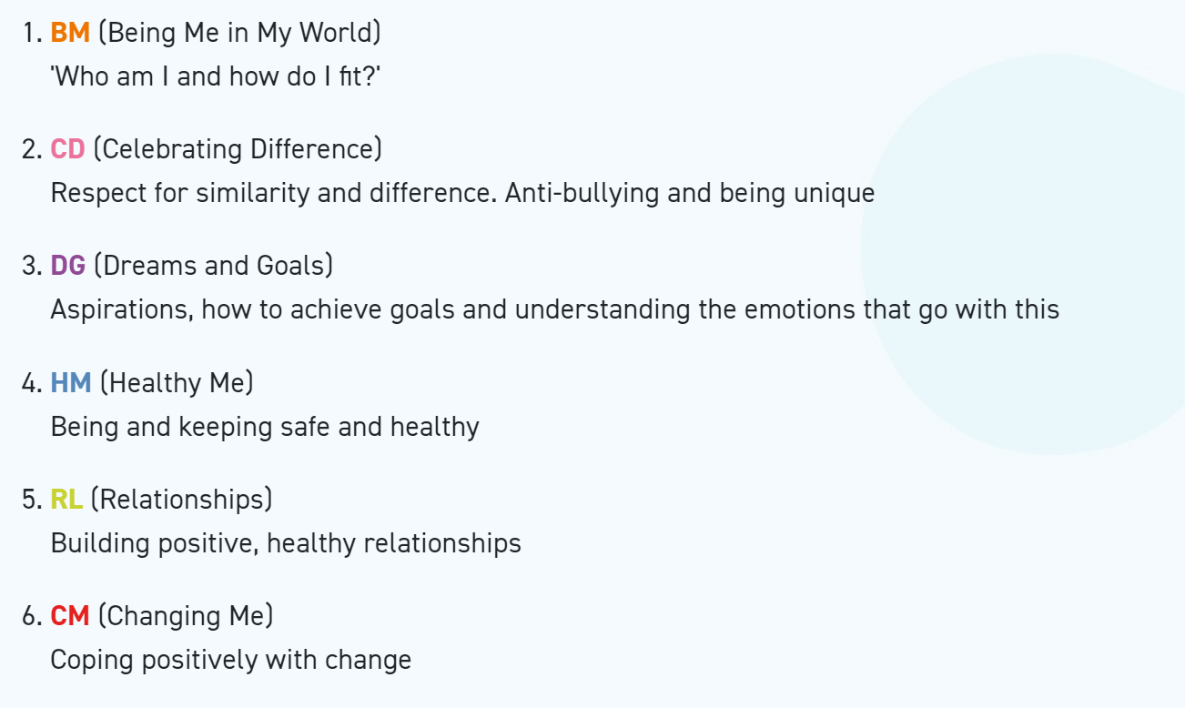
Year 2 Autumn 1 PSHE
Being In My World
Weekly Celebration | Piece | PSHE learning intention | Social and emotional development learning intention | Resources
Help others to feel welcome | 1. Hopes and Fears  for the Year | I can identify some of my hopes and fears for this year  I know how to use my Jigsaw Journal | I recognise when I feel worried and know who to ask for help | Jigsaw Charter, Jigsaw Chime, ‘Calm Me’ script,  Number cards, Jigsaw Jo, basket/bag, monster worries resource sheet,  My Jigsaw Learning, Jigsaw Journals, Jigsaw Jerrie Cat.
Try to make our school community a better place | 2. Rights and  Responsibilities | I understand the rights and responsibilities for being a member of my class and  school | I recognise when I feel worried and know who to ask for help | Jigsaw Charter, number cards, ‘Calm Me’ script, ‘Calm’ pictures, Jigsaw  Chime, My Jigsaw Learning, Responsibility Slide show, Jigsaw Journal,  Jigsaw Jerrie Cat.
Think about everyone’s right to learn | 3. Rewards and  Consequences | I understand the rights and  responsibilities for being a member of my class | I can help to make my class a safe and fair place | Jigsaw Charter, Jigsaw Chime, ‘Calm’ pictures, ‘Calm Me’  script, Jigsaw Jo, Jigsaw Jo’s bag of rewards, Jigsaw Song: Together as  One’, picture cards, My Jigsaw Learning, Jigsaw Journals, Jigsaw Jerrie  Cat.
Care about other people’s feelings | 4. Rewards and  Consequences | I can listen to other people and contribute my own ideas about rewards and consequences | I can help make my class a safe and fair place | Jigsaw Charter, Jigsaw Chime, ‘Calm’ pictures, ‘Calm Me’ script, ‘What  Might Happen?’ Slide show, scenario picture cards, flip chart traffic light  with red post-it learning behaviours from Piece 3, My Jigsaw Learning,  Jigsaw Journals, Jigsaw Jerrie Cat.
Work well with others | 5. Our Learning  Charter | I understand how following the Learning Charter will help me and others learn | I can work cooperatively | Jigsaw Charter, Jigsaw Chime, ‘Calm’ pictures, ‘Calm Me’ script, Jigsaw  Jo, art materials, Whole School Learning Charter or sample Jigsaw  version, Jigsaw Jo’s bag, Jigsaw pieces template, My Jigsaw Learning,  Jigsaw Journals, Jigsaw Jerrie Cat.
Choose to follow the Learning Charter | 6. Owning our Learning Charter | I can recognise  the choices I make  and understand the  consequences | I am choosing to follow the  Learning Charter | Jigsaw Charter, Jigsaw Chime, ‘Calm’ pictures, ‘Calm Me’ script, Learning  Charter, Children’s pictures from last week, A4 paper, My Jigsaw  Learning, Jigsaw Journals, certificates, Jigsaw Jerrie Cat.

Year 2 Autumn 2 PSHE
Celebrating Difference
Weekly Celebration | Piece | PSHE learning intention | Social and emotional development learning intention | Resources
Accept that  everyone is  different | 1. Boys and girls | I am starting to understand that sometimes people make assumptions about boys and girls (stereotypes) | I understand some ways in which boys and girls are similar and feel good about this | Jigsaw Chime, ‘Calm Me’ script, Jigsaw Jo, Jigsaw Jo’s bag, Four photo cards of children, Four description cards, Shield templates, Jigsaw Journals, My Jigsaw Learning, Jigsaw Jerrie Cat.
Include others when working and playing | 2. Boys and girls | I am starting to understand that sometimes people make assumptions about boys and girls (stereotypes) | I understand some ways in which boys and girls are different and accept that this is OK | Jigsaw Chime, ‘Calm Me’ script, Duvet covers (or pictures of), Jigsaw Jo, Difference shield templates, Jigsaw Journals, My Jigsaw Learning, Jigsaw Jerrie Cat.
Know how to help if someone is being bullied | 3. Why does bullying happen? | I understand that bullying is sometimes about difference | I can tell you how someone who is bullied feels I can be kind to children who are bullied | Jigsaw Chime, ‘Calm Me’ script, Jigsaw Song: ‘There’s a Place’, Jigsaw Jo, Scenario picture/description cards, Jigsaw Journals, My Jigsaw Learning, Jigsaw Jerrie Cat.
Try to solve problems | 4. Standing up for myself and others | I can recognise what is right and wrong and know how to look after myself | I know when and how to stand up for myself and others  I know how to get help if I am being bullied | Number cards, Jigsaw Chime, ‘Calm Me’ script, Jigsaw Song: ‘There’s a Place’, Jigsaw Jo, Scenario picture/description cards, Paper person chain template, Jigsaw Journals, My Jigsaw Learning, Jigsaw Jerrie Cat.
Try to use kind words | 5. Gender Diversity | I understand that it is OK to be different from other people and to be friends with them | I understand we shouldn’t judge people if they are different.  I know how it feels to be a friend and have a friend | Jigsaw Chime, ‘Calm Me’ script, Slides: story ‘Billy, Bella and B’, Jigsaw Friend, Birthday present template, Jigsaw Journals, My Jigsaw Learning, Jigsaw Jerrie Cat.
Know how to give and receive compliments | 6. Celebrating difference and still being friends  Assessment Opportunity  Puzzle Outcome: Trophy of Celebration | I can tell you some ways I am different from my friends | I understand these differences make us all special and unique | Jigsaw Chime, ‘Calm Me’ script, Pair cards, Jigsaw Jo, 3D Trophy template, Puzzle 2 Attainment Descriptor Grid, Jigsaw Journals, My Jigsaw Learning, Puzzle Certificate, Jigsaw Jerrie Cat.

Year 2 Spring 1 PSHE
Dreams and Goals
Weekly Celebration | Piece | PSHE learning intention | Social and emotional development learning intention | Resources
Stay motivated when doing something challenging | 1. Goals to Success | I can choose a realistic goal and think about how to achieve it | I can tell you things I have achieved and say how that makes me feel | Treasure chest filled with marbles, beads, coins, coloured stones, Jigsaw Jo, Jigsaw Chime, ‘Calm Me’ script, Success pictures, Treasure chest template,  Slide show, Jigsaw Journals, My Jigsaw Learning, Jigsaw Jerrie Cat.
Keep trying even when it is difficult | 2. My Learning Strengths | I carry on trying (persevering) even when I find things difficult | I can tell you some of my strengths as a learner | Treasure chest filled with marbles, beads, coins, coloured stones, Jigsaw Chime, ‘Calm Me’ script, Jigsaw Song; ‘For Me’, Jigsaw Jo, Ladder template, Treasure chest boxes/simple boxes, Jigsaw Journals, My Jigsaw Learning, Jigsaw Jerrie Cat.
Work well with a partner or in a group | 3. Learning with Others | I can recognise who I work well with and who it is more difficult for me to work with | I can tell you how working with other people helps me learn | Jigsaw Chime, ‘Calm Me’ script, Jigsaw Song: ‘There’s a Place’, Book: ‘The Owl and the Pussy Cat’ by Edward Lear, Materials for the challenge: French numbers 1-20, Manderin/Chinese numbers 1-10, Macerena dance moves, Card and colouring materials, Jigsaw Journals, My Jigsaw Learning, Jigsaw Jerrie Cat.
Have a positive attitude | 4. A Group Challenge  Puzzle Outcome: Dream Birds | I can work well in a group | I can work with others in a group to solve problems | Soft ball, Jigsaw Chime, ‘Calm Me’ script, Gentle music, Slide show, Jigsaw Jo, Art materials/modelling materials/ paints, My Jigsaw Learning, Jigsaw Jerrie Cat.
Help others to achieve their goals | 5. Continuing Our Group Challenge | I can tell you some ways I worked well with my group | I can tell you how I felt about working in my group | Soft ball, Jigsaw Chime, ‘Calm Me’ script, Gentle music, Slide show, Jigsaw Jo,  Art materials/ modelling materials/paints, Treasure chest boxes, My Jigsaw Learning, Jigsaw Jerrie Cat.
Are working hard to achieve their own dreams and goals | 6. Celebrating Our Achievement  Assessment Opportunity | I know how to share success with other people | I can tell you how being part of a successful group feels and I can store these feelings in my internal treasure chest | Jigsaw Chime, ‘Calm Me’ script, Special objects, Dream birds, Treasure chest template, Jigsaw Journals,  My Jigsaw Learning, Certificates, Jigsaw Jerrie Cat, Jigsaw Jo.

Year 2 Spring 2 PSHE
Healthy Me
Weekly Celebration | Piece | PSHE learning intention | Social and emotional development learning intention | Resources
Have made a healthy choice | 1. Being Healthy | I know what I need to keep my body healthy | I am motivated to make healthy lifestyle choices | Jigsaw Chime, ‘Calm Me’ script, Jigsaw Song: ‘Make a Good Decision’, Help Jigsaw Jo sheet, Jigsaw Jo, Music, Jigsaw Journals, My Jigsaw Learning, Jigsaw Jerrie Cat.
Have eaten a healthy, balanced diet | 2. Being Relaxed | I can show or tell you what relaxed means and I know some things that make me feel relaxed and some that make me feel stressed | I can tell you when a feeling is weak and when a feeling is strong | Jigsaw Chime, ‘Calm Me’ script, Slide show, Printed slide images, Jigsaw Journals, My Jigsaw Learning, Jigsaw Jerrie Cat.
Have been physically active | 3.Medicine Safety | I understand how medicines work in my body and how important it is to use them safely | I feel positive about caring for my body and keeping it healthy | Jigsaw Chime, ‘Calm Me’ script, Bag of empty medicine packets/bottles, Jigsaw Journals, My Jigsaw Learning, Jigsaw Jerrie Cat.
Have tried to keep themselves and others safe | 4. Healthy Eating | I can sort foods into the correct food groups and know which foods my body needs every day to keep me healthy | I have a healthy relationship with food and know which foods I enjoy the most | Jigsaw Chime, ‘Calm Me’ script, Food group word cards, Pictures of composite foods, Jigsaw Journals, My Jigsaw Learning, Jigsaw Jerrie Cat
Know how to be a good friend and enjoy healthy friendships | 5. Healthy Eating | I can make some healthy snacks and explain why they are good for my body | I can express how it feels to share healthy food with my friends | Jigsaw Chime, ‘Calm Me’ script, Jigsaw Jo, A range of healthy food choices/ snack ingredients, Basic cookery equipment, Recipe cards, Jigsaw Journals, My Jigsaw Learning, Jigsaw Jerrie Cat.
Know how to keep calm and deal with difficult situations | 6. Happy, Healthy Me!  Puzzle outcome: Healthy recipes  Assessment Opportunity | I can decide which foods to eat to give my body energy | I have a healthy relationship with food and I know which foods are most nutritious for my body | Jigsaw Chime, ‘Calm Me’ script, Happy Healthy Me Recipe templates, Optional: large pieces of paper for life-size child body outlines, JigsawJournals, My Jigsaw Learning, Certificates, Jigsaw Jerrie Cat.

Year 2 Summer 1 PSHE
Relationships
Weekly Celebration | Pieces | PSHE learning intention | Social and emotional development learning intention | Resources
Know how to make friends | 1. Families | I can identify the different members of my family, understand my relationship with each of them and know why it is important to share and cooperate | I accept that everyone’s family is different and understand that most people value their family | Jigsaw Chime, ‘Calm Me’ script, Families Slide show, Jigsaw Jo, Mixing bowl, post -it notes, wooden spoon, Happy Home recipe sheets, Jigsaw Journals, My Jigsaw Learning, Jigsaw Jerrie Cat.
Try to solve friendship problems when they occur | 2. Keeping Safe - exploring physical contact | I understand that there are lots of forms of physical contact within a family and that some of this is acceptable and some is not | I know which types of physical contact I like and don’t like and can talk about this | Jigsaw Chime, ‘Calm Me’ script, Slide show of different types of contact, My Jigsaw Learning, Jigsaw Journals, My Jigsaw Learning, Jigsaw Jo, Jigsaw Jerrie Cat.
Help others to feel part of a group | 3. Friends and Conflict | I can identify some of the things that cause conflict with my friends | I can demonstrate how to use the positive problem-solving technique to resolve conflicts with my friends | Jigsaw Chime, ‘Calm Me’ script, Slide show picture of children, ‘Mending Friendships’ chart, printed on A3 or displayed on whiteboard, ‘Mending Friendships’ resource sheet, Jigsaw Journals, My Jigsaw Learning, Jigsaw Jerrie Cat, Jigsaw Jo.
Show respect in how they treat others | 4. Secrets | I understand that sometimes it is good to keep a secret and sometimes it is not good to keep a secret | I know how it feels to be asked to keep a secret I do not want to keep and know who to talk to about this | Jigsaw Chime, ‘Calm Me’ script, Wrapped gift box, Jigsaw Jo, Picture of ‘good secret’ and ‘worry secret’, Jigsaw Journals, My Jigsaw Learning, Jigsaw Jerrie Cat.
Know how to help themselves and others when they feel upset or hurt | 5. Trust and Appreciation | I recognise and appreciate people who can help me in my family, my school and my community | I understand how it feels to trust someone | Jigsaw Chime, ‘Calm Me’ script, Balloon, People cards, Flip chart paper, Jigsaw Journals, My Jigsaw Learning, Jigsaw Jo, Jigsaw Jerrie Cat.
Know and show what makes a good relationship | 6.Celebrating My Special Relationships  Puzzle Outcome: Relationship Flag/Bunting  Assessment Opportunity | I can express my appreciation for the people in my special relationships | I am comfortable accepting appreciation from others | Jigsaw Chime, ‘Calm Me’ script, Jigsaw Jo, String, Coloured paper cut into triangular flag shapes, Jigsaw Journals, Certificates, My Jigsaw Learning, Jigsaw Jerrie Cat.

Year 2 Summer 2 PSHE
Changing Me
Weekly Celebration | Pieces | PSHE learning intention | Social and emotional development learning intention | Resources
Understand that everyone is unique and special | 1. Life Cycles in Nature | I can recognise cycles of life in nature | I understand there are some changes that are outside my control and can recognise how I feel about this | Find your pair cards, Jigsaw Jo, Jigsaw Chime, ‘Calm Me’ script, Slide show of seasonal changes and lifecycle, Jigsaw Journals, My Jigsaw Learning, Jigsaw Jerrie Cat.
Can express how they feel when change happens | 2. Growing from Young to Old | I can tell you about the natural process of growing from young to old and understand that this is not in my control | I can identify people I respect who are older than me | Jigsaw Chime, ‘Calm Me’ script, Jigsaw Jo, Slide show - young to old, Photos from home, Card leaf templates A4 size - one per child, Jigsaw Journals, My Jigsaw Learning, Jigsaw Jerrie Cat.
Understand  and respect the changes that they see in themselves | 3. The Changing Me | I can recognise how my body has changed since I was a baby and where I am on the continuum from young to old | I feel proud about becoming more independent | Jigsaw Jo, Jigsaw Chime, ‘Calm Me’ script, Timeline labels: Baby, Toddler, Child, Teenager, Adult, A box or bag of collected items to represent different stages of growing up (see below for details), Timeline template, Jigsaw Journals, My Jigsaw Learning, Jigsaw Jerrie Cat.
Know who to ask for help if they are worried about change | 5. Assertiveness | I understand there are different types of touch and can tell you which ones I like and don’t like | I am confident to say what I like and don’t like and can ask for help | Jigsaw Chime, ‘Calm Me’ script, Jigsaw Jo, Feely bag 1 (containing e.g. pebble, sandpaper, Playdoh, fur, velvet, pine cone, plastic dinosaur toy and any other suitable objects), Feely bag 2 (containing soft material like velvet, satin or silk, a soft toy)  Poem: ‘What about you?’, Jigsaw Journals, My Jigsaw Learning, Jigsaw Jerrie Cat.
Are looking forward to change | 6. Looking Ahead  Assessment Opportunity | I can identify what I am looking forward to when I move to my next class | I can start to think about changes I will make when I am in Year 3 and know how to go about this | Jigsaw Jo, Jigsaw Chime, ‘Calm Me’ script, Card leaf templates on A4, Slide show slide of leaf mobile instructions, Jigsaw Journals, My Jigsaw Learning, Certificates, Jigsaw Jerrie Cat.

