UKS2 Earth and Space (Year 5)
Prior Learning: Sun is a light source
P.O.S – Earth and Space
Concept – Physics - forces
Facts | Vocabulary
- Earth:  - Earth is a sphere  - Spins on an axis as it travels round the sun  - When one sides faces the sun the other faces space  - The side facing the sun is bathed in light and heat – daytime  - Side facing space, cooler and darker – night  - A day on Earth last 24 hours – how long it takes to orbit the sun  - The Earth’s tilt on its axis is what causes the 4 seasons. Sometimes it points towards the sun and other times it points away from the sun. | - Orbit - comes from the Latin orbita, “course,” or “track.”  Day and night:  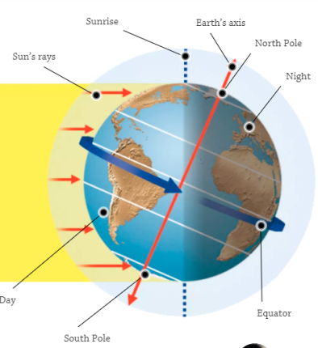  Phases of the moon:  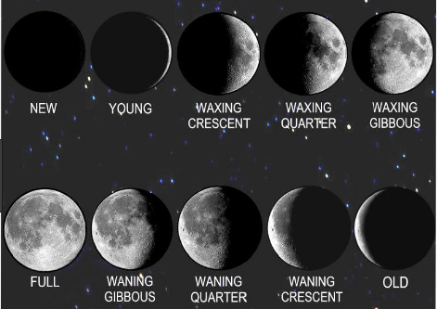  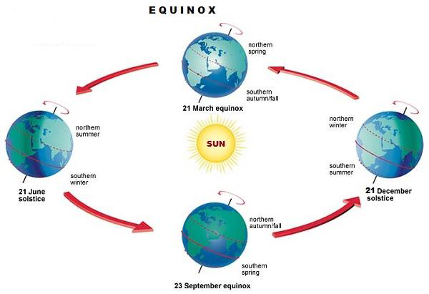
- The solar system:
- The sun is a star and it is at the centre of the solar system.
- The sun is 15 million degrees hot at its centre.
- The sun is 1.3 million times bigger than earth.
- Our solar system has 8 planets.
- Order of planets from the sun:
- Mercury, Venus, Earth, Mars, Jupiter, Saturn, Uranus, Neptune
- Moon:
- The moon moves around the Earth in an approximately circular orbit
- Going once around the Earth in approximately 27.3 days
- As it orbits the earth its position changes, relative to the stars.
- Phases of the moon:
- Waning means the moon looks like it is getting smaller.
- Waxing means the moon looks like it is getting larger.
- How much of the moon we see, depends on how much sunlight is hitting it. The moon reflects this sunlight.
- Scientists who have worked on the model of the solar system:
- Ptolemy, Alhazen, Copernicus
Websites:
https://www.bbc.com/bitesize/topics/zkbbkqt

