UKS2 Electricity (Year 6)
Prior Learning: series and parallel are two types of circuit, the current in a circuit can vary
P.O.S – Electricity
Concept – physics - energy transfer
Facts | Vocabulary
- Voltage:  - the difference in electrical energy between two parts of a circuit.  - measured in volts  - the bigger the voltage, the bigger the current. | - Cell - Old French celle or Latin cella ‘storeroom or chamber’
- Current:  - the amount of electricity flowing through the circuit (a flow of electrons moving in a loop in the circuit).  - measured in amps. | 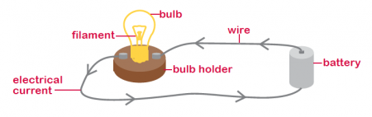  Simple circuit  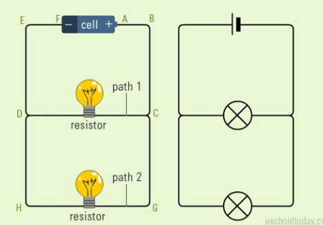  Parallel circuit  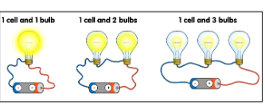  Cells and bulbs  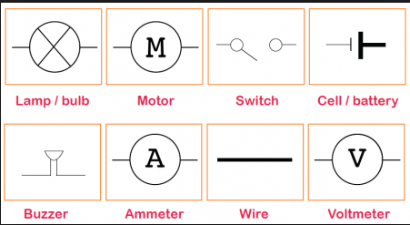  Circuit symbols
- Simple electrical circuit:
- The battery pushes the electricity along the wires from the positive terminal, through the bulb and back to the negative terminal. This creates a circuit.
- To turn out the light, the circuit needs to be broken by adding a switch. It does not matter where the switch goes as the effect is the same.
- The bulb glows because electricity flows through the filament.
- Variations in how components function:
- More cells and voltage through a circuit the brighter (bulb) or louder (buzzer)
- Less cells and voltage through a circuit the dimmer (bulb) or quieter (buzzer)
- If you make the wires longer, the bulb will get dimmer. This is because there is more resistance.
- If you add more batteries, the bulbs will get brighter. This is because there is less resistance and a greater current.
- Parallel circuit:
- There is more than one resistor (bulb) and they are arranged on many paths.
- These are found in most homes and devices. Because it provides more than one way for a current to flow through to a device.
- Websites:
https://www.bbc.com/bitesize/topics/zq99q6f

