UKS2 Living things and their habitats (Year 5)
Prior Learning: An environment is a system which can be harmed
P.O.S – Living things and their habitats
Concept – Biology- cell development
Facts | Vocabulary
- A life cycle is the different stages of life for a living thing  - Metamorphosis - a process some animals go through to become adults. It is a series of physical changes | - Habitat - Latin habitare meaning "to live or dwell," which itself goes back to habere meaning "to have or own."  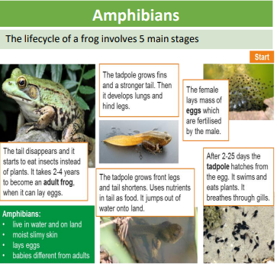
- Stages of a Life cycle . Typically there are 4 stages:  - birth , growth , reproduction, death | 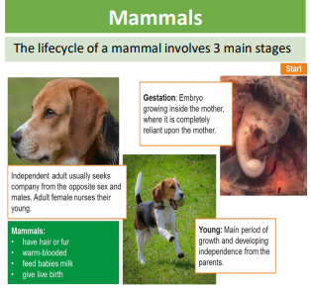  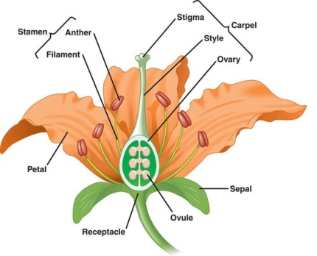  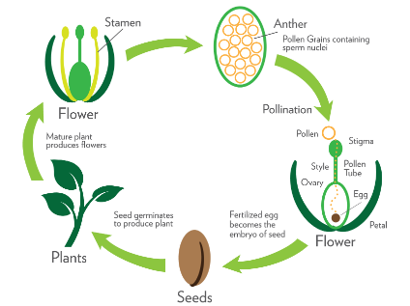  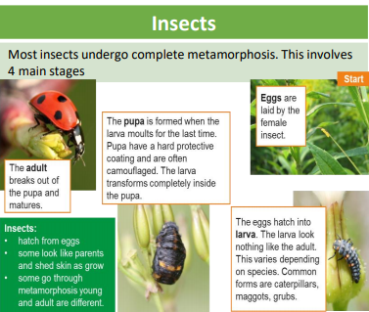
- Life cycle of a mammal:
- Live young born and get milk from mothers
- Grow from babies to adults
- Reproduce
- Die
- Life cycle of an amphibian:
- Egg in jelly laid in water
- Develops tail and legs
- Grows lungs to breathe and leaves water
- Takes 2 years to grow to adult size
- 5. Life cycle of an insect:
- Eggs laid by the female insect.
- Larva – Eggs hatch and larva is born. It sometimes looks different to the adult self
- Pupa – When the larva moults for the last time, a pupa is formed. It acts as a camouflaged, protective shell for the larva to transform
- Adult – The adult breaks out of the pupa and matures.
Some insects only have a 3 stage: The insect is born as an egg, hatches as a nymph and changes into an adult.
- Life cycle of a bird:
- Egg
- Hatches and is fed by the parents
- Juvenile– leaves the nest when flight feathers are grown
- Adult attracts mate to reproduce
7. Reproduction in plants:
a) the production of new offspring in plants
b) Sexual reproduction involves pollen from one flower fertilising the egg of another to produce a seed.
c) Only one parent is needed in asexual reproduction and the offspring are exact copies.
Websites:
Life cycles:
https://www.youtube.com/watch?v=dyZjCw5Rl2Y
https://www.youtube.com/watch?v=AMs3waaW75g
https://www.youtube.com/watch?v=7AUeM8MbaIk
Plants:
https://www.youtube.com/watch?v=4zCAtCI-J8w
https://www.youtube.com/watch?v=2ycl2E9r-_o
https://www.bbc.com/bitesize/articles/zyv3jty

