UKS2 Evolution (Year 6)
Prior Learning: All living things are made up of cells
P.O.S – Evolution
Concept – biology – cell development
Facts | Vocabulary
- Definition of evolution:  - a change in the characteristics of living things over time.  - It happens when there is competition to survive (natural selection)  - It also happens when there are differences within a species caused by inheritance and mutations. | - Evolution - from Latin evolutio(n- ) ‘unrolling’  - Fossil - Latin fossilis ‘dug up’
- Definition of inheritance:  - is when something is passed on to the next generation.  - Offspring are not identical to their parents and some characteristics are inherited  - other differences are new in the offspring – these are called mutations | Evolution:  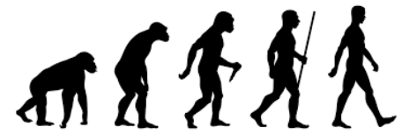  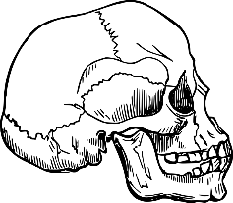  Human skull  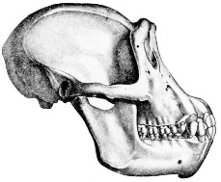  Chimpanzee skull  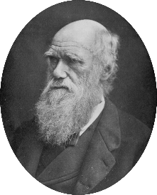  Charles Darwin  (1809 – 1882)
- Fossils:
- provide information about living things that inhabited the Earth millions of years ago
- When palaeontologists compare fossils to animals from today, they can see similarities and identify relationships between them.
- evolution of a species happens over such long periods of time, evidence is usually taken from fossils.
- Adaptation:
- the action or process of adapting or being adapted
- is a way an animal's body helps it survive, or live, in its environment.
- animals depend on their physical features to help them obtain food, keep safe, build homes, withstand weather, and attract mates and will adapt to survive
- Adaptation leading to evolution:
- Evolution by natural selection, organisms that possess heritable traits that enable them to better adapt to their environment compared with other members of their species will be more likely to survive, reproduce, and pass more of their genes on to the next generation
- Animals and plants that have adapted to their environment:
- camel has humps of fat storage to use up for energy in the dry desert when there is a shortage of food.
- polar bear has camouflaged itself against white snow/ice so it can hunt without being seen.
- cactus stores water to help keep it alive in the desert.
- Scientists linked to evolution:
- Mary Anning – English palaeontologist known for fossil finds in Dorset
- Charles Darwin - English scientist best known for his theory of evolution. His book ‘Origin of the Species’ was released in 1851 and was controversial because it went against the creation story in the Bible.
Websites:
https://www.youtube.com/watch?v=T0B6os-6uuc
https://www.bbc.com/bitesize/topics/zvhhvcw

