UKS2 forces (Year 5)
Prior Learning: Force is strength or energy as an attribute of physical action or movement and a mechanism is a system of parts working together.
P.O.S – Forces
Concept – Physics - forces
Facts | Vocabulary
- Definition of a force:  - A force is any interaction that, when unopposed, will change the motion of an object | - Force - Middle English: from Old French force (noun), forcer (verb), based on Latin fortis ‘strong’.
- The action from a force can cause an object to:
- move or speed up (accelerate)
- to slow down (decelerate)
- to stop
- to change direction.
- Types of forces:  - Gravity - the force by which a planet or other body draws objects toward its centre. The Earth’s gravity is what keeps you on the ground and makes things fall.  - Air resistance - describes the forces that are in opposition to the motion of an object as it passes through the air thus slowing the object down.  - Water resistance – A force that is cause by water with the force acting in the opposite direction to an object moving through the water.  - Friction - the resistance that one surface or object encounters when moving over another. | Gravity  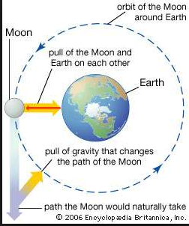  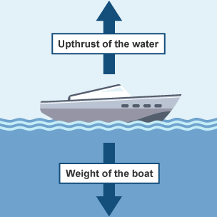  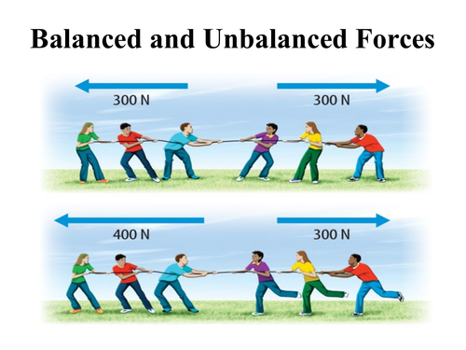  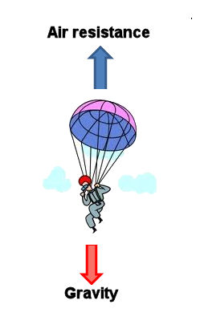
- Balanced and Unbalanced forces:
- Balanced forces do not cause a change in motion.
- Unbalanced forces cause a change in the motion of an object .
- Simple machines that allow a smaller force to have a greater effect:
- A lever - a rigid bar resting on a pivot, used to move a heavy or firmly fixed load with one end when pressure is applied to the other.
- A pulley - a wheel with a grooved rim around which a cord passes, which acts to change the direction of a force applied to the cord and is used to raise heavy weights.
- A gear - a toothed wheel that works with others to alter the speed of a driving mechanism and the speed of the driven parts
6. Unit of measurement for forces:
- Newtons (N)
7. Scientists who helped develop gravitational theory:
- Galileo Galilei
- Isaac Newton
Websites:https://www.bbc.com/bitesize/topics/znmmn39
https://www.schoolsofkingedwardvi.co.uk/ks2-science-year-5-5b-forces-gravity/
https://www.schoolsofkingedwardvi.co.uk/ks2-science-year-5-5c-forces-simple-machines/

