UKS2 Living things and their habitats (Year 6)
Prior Learning: An environment is a system which can be harmed
P.O.S – Living things and their habitats
Concept – biology – cell development
Facts | Vocabulary
- Definition of classification:  - the arrangement of animals and plants in groups according to their observable characteristics | - Classify - which means "category" and comes from the Latin classis, which actually referred to an army or group called to arms. It eventually came to mean "a group," and thus classify means "to group."
- Carl Linnaeus:  - simplified the naming of living things in 1735.  - he gave them a two-part (binomial) name.  - It was a mixture of genus and species (and in Latin) e.g. Human was Homo Sapien | 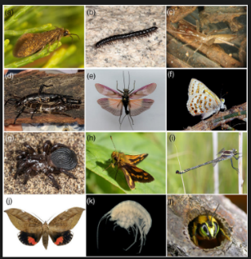  Invertebrates: vertebrates:  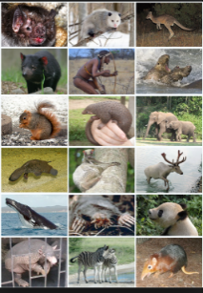  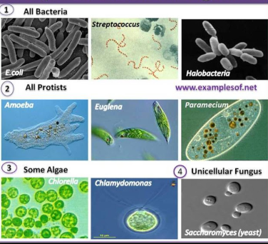  Micro-organisms:
- Classification groups:
- Invertebrates – insects, arachnids, snails, worms
- Vertebrates- reptiles, fish, amphibians, birds, mammals
- Plants -Non-flowering and flowering
- Micro-organisms- Bacteria, fungi (yeast and mould) viruses, algae, protists
- Definition of micro-organism:
- An organism which is microscopic, making it too small to be seen unaided by the human eye
- Bacteria:
- are single celled organisms
- come in all sorts of shapes including rods, spirals and spheres
- Funghi:
- have complex cells like animals and plants
- get food by decomposing matter
- Viruses:
- Do not have an organised cell structure
- Can infect animals and plants and make them sick
- Algae:
- are protists that perform photosynthesis
- are very similar to plants but don’t have leaves, roots and stems
- Protists:
- Are any other organism that is not a plant, animal, bacteria or funghi
- Useful micro-organisms:
- in dairy products to make butter, cheese and yoghurt
- used to make bread
- in sewage treatment
Websites:
https://www.bbc.com/bitesize/topics/z6wwxnb

