Year 1 History- Lewis Carroll
POS: Significant historical events, people and places in their own locality
Prior content: Significant events in their own lives.
Facts | Vocabulary
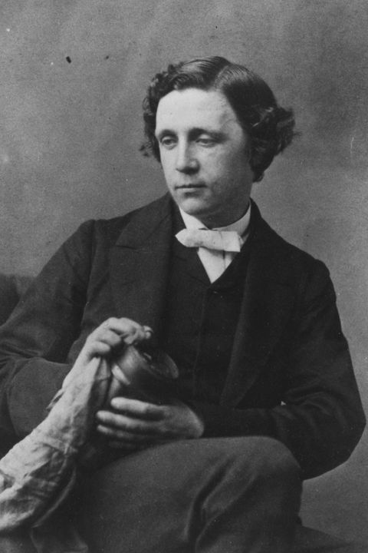  - Lewis Carroll  - Real name Charles Dodgson  - Born 17th January 1932 in Daresbury Park  - Died 14th January 1898 aged 65  - 7 sisters  - 3 brothers | - Author – The writer of a book or article  - Deacon- A minister  - Published- Prepare and issue  - Church- A building for worship  - Significant- Important and worth attention  - Famous—Known about by many people
- Significant events
- 1846- attended boarding school
- 1851- enrols at Oxford University
- 1854- Graduates with a degree in Mathematics
- 1856- Becomes a photographer
- 1856- Given the pan name Lewis Carroll
- 1861- Becomes a Deacon
- 1862-Invents ‘Alice’
- 1865- ‘Alice in Wonderland’ is published.
- 1871- ‘Through the Looking Glass’ is published.

- Alice in Wonderland Characters  - Alice- A real girl named after his bosses daughter  - Dodo- Based on his own name ‘Dodgson’  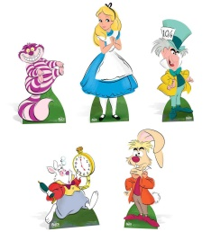  - Cheshire Cat- Climbed a tree at his home in Oxford  Other key characters  - The White Rabbit  - The Dormouse  - Tweedledee and Tweedledum  - Mad Hatter  - Queen of hearts | 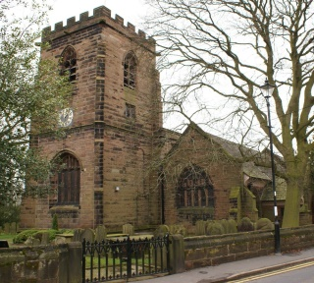  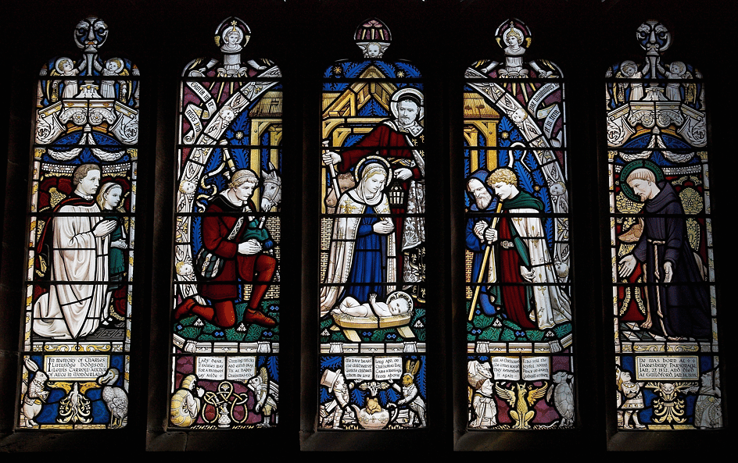  Stained glass windows in Daresbury Church
- Through the Looking Glass
- A sequel to Alice in Wonderland

- Daresbury Church
- White rabbit- Statue in the grounds
- Stained glass windows- Alice in Wonderland characters
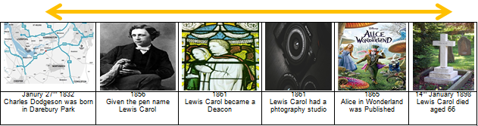
- All Saints Lewis Carroll Centre inside the church to celebrate his life.
- Bookshop- Selling Lewis Carroll souvenirs.
Warrington links:

Mad Hatter Monument in the Golden Square
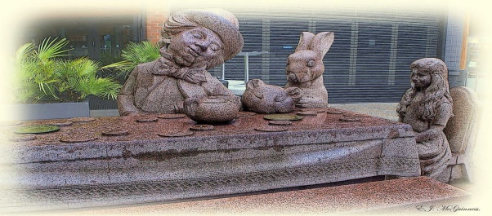

Texts:
Alice in Wonderland 1856
Through the Looking Glass 1871

