Year 1 History- Shops
POS: Changes within living memory and the changes in National life
Prior content : Significant events in their own lives. Changes over time from baby to adult.
Facts | Vocabulary
- Timeline Past, present and future in their own lives  - Past- Gone with time  - Present- Existing an occurring now  - Future- Time still to come. | - Past – Gone with time  - Present – Existing and occurring now  - Future- Time still to come  - Chronology- Events in date order  - Material- That something can be made from  - Manufacture- How something is made  - Grocery- Items of food  - Significant- Important and worth knowing  - Difference- A way in which things are dissimilar
- Chronology-
- Events in date order from when the occurred
- Oldest- youngest
- Old-New
- Types of Shops  - Butcher- Sells fresh meat  - Baker- Sells fresh bread and cakes  - Fishmonger-Sells fresh fish  - Haberdashery- Sells items for clothing  - Toy shop- Sells all types of toys  - Flea market- Stalls selling furniture, clothes and ornaments  - Chemist- Sells medicines and toiletries  - Supermarket- A large shop selling food, clothing, household goods.  - Greengrocer- Sells fresh fruit and vegetables | 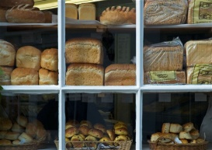  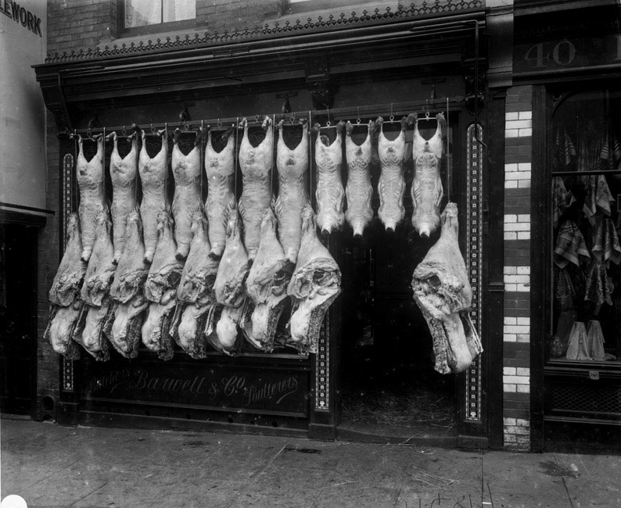  Butcher’s Bakery  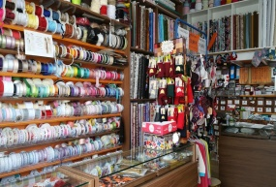  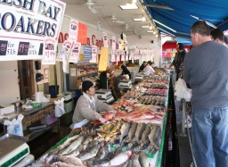  Fishmonger Haberdashery  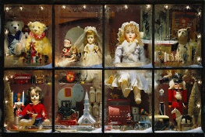  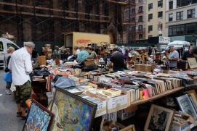  Toy Shop Flea Market  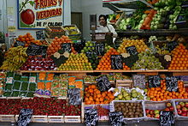  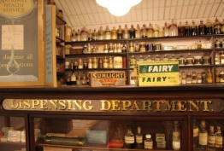  Chemist Greengrocer  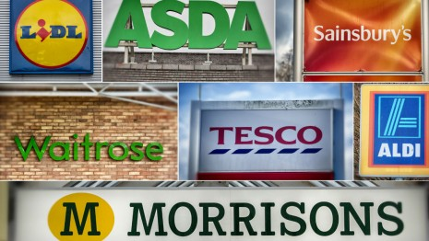  Supermarket
- Transport- Taking something or someone from one please to another
- Past- Horse and cart, bicycles, ships
- Present- Cars, bus, aeroplane,

- Toys old and new
- Materials- what toys are made from.
Old- wood, tin, lead, china
New- Plastic, rubber, foam,
- Manufacture- how they are made
Old- Handmade
New- Factories
Warrington links:

Development of Golden Square Shopping centre.

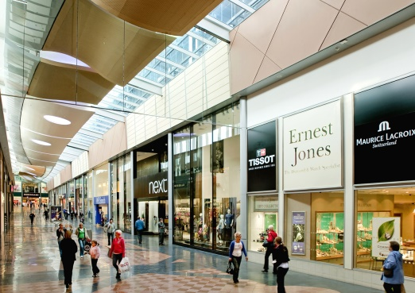

Texts:
Shopping in Grandmas Day- Valerie Webber 1999
Shops an shopping, sense of History- Gail Durbin 1991

