Year 2- History – Christopher Columbus
POS: The lives of significant individuals in the past who have contributed to national and international achievements
Prior content: Changes within living memory- Y1
Facts | Vocabulary
- Facts about Christopher Columbus  - He was born in 1451 in Italy  - He was the son of a wool merchant  - He got his first job on a merchant ship in 1476, until his ship was attached by pirates  - He floated on a scrap of wool and ended in Lisbon  - He studied mathematics, astronomy, cartography and navigation | - Explorer- A person who explores a new area  - America- the 3rd largest country  - Asia- A continent  - Europe-A continent  - Sail- To travel in a boat  - Christianity- A religion based on Jesus Christ  - Slavery-Working hard without proper appreciation  - Atlantic-A coast  - Voyage- A long journey involving travel by sea or space.  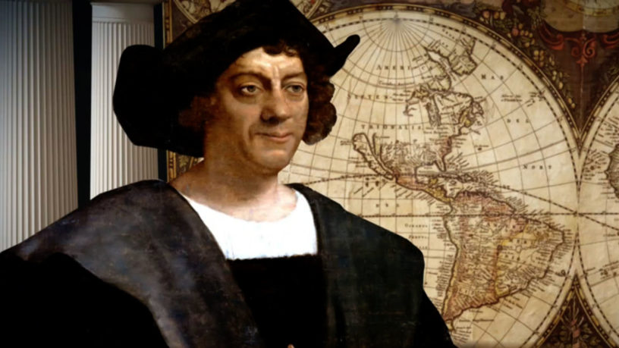  Christopher Columbus
- Voyages

- 1465- 1st sea voyage aged 14
- 1492- 2nd voyage to America to find all water route to Asia
- 1498- third sea voyage to South America Mainland
- 1502- final sea voyage to Central America
- Ships

- The Nina
- The Pinta
- The San Maria
- Funding

- King Ferdinand
- Queen Isabella
- Impact on Britain  - Benefits from the ‘New World’  - New food and material can be imported from America | 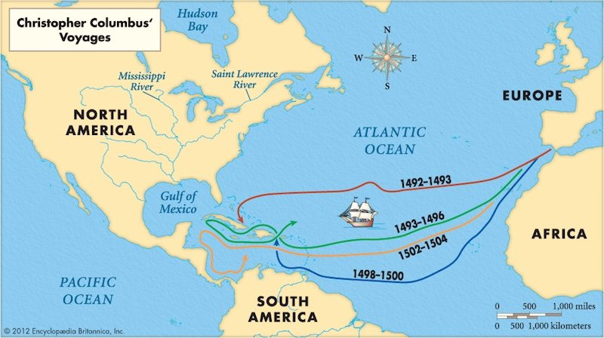  3 Voyages  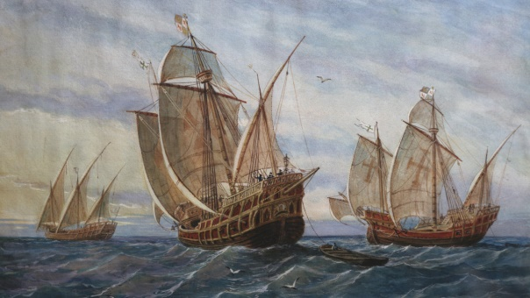  Nina Pinta San Maria
