Year 5 Global Trade – (Central America)
Context:
Central America is in North America. North America is one of the seven continents of the world.
Concepts:
Place, space, environment, interconnection, scale, change

Facts | Vocabulary
1.Central America is in North America, it is a large isthmus, or land bridge between North and South America. | Isthmus – a narrow strip of land with sea on either side, forming a link between two larger areas of land.
2.Central America consist of seven countries Belize, Costa Rica, El Salvador, Guatemala, Honduras, Nicaragua and Panama.
3.The major cities in Central America are Guatemala City, Panama City, San Jose, Managua, | World Countries  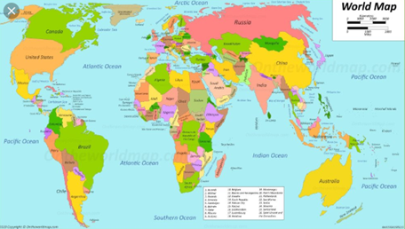  Central America  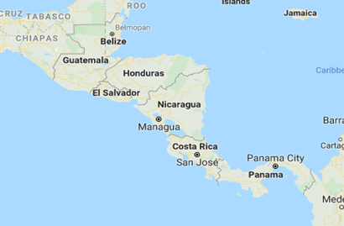  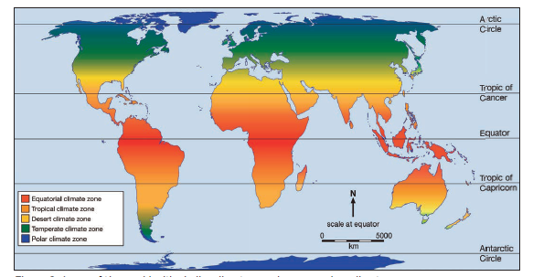  Climate Zones – tropical climate zone  https://www.fairtrade.org.uk/what-is-fairtrade/where-fairtrade-works/  https://mocomi.com/tropics-of-cancer-and-capricorn/  https://online.seterra.com/en/vgp/3015  https://www.educationquizzes.com/ks2/geography/
4.Physical Features of Central America
The Pacific Ocean lies to the southwest, the Caribbean Sea lies to the northeast, and the Gulf of Mexico lies to the north.
Longest mountain ranges within Central America, Sierra Madre de Chiapas, Cordillera Isabelia and Cordillera de Talamanca.
Highest peak Volcán Tajumulco
5.Human Features of Central America
Between the mountain ranges lie fertile valleys that are suitable for the raising of livestock and for the production of coffee, tobacco, beans and other crops. Most of the population of Honduras, Costa Rica and Guatemala lives in valleys.
Globalisation the process by which businesses or other organizations develop international influence or start operating on an international scale.
Fair trade is an arrangement designed to help producers in developing countries achieve sustainable and equitable trade relationships. Members of the fair trade movement add the payment of higher prices to exporters, as well as improved social and environmental standards
Climate zones divide the world into areas with similar patterns of average temperature and precipitation
Biomes demonstrate diversity of flora and fauna
Vegetation belt: refers only to plants found in the specific location
6. Places to the north of the equator lie in the northern hemisphere. The northern hemisphere has much more land and contains three continents: Asia, Europe and South America.
7. Places to the south of the equator lie in the southern hemisphere.
The southern hemisphere has the Antarctic ice sheet and the tiny tropical islands of Oceania.
8. An imaginary grid centred on the equator and poles enables people to define their location.
Lines of Latitude measure distance in degrees north or south of the equator. They run parallel which means they never meet.
Lines of Longitude measures distance in degrees east or west of the prime meridian.
9. The Prime Meridian is the line of longitude which goes through Greenwich and from which time is measured.
10. The Tropic of Cancer is the most northerly circle of latitude on Earth at which the Sun can be directly overhead. The Tropic of Cancer is located at around 23.5° North of the equator and runs through Mexico, the Bahamas, Egypt, Saudi Arabia, UAE, Oman, India, and southern China.

The Tropic of Capricorn is the southernmost latitude on Earth at which the Sun can be directly overhead. The Tropic of Capricorn runs through 10 countries: Namibia, Botswana, South Africa, Mozambique, Madagascar, Australia, Chile, Argentina, Paraguay, and Brazil.

