Year 5 Resources Sustainable Development Goals
Context:
The 2030 Agenda for Sustainable Development, adopted by all United Nations Member States in 2015, provides a shared blueprint for people and the planet, now and into the future. At its heart are the 17 Sustainable Development Goals (SDGs), in a global partnership
Concepts:
Place, space, environment, interconnection, scale, change

Facts | Vocabulary
1: Resources - any materials or asset humans can make use of | Renewable, resources, energy,
2: Renewable – to not be depleted by use; it won’t
run out
3: Non-renewable – a natural source of energy that  cannot be replenished | 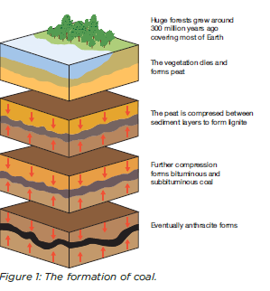Formation of coal  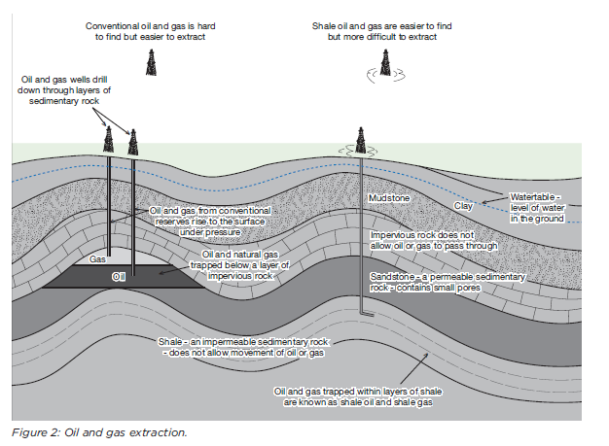  gas extraction  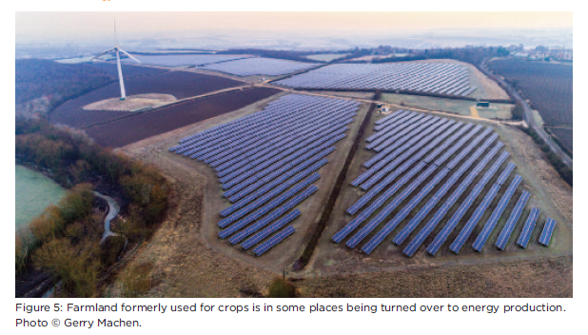  Solar Farm  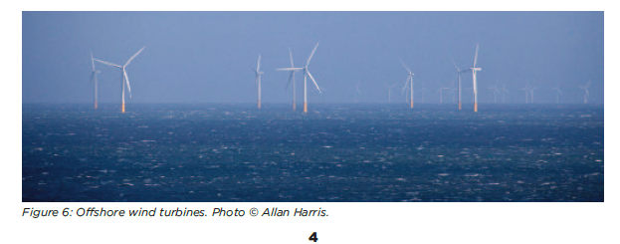  Wind farm
4. Sustainable – able to meet the needs of the
present without compromising the ability of
future generations to meet their needs
5. Reduce, reuse, recycle – a slogan designed to encourage people to protect the environment by reducing waste, finding other uses for it, and recycling it
6. The average UK household throws away £470 worth of food that could have been eaten every year
7. Over 25% of the world’s population
does not have enough food.

8. The NFU have calculated that, if we relied only on
UK-produced food, we’d only have enough food supplies to last until the middle of August each year.

9. 20% of the world’s population use 80% of the energy.

10. The energy saved by recycling 1 plastic bottle will power a computer for 25 minutes.

11. 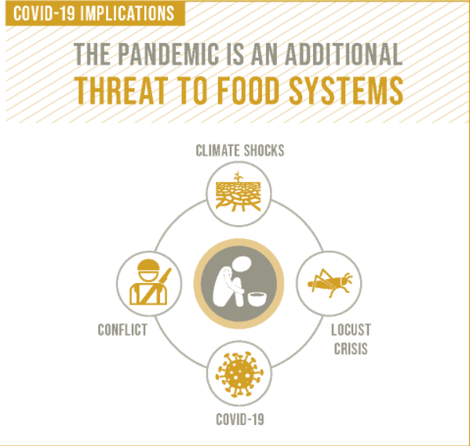
12. 