Y6 WPAT Geography KO: Climate Change :- Our World, Our Responsibility
Context:
Antarctica and polar regions are of immense value to scientists for the study of climate change as it has an important effect on the world's climate and ocean systems
Concepts:
Place, space, environment, interconnection, scale, change ,climate, bimoes

Facts | Vocabulary
Seven-eighths of the world’s polar ice is located at the Antarctic. | 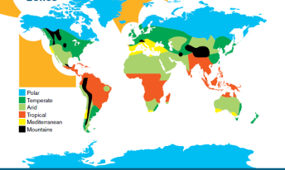  Climate Zones  Rise in emissions  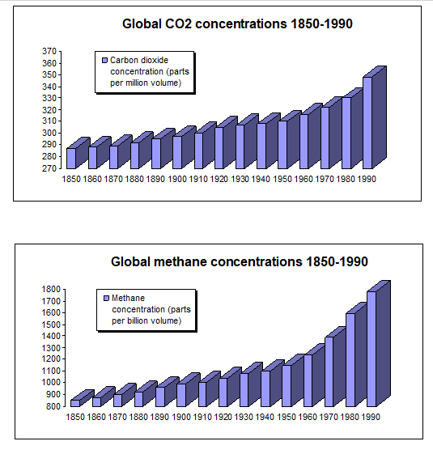  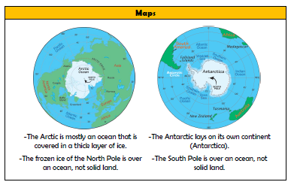  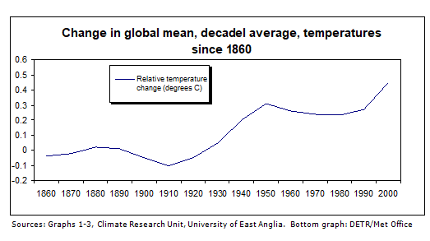
The Antarctic is the coldest place on Earth. The average temperature there is -49°C.

Antarctica is the coldest continent - Russia's Vostok Station recorded the world's coldest temperature of -89°C in 1983. It is also the driest continent with an average annual snowfall of 125mm. It has no permanent inhabitants and it is the most isolated continent.
It is of immense value to scientists for the study of climate change as it has an important effect on the world's climate and ocean systems
The average winter temperature in the Arctic is -34°C. This rises to around 6°C during the summer.

Polar bears are found only in the Arctic, not in the Antarctic; conversely, penguins are found in the Antarctic but not the Arctic.

No land animals are able to live in the Antarctic; only birds, or sea animals that have adapted to the cold, such as penguins and seals, can spend any time on land.

Rising sea level is a danger to people, plants and animals that live near the ocean. The effects could range from frequent flooding and the associated contamination of land, crops and drinking water from the salt, to being completely submerged.

The dying out of coral reefs, and the effects of this loss of food and habitat on a multitude of sea creatures, is attributed in large part to a warming of sea temperature.
The North and South Poles are the axis points on Earth (the Earth spins from these two points).
https://www.nationalgeographic.com/magazine/2018/11/antarctica-climate-change-western-peninsula-ice-melt-krill-penguin-leopard-seal/
https://www.globe.gov/search-results
http://news.bbc.co.uk/cbbcnews/hi/specials/climate_change/default.stm
https://www.wwf.org.uk/get-involved/schools/resources/climate-change-resources
https://climatekids.nasa.gov/menu/teach/
https://www.coolantarctica.com/
https://discoveringantarctica.org.uk/challenges/sustainability/impacts-of-climate-change/

