Year 6 South America
Context:
South America is one of the seven continents of the world.
Concepts:
Place, space, environment, interconnection, scale, change

Facts | Vocabulary
1. South America is the fourth largest continent. Surrounded by the Pacific, Atlantic and Southern oceans. | A biome - a community of animals and plants spreading over an extensive area with a relatively uniform climate  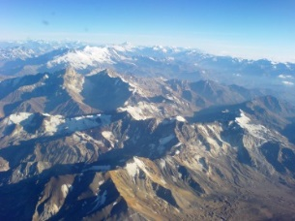  The Andes Mountains  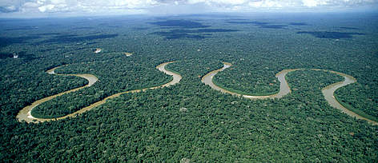  Amazon Rainforest  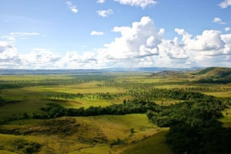  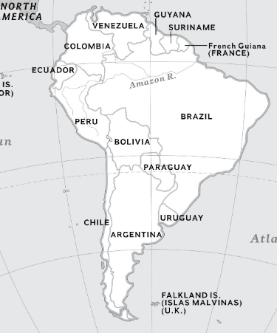  Llanos  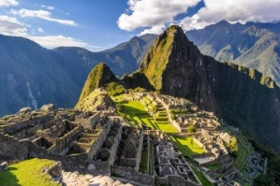  The Inca Trial
2. Made up of 13 countries.
-Argentina, Bolivia, Brazil, Chile, Colombia, Ecuador, Guyana, Paraguay, Peru, Suriname, Uruguay, Venezuela, French Guiana
3.Brazil is by far the largest country. It covers about half the continent and has about half the population.
4.South America is a tropical, wet climate with hot temperatures and heavy rainfall.
5.Since it falls below the equator the seasons are opposite to the UK. Summer is December to February. Winter is June to August.
6.South America can be divided into three physical regions:
-mountains and highlands
-river basins
-coastal plains
Mountains and coastal plains generally run in a north-south direction, while highlands and river basins generally run in an east-west direction.
7. South America Biomes
There are many biomes in South America including:
Alpine biome - Andes mountains.
Tropical rainforest biome - Amazon
Grassland biome – Llanos
8. Physical Geography
-The Andes – longest mountain range in the world, 4,500 miles long.
-Mount Aconcagua – highest mountain in South America, 6,962m high.
-Four main zones of volcanoes – Northern, Central, Southern and Austral.
-Ojos del Salado – tallest volcano in the world, 6,893m high.
-The Amazon – one of the longest rivers in the world.
-Atacama desert – driest place on Earth.
5. Human Geography
-South America’s human landscape is deeply influenced by indigenous and immigrant populations, and their connection to the physical environment.
-The Incan Empire is the most well known indigenous culture of South America. In order to communicate throughout this vast region, the Inca built an expansive network of roads. The Inca built forts, inns, food storage facilities, and signal towers along this impressive “foot highway.”
-There has been an increase in urbanisation in South America. Urbanisation will define the future human geography of South America.
-Urbanisation and industrialisation are also destroying the unique biomes of South America. The Amazon rain forest is being burned at a rate of one acre every second. Trees are harvested for the timber industry, while the plains of the rain forest are turned into ranches, farms, and towns. This development is increasing the amount of air and water pollution in the Amazon basin and elsewhere.

You tube: https://youtu.be/R35URiT_fm8
https://world-geography-games.com/continents/index.html

