Year 2 RE – Christianity Church
Curriculum Aims: In this unit, children should explore the core beliefs and symbols of Christianity. They should know that belief in one God and Jesus Christ unite the Christian community and that the cross is an important Christian symbol. This should build on their previous learning about symbolism contained in the idea of Jesus as ‘the light of the world’.
They should learn about the importance of the church as a place to bring together the community for worship and Christian fellowship. Children should be able to talk about key aspects of worship such as prayer, use of music and readings from the Bible.
Children should also have opportunities to consider why people might want to be part of a community and the shared values and interests that bring people together. They should be able to talk about communities that they belong to and what unites them with others.

Prior Learning: An understanding of why Jesus is believed to be the ‘light of the world’ by Christians.
Facts | Vocabulary
- Beliefs & Values  - Suggest beliefs and values that might unite the Christian community.  - Talk about why some Christians might think it is important to come together to worship God. | God, Jesus, Cross, symbols, unite, Christian community, worship, symbols, church, Pulpit, lectern, alter, pew
- Living religious traditions
- Identify symbols (images and actions) used in Christian worship.
- Talk about how and why symbols might be used in Christianity.
- Identify and describe features of a church.

- Shared human experiences  - Identify signs and symbols in the world around them.  - Talk about the school logo – what values it might represent and how it might unite the school community. | 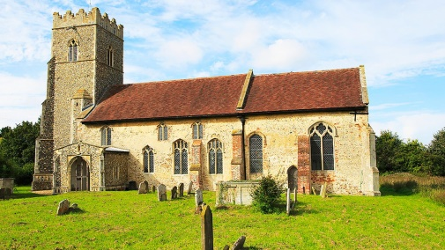  Christian Church  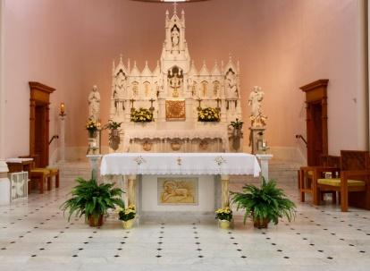  The altar  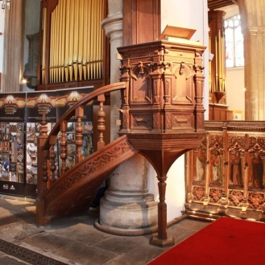  The pulpit
- Search for personal meaning
- Ask thoughtful questions about signs and symbols.
- Talk about communities that they belong to – and how they show their commitment to these communities.

Warrington Links:

Christian churches around Warrington
Texts:
YouTube clip – What is Christian worship?
https://www.youtube.com/watch?v=E5-aKSrLXM4
Enrichment:
- Visit two different churches in the local area – what do they have in common? What is different?
- Visit/video call from a Priest or Vicar to discuss the features of a Church.

