Year 1 RE – Christianity God
Curriculum Aims: This unit enables pupils to explore Christian use of the term ‘father’ to address God, especially in prayer (Our Father…). In Hebrew, the term Abba best translates as ‘daddy’, suggesting a loving and personal relationships with God. Pupils should consider the importance of prayer in Christian life. They should reflect on the human need for loving relationships, comfort and someone to talk to – both in good times and bad
Prior Learning: EYFS celebrations
Facts | Vocabulary
- Beliefs & Values  - To know that Christians refer to God as ‘Father’  - To talk about why Christians might compare God to a loving parent  - A church is the place of worship  - A cross is the symbol | Family, relationship, love, mum, dad, sister, brother, nan, grandad, grandma, stepmum, stepdad, mother, father, Christian, God, Father, Pray, Lord’s Prayer, candles, icons, church, bible, cross, sins/mistakes, The Lost Son, forgiveness, sorry
- Living religious traditions
- To talk about how and why Christians might want to talk to God
- To suggest symbolic meanings of rituals and items used in Christian prayer
- Shared human experiences  - To talk about the importance of love in families  - To talk about the ways in which they are cared for and supported by family members | 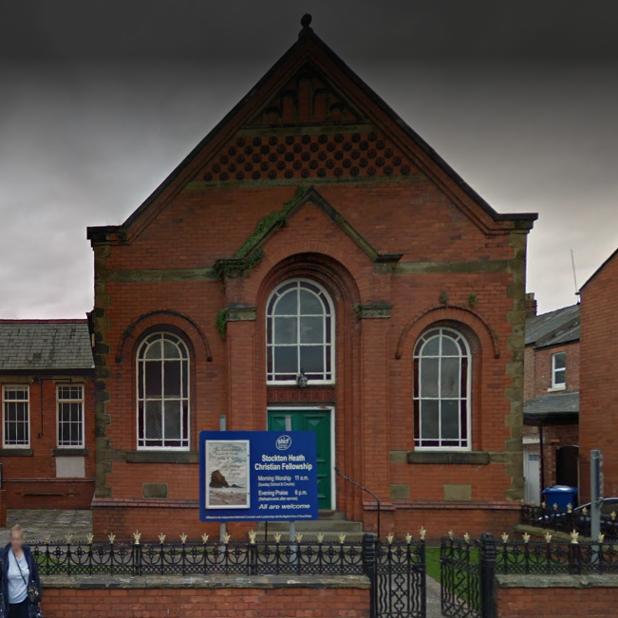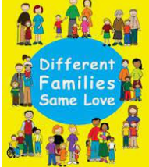  Church Families Cross  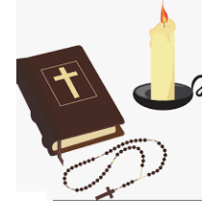  Pray Bible / Rosary Beads/ Candle  Emotions
- Search for personal meaning
- To reflect on their own role within the family
- To discuss who they can talk to when they are happy/sad/worried

Warrington Links :
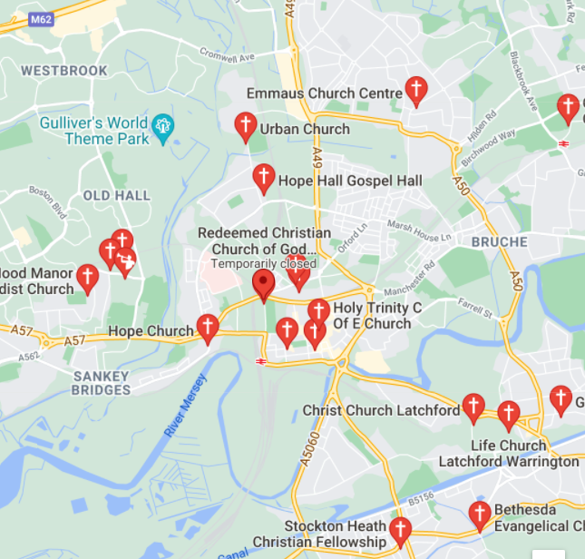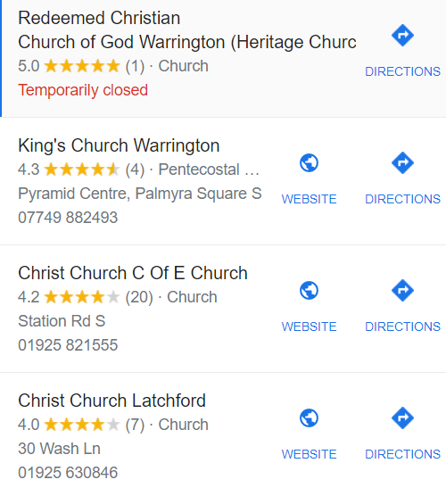

Texts:
The Parable of the Prodigal Son (also known as the parable of the Two Brothers, Lost Son, Loving Father, or of the Forgiving Father)is one of the parables of Jesus in the Bible, appearing in Luke 15:11–32.

https://www.youtube.com/watch?v=uR3sFOfGDAg – The parable of The Lost Son

Enrichment:
- Arrange to visit a church
- Ask a Christian to come into school to talk to children about why they pray.

