Year 2 RE – Christianity God
Curriculum Aims: In this unit, pupils will look at Christian beliefs about God as creator and sustainer, and consider how these beliefs might influence Christian attitudes towards the planet. They should be able to retell the creation account in Genesis 1. Discussions might extend thinking by considering different ways that this story might be interpreted (as literal truth or as a myth containing religious messages). They will explore how Christians might express their beliefs and values through acts of stewardship and/or through harvest festivities.
Pupils should also discuss their own ideas and values in regards to the importance of caring for the planet. They should consider this as a human value, not just a religious one. This is an opportunity to discuss their own concerns about environmental issues and what they can do to make a difference.
Prior Learning: An understanding of God the creator.
Facts | Vocabulary
- Beliefs & Values  - Retell (simply) the Genesis 1 story of creation.  - Suggest why Christians might think it is important to look after the world. | Christianity, God, creation, Genesis 1, Bible, worship, Harvest, creator, sustainer, stewardship, hymn, charity.
- Living religious traditions
- Suggest ways that Christians might express their concern for the natural world.
- Describe how and why Christians might thank God for creation at Harvest festivals.
- CAFOD – a Christian organisation. One of its aims is to create a ‘common home’.
- Harvest – an important time for Christians to give thanks to God for all of the food and good things that He provides.

- Shared human experiences  - Identify ways in which humans use (and abuse) the natural world.  - About why out planet should matter to all humans – and how this should influence our behaviour. | 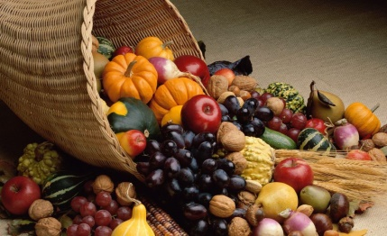  Harvest  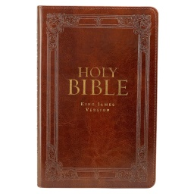  The Bible  CAFOD
- Search for personal meaning
- Reflect on their own use of the world’s resources.
- Ask questions about what they can do to show that they care about the world.

Warrington Links:
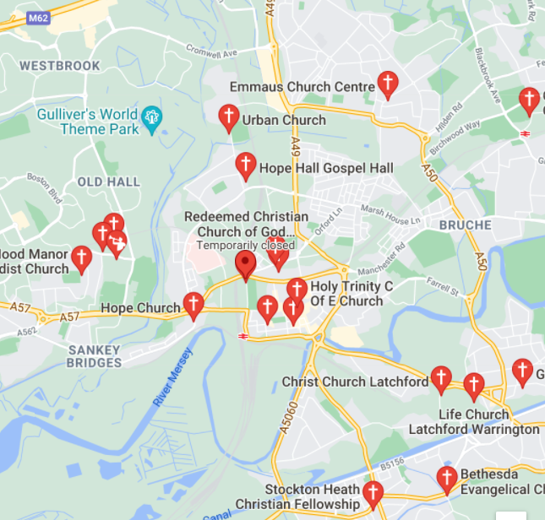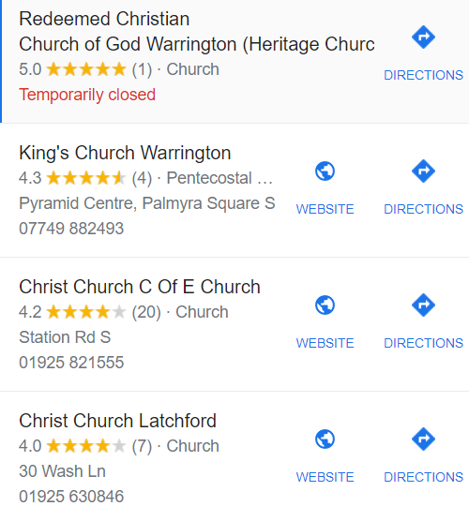

https://cafod.org.uk/Campaign/Climate

Texts:
Listen to a children’s version of Genesis 1 eg. http://www.dltk- bible.com/genesis/chapter1-cv.htm or https://www.youtube.com/watch?v=yZ1Fd_SPC18

Enrichment:
- Contact a CAFOD volunteer to talk to the children about the work they do.

