Year 2 RE – Christianity Jesus
Curriculum Aims: This unit enables pupils to explore the use of light to and how it might be used in religious communities to indicate the presence of God and as a description for Jesus as God incarnate. Pupils should be able to make links between the imagery and symbolism of light in the Christian context and significant events in their own lives.
This unit should build on the Y1 unit ‘Why is Jesus special to Christians?’ – Pupils should be encouraged to recall information about why the birth of Jesus is important to Christians and why Jesus is seen as a gift to the world.
Prior Learning: An understanding of why the birth of Jesus was important and why he is seen as a gift to the world.
Facts | Vocabulary
- Beliefs & Values  - Suggest what Christians might mean when they refer to Jesus as the ‘Light of the World’.  - Talk about the different titles that might be given to Jesus – Christ/ Messiah/ Saviour/ Son of God | Jesus, Advent, Christmas, preparing, Christingle, Advent wreath, symbols, light, dark, Bible.
- Living religious traditions
- Identify ways in which Christians might use light as part of their Christmas celebrations (advent candles, candle-light carl services, Christingle) – and the symbolic meaning.
- Talk about the different ways that Christians might celebrate Christmas.

- Shared human experiences  - Identify different ways that humans use light.  - Discuss the importance of light – as a source of comfort, security and hope.  - Talk about how and why light might be an important symbol. | 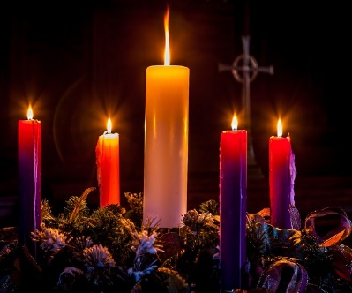  Advent  Christingle
- Search for personal meaning
- Ask questions about the value of sources of light in their own lives.
- Talk about the people who provide comfort, security and hope for them.
- Suggest ways in which they might be a light for others.

Warrington Links:
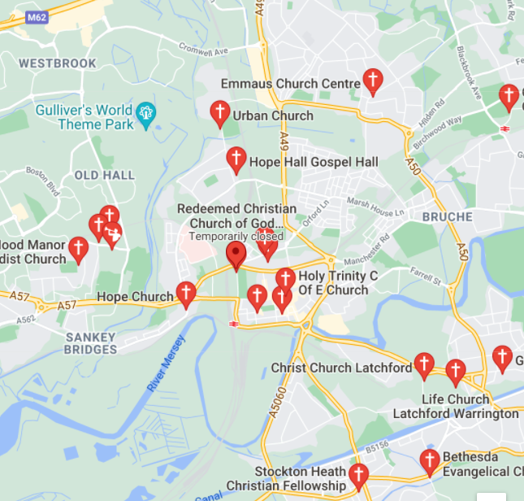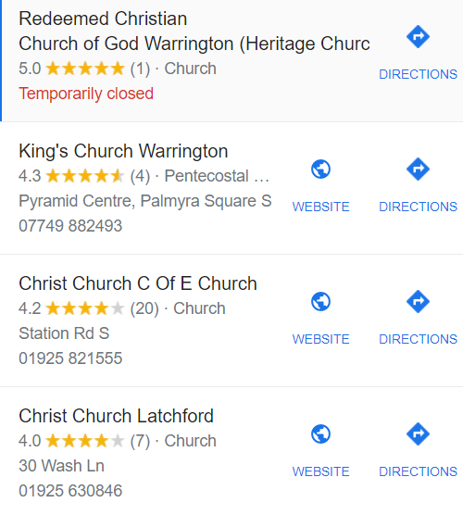

Texts:
Bible – John 1:4-5 – Jesus is referred to as a light of the world many times throughout the Bible. One of the most famous is “In him was life, and that was the light of all mankind. The light shines in the darkness, and the darkness has not overcome it.”
Enrichment:
- Christingle festival/fundraiser
- Visit Advent displays at places of worship

