Year 5 RE – Christianity Jesus What do we mean by a miracle?
Curriculum Aims: This unit enables pupils to explore what the Christian belief in Jesus as ‘fully human and fully divine’ means. They will build on their prior learning about the incarnation and to consider why some people regard the miracles of Jesus as signs of his divine nature. They might also reflect on what miracles such as healing the sick and feeding people reveal about the humanity of Jesus.
Pupils should have opportunities to discuss why some people believe in miracles and why others do not. In the context of Christianity, they should understand the importance for many Christians, of believing in the possibility of miracles and in belief in the resurrection of Jesus.
Pupils will investigate why some Christians might want to travel to a place associated with a miracle. They should reflect on the impact of bringing beliefs to life by standing in the place where an important event is believed to have happened. They should consider the meaning of the word faith and the experiences that might strengthen the faith of a believer.
Prior Learning: In year 4 children will have explored Christianity Jesus and they will have had opportunity to retell the story of Jesus in the wilderness & identify beliefs about Jesus reflected in this story. Children will have suggested why sacrifice might be an important Christian value. Children will have explained what is meant by sacrificial love – agapé & discussed Christians examples and motivations.
Facts | Vocabulary
- Beliefs & Values  - To describe Christian beliefs about miracles as ‘signs’ of the divinity of Jesus  - To retell a selection of miracle stories – and explain what these might reveal to Christians about the nature of Jesus | Christian, fully human, fully divine, incarnation, miracles, resurrection, pilgrimage, power, prayer, ’signs’ of the divinity of Jesus,
- Living religious traditions
- To describe why some Christians might go on pilgrimage to places associated with miraculous events
- To explain the impact that belief in miracles and the power of prayer might have on a Christian
- Shared human experiences  - To explain the difference between fact, opinion and belief  - To consider differing interpretations of the word miracle – i.e. an amazing event, a very lucky experience, a strange coincidence, an act of God | The Holy land
- Search for personal meaning
- To discuss their own beliefs – is there anything that they accept as truth which others may not agree with?
- To reflect on how they make decisions about what is/is not true
Warrington Links :

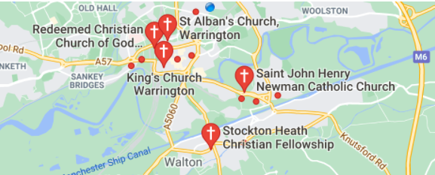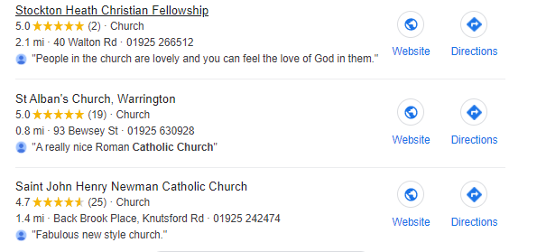

Texts:
Show video clips of pilgrimage to the holy land
https://request.org.uk/life/spirituality/pilgrimage
https://www.youtube.com/watch?v=yEtR2ouw76c
Play a suitably adapted version of ‘I believe and I care about’ game with class : https://www.uua.org/re/tapestry/children/welcome/session14/119826.shtml
Show the video clip from the insurance advert; https://www.youtube.com/watch?v=NZEFpTuK6Ks
Ask pupils if we need to see something in order to believe it.
Enrichment:
- Arrange a visit to church to speak to the priest about miracles and perhaps read/discuss stories from the Bible.
- Invite a visitor into school to discuss miracles and believing.
- Hold a cohort debate / send questionnaire home to get opinions about miracles.

