Year 5 Religious Education and World Views – Where can we find guidance about how to live our lives?
Christianity Church: How do people decide what to believe?
Curriculum Aims: Explore Christian beliefs and teachings contained in the Apostle’s Creed and how shared beliefs unite the world-wide Church. Recognise the idea of one God in Trinity and be able to explain the role of each person of the Trinity. Explain these concepts using subject specific vocabulary and make connections between beliefs, teachings and practices. Pupils will begin to explore diversity within Christianity by looking at differences in worship. They should consider different ideas about diversity within a community – and the importance of being respectful of difference. Explore the question of how people can live together well in modern Britain – and the value of being united in diversity.

Prior Learning: Pupils should know that there is one worldwide Christian community - the Church – but that there are many types of Christians and churches that belong to this
Facts | Vocabulary
Beliefs & Values  - God in Trinity is the belief that God is three separate persons but is still a single God.  - The trinity is:  - God the Father - the creator and sustainer of all things  - God the Son - the incarnation of God as a human being, Jesus Christ, on Earth  - God the Holy Spirit - the power of God which is active in the world, drawing people towards God  - The Apostles’ Creed – This expresses and makes clear the most important Christian beliefs, including the nature of God. The congregation often recites them during acts of worship, usually standing. The Apostles’ Creed is accepted by Catholics and Protestants. | The Trinity – The three parts of God in Christianity.  Denominations – The different branches of Christianity.  Ecumenical – bringing together the different branches of Christianity.
Living religious traditions
- The Trinity is represented through a range of symbols which can explain and describe it.
- These symbols unite Christians from different denominations.
- Denominations of Christianity – Christianity is the largest of the world religions, with approximately 2.4 billion followers (one third of the world’s population). There are various branches within Christianity, referred to as denominations. The main three are Catholic, Orthodox and Protestant. There are also Anglican, Quaker and Pentecostal, among others. All Christian religions believe in the Trinity.
- Ecumenical – this is a movement to bring together the different denominations of Christianity to focus on their shared values and bring unity to the Church (The Taizé community is an ecumenical monastic order with a strong devotion to peace and justice through prayer and meditation).
Shared human experiences  - Sources of authority are religious texts or bodies responsible for guiding people on how to live. They can be friends and family, conscience, experiences, sacred texts, founders of faith and rules.  - People can interpret and respond to these sources of authority in different ways. | 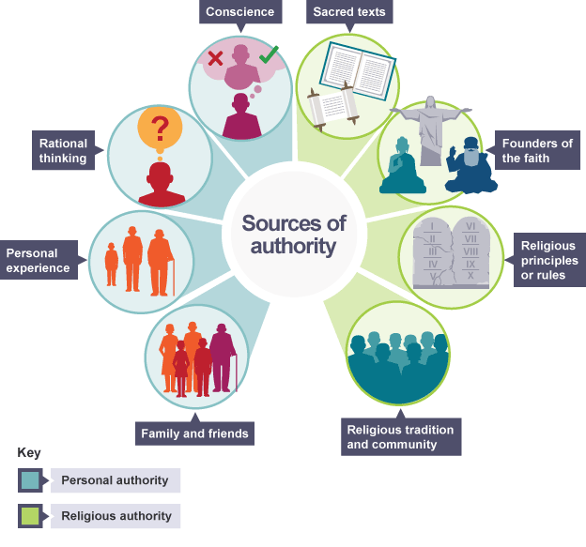  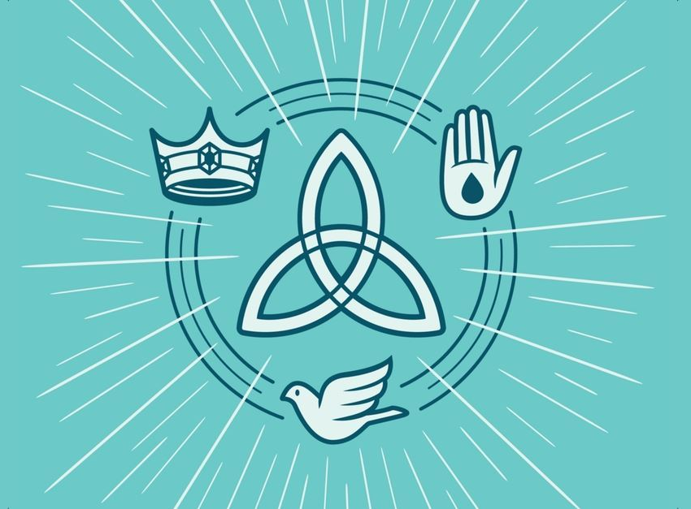
Search for personal meaning
- Some questions can be answered with facts and other through interpretation of sources of authority.
Warrington Links :
Explore a variety of churches locally and search for symbols of the trinity on the outside and inside.
Texts: https://www.youtube.com/watch?v=E5-aKSrLXM4&list=PLcvEcrsF_9zJxDHG9JtcCmiAgwVFRW3uK&index=27

Enrichment:
- Visit churches locally and search for symbols around the building and on objects such as hymn books or information leaflets. Talk to church leaders about their beliefs about the Trinity and Apostles Creed

