Year 2 RE – Hindu dharma
Curriculum Aims: This unit enables pupils to explore the purpose of and some of the practices associated with Hindu worship. The focus includes beliefs about Brahman, family, community and Worship.
Opportunities are provided for pupils to investigate ways that Hindus might express their devotion to God through worshipping the deities. They should know that Hindus believe in one God with many forms and so whichever deity is worshipped, it is ultimately a way of worshipping God.
They should have opportunities to discuss the concept of being devoted to something/someone – and the various ways in which human beings might show their devotion through clothing, special words or songs, rituals and actions.
Prior Learning: An understanding of what Hindus believe about God.
Facts | Vocabulary
- Beliefs & Values  - Know that Hindus believe in one God (Brahman) who can be worshipped in many forms.  - Know that these forms (the deities) have different qualities and are portrayed in different ways.  - Suggest why Hindus might believe that it is important to show devotion to the deities. | Hindu, God, Brahman, worship, qualities, devotion, deities, Mandir, shrine, puja tray, Shiva, Vishnu, Brahma, Lakshmi, Durga, Saraswat, bell, incense holder, incense stick, diva lamp, water pot and spoon, kum kum powder Arti ceremony
- Living religious traditions
- Know that Hindus might worship at a Mandir and /or the home shrine.
- Suggest why worship in the home might be important.
- Describe the meaning and symbolism of items used in worship (e.g. arti lamp, items on the puja tray).

- Shared human experiences  - Talk about qualities that make some people special.  - Identify ways in which humans show their gratitude to the people who matter in their lives. | 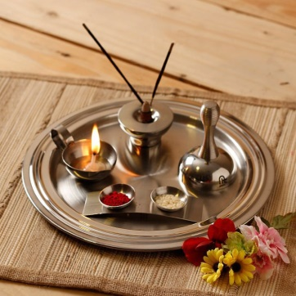  Puja tray  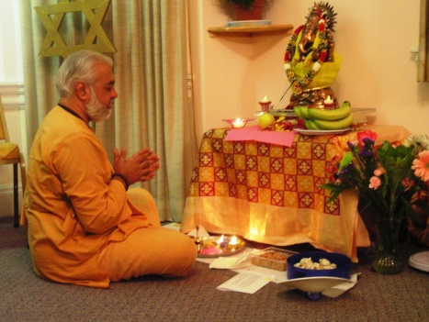  Puja at home
- Search for personal meaning
- Talk about who is special to them and why.
- Reflect on who they should be grateful to and how they might show this in words and actions.

Warrington Links:

Hindu temple in Warrington
Texts:
YouTube clip – Visiting a Mandir (Hindu temple)
https://www.youtube.com/watch?v=o-s0mN5P8jo

Enrichment:
- Visit to a Hindu temple.
- Invite a Hindu to school to demonstrate an arti ceremony.

