Year 4 RE – Hindu dharma
Curriculum Aims: This unit gives pupils the opportunity to revisit the story of Rama and Sita (they will have been introduced to this story in Y3) and to explore the theme of good overcoming evil – just as light overcomes darkness. Pupils should deepen their understanding of Hindu beliefs about God by learning about Rama as an avatar of Vishnu. They should be able to connect this with the Diwali theme – Rama is a deity and therefore represents goodness. As an avatar of Vishnu, it is his role to uphold dharma and fight evil. This is exemplified in the story of Rama and Sita which is celebrated at Diwali. Pupils should know that Diwali is a popular Hindu festival and be able to explain the deeper meaning of festival celebrations such as the lighting of diva lamps, fireworks, decorating homes with rangoli patterns. They should reflect on the symbolism of light within all human cultures, and consider how light might be a universal symbol of goodness and hope.

Prior Learning: Why family is important to Hindu life and the festival of Raksha Bandhan.
Facts | Vocabulary
- Beliefs & Values  - Explore teachings about good and evil in the story of Rama and Sita.  - Describe what moral guidance Hindus might gain from the story of Rama and Sita.  - Make links between the actions of Rama and the belief that he is an avatar of Vishnu, appearing on earth to destroy evil and uphold dharma. | Hindu, Hinduism, good, evil, Rama, Sita, Lakshman, Ravanna, Hanuman, King  Dasharatha, God, Vishnu, Deities, avatar, Diwali, Rangoli patterns, diva lamps
- Living religious traditions
- Use subject specific language to describe how and why Hindus celebrate Diwali.
- Explain the importance of light in the Diwali celebrations, and how this is a symbol of good overcoming evil.

- Shared human experiences  - Discuss (with relevant examples) the importance of the belief that good overcomes evil.  - Suggest people, words or stories that might be inspiring when trying to overcome difficulties in life. | 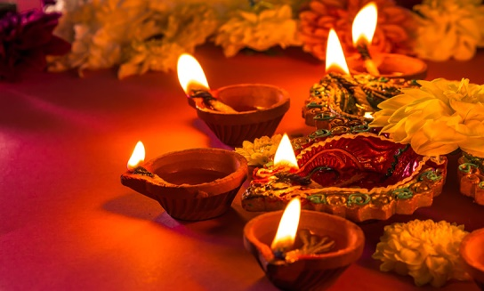  Diva lamps  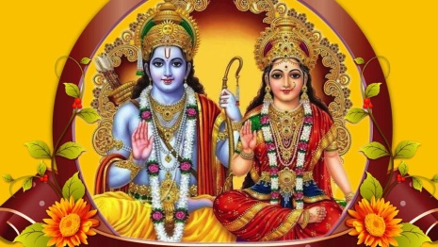  Rama and Sita
- Search for personal meaning
- Reflect on their own concept of ‘goodness’.
- Discuss what gives them hope during difficult times.

Warrington Links:

Texts:
Read/watch the story of Rama and Sita.
https://www.youtube.com/watch?v=jCNNwPaVIaU
Enrichment:
- Invite a Hindu priest or member of the Hindu faith to talk about the meaning behind the story of Rama and Sita and how it impacts their lives.
- Visit the Gujarat Hindu Society in Preston to learn more about the celebration of Diwali.

