Year 5 Religious Education and World Views – Where can we find guidance about how to live our lives?
Hindu Dharma: What might Hindus learn from stories about Krishna?
Curriculum Aims: Examine how Hindu truths are transmitted using stories from revered literature. The focus includes beliefs about Brahman, Vishnu, Avatar (especially Krishna) and Scriptures. Explore some forms of Hindu literature and the beliefs and practices associated with a key story. Consider whether there are links between the ‘truths’ and values revealed in the story and their own beliefs, values and experiences.

Prior Learning: Hindus believe in one God in many forms (Brahman) and that Vishnu is a popular form of Brahman as he is seen as the protector and preserver. One way that Vishnu fulfils this role is through avatars. They will already be aware of one of Vishnu’s avatars (Rama) through learning about Diwali and the story of Rama and Sita.
Facts | Vocabulary
- Beliefs & Values  - Hindu beliefs about devotion and loyalty can be told through stories such as the story of Holi.  - Holi is told through The Story of Prahlad and Holika is a Hindu story in which Prahlad, the son of an evil king, disobeyed his father and worshipped Vishnu. Prahlad’s father planned to kill him. Holika, the king’s sister, tried to kill Prahlad, but the plan failed and Vishnu defeated the evil king.  - The main message of Holi is that devotion to God will be rewarded.  - Krishna is believed to be an incarnation of the God Vishnu. His role on earth is to protect and preserve his devotees.  - Hindus believe that God is present in all people (through the atman) and this impacts them as a believer. | Krishna – an incarnation of the God Vishnu.  Holi – a Hindu festival, also known as the ‘festival of colours’.  Namaste – a respectful greeting.  Atman - refers to a person's 'soul' or 'spirit'. Hindus believe that atman is part of the spirit of Brahman, their ultimate God. Hindus also believe the atman is eternal, meaning it never dies
- Living religious traditions
- Holi is a Hindu festival that celebrates spring, love and new life. It is a colourful festival, with dancing, singing and throwing powder paint and coloured water. It is usually celebrated in March.
- Colour is a huge part of Holi. At Holi, distinctions between people are forgotten. Everyone looks the same when covered in colourful powder. This is a reminder of equality and that all people are believed to contain the energy of Brahman.
- The way Holi is celebrated in the UK can be different from how it is celebrated in India.

- Shared human experiences  - Festivals and celebrations (such as Holi) can be used to pass on values, guidance and traditions  - Hindus use stories and myths to explain ‘truths’ about their beliefs and values. | Holi  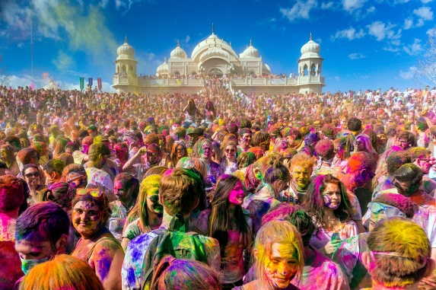
- Search for personal meaning
- There can be different types of truth e.g. empirical truth, historical truth and
Warrington Links :
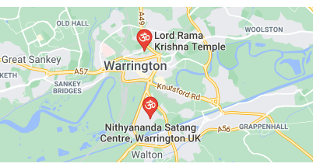
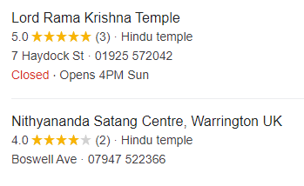

Texts:
https://www.youtube.com/watch?v=3si_OQBwSEc
https://www.bbc.com/teach/class-clips-video/religious-studies-ks2-ks3-my-life-my-religion-hinduism-holi-spring-festival/zkkygwx
https://www.bbc.co.uk/teach/school-radio/audio-stories-holi-the-story-of-holika-and-prahad/zm44bdm - The story of Holika and Prahad

Enrichment:
- Visit a Hindu temple or invite a Hindu guest into school to discuss how and why they celebrate Holi
- Create own Holi celebration activities

