Year 5 Religious Education and World Views – Where can we find guidance about how to live our lives?
Islam: Why is the Qur’an important to Muslims?
Curriculum Aims: Explore and examine the origins and role of the Qur’an as a source of wisdom and authority for Muslims. Understand the importance of revelation within Islam and how this impacts on the way that the Qur’an is viewed and treated. They should develop knowledge and understanding of the Prophet Muhammad and how/why he is a role model and source of guidance for Muslims. Discuss what is meant as ‘Ultimate Authority’ and recognise how this may differ for different members of society – including religious and non-religious individuals and communities. They should be able to link this with their learning about the Qur’an as the word of God and ultimate source of authority for Muslims.

Prior Learning: LKS2 unit (Why do Muslims fast during Ramadan) Laylatul Qadr, the Night of Decree or Night of Power, is one of the most sacred nights in the Islamic calendar. It takes place in the last ten days of Ramadan and was the night in which the Qur'an was revealed to the Prophet Muhammad (peace be upon him).
Facts | Vocabulary
Beliefs & Values  - Qur’an – This is the holy book for Muslims, revealed in stages to the Prophet Muhammad over 23 years. Qur’anic revelations are regarded by Muslims as the sacred word of God.  - Muhammad is the final prophet in Islam, known as the ‘Seal of the Prophets’. This means that Muslims regard Muhammad as Allah’s final messenger. The Qur’an is formed from the revelations Muhammad received from God through the Angel Jibril.  - Muslims regard the Qur’an as a source of guidance or road map for life, as well as being a source for knowledge about their faith and traditions. | Qur’an – the Islamic sacred book, believed to be the word of God.  Five Pillars – these are the basic norms of Islamic practice. They are respected by Muslims globally.  Night of Power – the holiest night in the Islamic calendar.  Ramadhan – the ninth month of the Muslim year, during which strict fasting is observed from dawn to sunset.
Living religious traditions
- Muslims treat the Qur’an with great respect. This means treating individual copies of the Qur’an in a special way, separate from all other books.
- The Night of Power (Laylat Al Qadr) – considered to be the holiest night in the Islamic calendar. This was the night when the first verses of the Holy Qur’an were revealed to the Prophet Muhammad. This night falls within the last 10 days of Ramadhan.
- Muslims commemorate the Night of Power in different ways - Muslims try to stay awake for the whole night to pray and study the Qur’an. It is a time of thanksgiving for the Qur’an. They come together to celebrate in the mosque - it is believed that this is a time when Allah will forgive their sins.
Shared human experiences  - People may seek guidance at different points in their life for different reasons.  - There are different sources of wisdom and authority, which people may seek out for different reasons. | 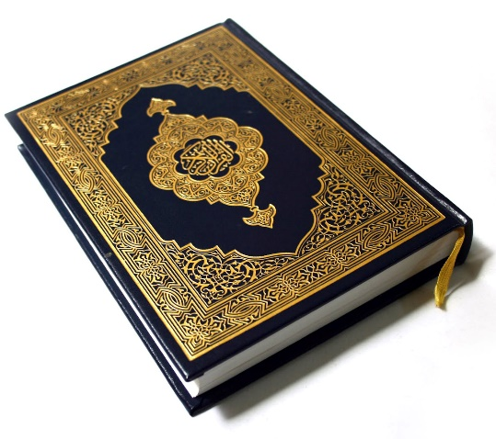
Search for personal meaning
- The ‘Ultimate authority’ for Muslims is the Qu’ran
Warrington Links :

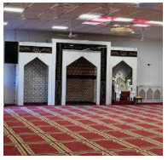
Visit to or from Islamic Centre Warrington

Texts: https://www.bbc.co.uk/bitesize/clips/zympvcw
https://www.bbc.co.uk/bitesize/clips/zv6sb9q
Enrichment:
- Invite a Muslim leader into school to discuss how they are guided by the Qur’an and how they treat the book

