Year 5 Religious Education and World Views – Where can we find guidance about how to live our lives?
Judaism: Do people need laws to guide them?
Curriculum Aims: This unit enables pupils to explore the importance of the Torah to Jewish people as a guide to life and faith. Pupils will learn that Jewish people attend the synagogue in order to find out more about how to live their lives and to seek guidance from religious leaders. They will explore how the Torah is respected and honoured through Jewish worship and the way that it is used and handled at the synagogue. Pupils will then have time to reflect upon how they personally make decisions and who or what can have influence over this.

Prior Learning: This unit has links with the KS1 unit ‘What aspects of life really matter?’ and pupils will have opportunities for revisiting prior learning on how the Torah was given to Moses.
Facts | Vocabulary
Beliefs & Values  - The Torah – it is believed that the Torah was given to Moses when God made a covenant with the Jewish people after they had been freed from slavery in Egypt. The Torah was given to them to be a foundation of how to live as people of God.  - Stories from the Torah all have lessons for Jews and help guide them and live their lives. The book contains 613 rules that teach people how to live.  - One of the rules is that Jewish people should learn about and study the Torah throughout their lives. They do this by attending the synagogue. | Tanach (Tenach) - The collection of Jewish scripture is known as the TaNaCH (TeNaK) which derives from the three parts to the Jewish scriptures; the Torah, the Nevi'im and the Ketuvim. The word TaNaCH is actually an acronym for the parts of the Hebrew Bible: "T" is for Torah, "N" is for Nevi'im, and "CH" is for Ketuvim. The Torah is the first part of the TaNaCH.  The Torah – The Jewish book which gives Jewish people important lessons of how to live as people of God.  The Synagogue – the Jewish place of worship.  Rabbi - literally ‘teacher’  vellium - a prepared animal skin  yad - a pointer used to follow the words in the Torah. The Torah scroll should not be touched by hand.  Bimah – a raised platform with a reading desk  Ark – the most important place inside the synagogue where the Torah is kept
Living religious traditions
- The Synagogue – this is the Jewish place of worship, but is also used as a place to study, and often as a community centre as well.
- Attending the synagogue gives Jewish people time to focus on God and for the Rabbi and community to pass on religious and moral teachings to the people.
- The Sefer Torah – this is the Torah scroll, which are handwritten by a specially trained scribe onto vellium (a prepared animal skin). This is treated with the utmost respect. It is an honour to be asked to read from it at a service in the synagogue, and importantly no one is allowed to touch it with their bare hands. Instead, a pointer called a yad is used to follow the words.
- In the Torah, rules for everyday life are only talked about very briefly.
- Over thousands of years, Rabbis have talked about what the Torah meant and came up with details of how Jewish people should live their lives.
Shared human experiences  - Rules and guidance can unite communities | 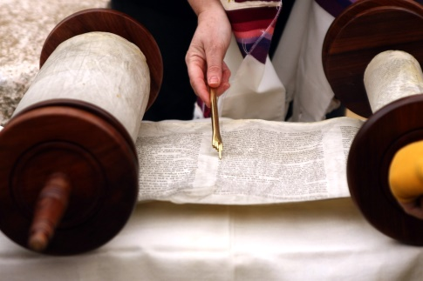
Search for personal meaning
- There are different sources of guidance available to followers of the Jewish faith – they may seek out and value different sources of guidance for different situations in their lives
Warrington Links :
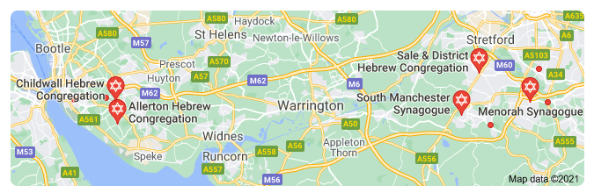
Texts:
https://www.bbc.co.uk/bitesize/clips/z8r87ty - The rules of Judaism
https://www.bbc.co.uk/bitesize/clips/zjkq6sg - The Torah and Abraham’s search for a wife for his son
https://www.bbc.co.uk/bitesize/clips/z834wmn - The Synagogue

Enrichment:
- One of the rules is that Jewish people should learn about and study the Torah throughout their lives. They do this by attending the synagogue where the Torah is read aloud and the Rabbi (literally ‘teacher’) is there to offer insight and guidance into its teaching.
- ‘Email a believer’ resource at http://pof.reonline.org.uk/

