Year 2 RE – Why do Muslims believe it is important to obey God?
Curriculum Aims: In this unit pupils will examine Islamic beliefs and practices linked to prayer. Opportunities are provided for pupils to explore the significance of prayer as one of the Five Pillars of Islam and to consider the purpose of prayer for religious people.
Within this, they will discuss the importance of rituals and how these might unite communities and give a sense of order, security and belonging to individuals. Children should have opportunities to reflect on the value of making time for those things that are important to us – for religious people this may be God, but for others it may be the family and friends. Making time is a way of showing that we are thankful to have these people in our lives.
Prior Learning: In year one children will have understood that Muslims believe in one God (Allah) who Muslims believe created the world. To discuss why Muslims might value the natural world. They will also know that Islam teaches that humans should be caretakers (stewards/Khalifahs) of the planet and how Muslims show respect to God when caring for the world.
Facts | Vocabulary
- Beliefs & Values  - To suggest why Muslims, believe that it is important to respect God.  - To talk about why Muslims would want to show their gratitude to God.  - To know that submission to God is an important aspect of Islamic life. | Islam, founders, Prophet Muhammad (pbuh), Five pillars of Islam, Zakah, charity, guidance, prayer, salah, Unmah, Wudu, obey
- Living religious traditions
- To identify that Islamic beliefs about God motivate most Muslims to pray on a regular basis
- To describe the rituals of Islamic prayer (salah), including wudhu and use of a prayer mat
- To suggest how making time for the five daily prayers is an act of submission.
- Shared human experiences  - To talk about the ways in which shared rituals might unite communities (make links with the way that the Islamic. Community – the Ummah – is united by prayer)  - To identify ways in which humans show their gratitude. | 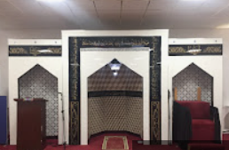  The Islamic Centre  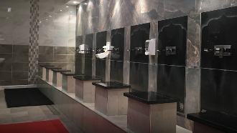  The Wudu area in the Mosque  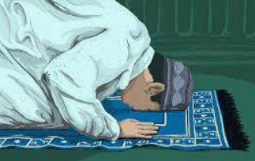  Muslim prayer
- Search for personal meaning
- To talk about the things, they do on a regular basis as a sign of their commitment and belonging.
- To reflect on who they should be grateful to and how they show this.
Warrington Links :
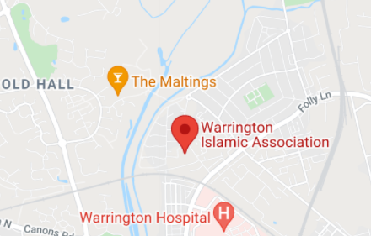
The Islamic Centre is very happy to support schools, colleges and places of education in their quest of knowledge about Islam and its teachings. Students are welcome to visit Warrington Islamic Centre. Visiting times and schedules can be obtained by emailing info@warringtonislamicassociaition.org.uk
Texts:
Class clip to illustrate ritual - https://www.bbc.com/teach/class-clips-video/wudu-the-washing-ritual/zvmrwty
Encourage children to investigate where and how Muslims pray https://www.bbc.com/teach/class-clips-video/the-mosque/zmctvk7
To explain the Shahada (the declaration of faith) https://www.bbc.com/bitesize/clips/zstfgk7
Enrichment:
- Arrange to visit the Islamic Centre in Warrington
- Invite Muslim parents into school to talk to the children about rituals and prayer.

